**Department of Computer Science**

**Lab Manual**

**DATA STRUCTURE AND ALGORITHMS**

Instructor’s Name: Shahrooz Shamim

Student’s Name: Muneeb Mughal

Roll No: 27855 Batch: thrusday

Semester: 3rd Year: 2025

Department: Computer Science

**Department of Computer Science**

**Lab Manual**

# DATA STRUCTURE AND ALGORITHMS

Prepared By:

Reviewed / Approved By

_____________________

Table of Contents

DATA STRUCTURE AND ALGORITHMS 2

Psychomotor Rubrics Assessment Hardware Lab 9

Psychomotor Rubrics for Software based Lab 10

Psychomotor Rubrics Assessment Software based Lab 12

Affective Domain Rubrics Assessment 13

Open Ended Lab Assessment Rubrics 14

Open Ended Lab Assessment Rubrics 15

Rubrics for Lab Project / CCA 16

Project / CCA Rubric based Assessment 17

Mid Term Rubrics 18

Mid Term Rubrics based Assessment 18

Final Term Rubrics 19

Final Term Rubrics based Assessment 19

Final Lab Assessment 20

Lab Session 1: Exploring Arrays in Java 21

Part 1: Creating and Initializing an Array 21

Part 2: Basic Array Operations 21

Part 3: Sorting the Array 22

Part 4: Practical Application - Finding the Maximum and Minimum Elements 22

Part 5: Applying Array Operations in a Small Project 23

Home Tasks: Further Exploration of Arrays 23

Home Task 1: Array Rotation 23

Home Task 2: Removing Duplicates from a Sorted Array 24

Home Task 3: Finding Pairs with a Given Sum 24

Grading Rubric: 24

Lab Session 2: Understanding Sorting Algorithms 25

Objective: 25

Part 1: Bubble Sort 25

Part 2: Selection Sort 25

Part 3: Insertion Sort 26

Final Task: Comparing Sorting Algorithms 27

Objective: 27

Steps: 27

Home Tasks: Implementing and Exploring Other Sorting Algorithms 27

Home Task 1: Implement Merge Sort 27

Home Task 2: Implement Quick Sort 27

Home Task 3: Implement Heap Sort 28

Grading Rubric: 28

Lab Session 3: Understanding Singly Linked Lists 29

Part 1: Creating a Node 29

Part 2: Creating a Linked List Class 29

Part 3: Inserting Nodes 30

Part 4: Displaying the List 30

Part 5: Deleting a Node 31

Part 6: Searching for an Element 31

Home Tasks: Expanding Linked List Operations 32

Home Task 1: Reverse the Linked List 32

Home Task 2: Find the Middle Element of the Linked List 32

Home Task 3: Detect and Remove Cycles in the Linked List 32

Grading Rubric: 33

Lab Session 4: Understanding Doubly Linked Lists 34

Part 1: Creating a Node for the Doubly Linked List 34

Part 2: Creating a Doubly Linked List Class 34

Part 3: Inserting Nodes 35

Part 4: Displaying the List in Both Directions 35

Part 5: Deleting a Node 36

Home Tasks: Expanding on Doubly Linked List Operations 37

Home Task 1: Inserting at a Specific Position 37

Home Task 2: Finding and Counting Elements 37

Home Task 3: Sorting the Doubly Linked List 37

Grading Rubric: 38

Lab Session 5: Understanding Stacks and Recursion 39

Part 1: Implementing a Stack using Arrays 39

Part 2: Implementing Stack Operations 39

Part 3: Application of Stack - Reversing a String 40

Part 4: Introduction to Recursion 41

Part 5: Application of Recursion - Fibonacci Sequence 41

Home Tasks: Further Applications of Stacks and Recursion 42

Home Task 1: Balancing Parentheses Using Stack 42

Home Task 2: Recursive Solution for Power Calculation 42

Home Task 3: Implementing Tower of Hanoi with Recursion 42

Grading Rubric: 43

Lab Session 6: Understanding Queues 44

Part 1: Implementing a Simple Queue Using Arrays 44

Part 2: Implementing Queue Operations 44

Part 3: Implementing a Circular Queue 45

Part 4: Application of Queue - Simulating a Printer Queue 46

Home Tasks: Advanced Queue Implementations 46

Home Task 1: Implementing a Queue Using Linked List 46

Home Task 2: Implement a Priority Queue 46

Home Task 3: Implement Recursive Queue Reversal 47

Grading Rubric: 47

Lab Session 7: Understanding P - Queues, Heaps 48

Part 1: Introduction to Heaps and Priority Queues 48

Part 2: Implementing a Max Heap 48

Part 3: Inserting into the Max Heap 49

Part 4: Removing the Maximum Element 49

Part 5: Implementing a Priority Queue with Max Heap 50

Home Tasks: Further Applications of Priority Queues and Heaps 51

Home Task 1: Implement a Min Heap 51

Home Task 2: Implement a Heap Sort 51

Home Task 3: Implement a Median Finder Using Heaps 51

Grading Rubric: 52

Lab Session 8: Open-Ended Lab 53

Build a Real-World Application with Custom Data Structures 53

Objective 53

Lab Structure 53

1. Proposal Submission (Problem Definition) 53

2. Data Structure Design 53

3. Algorithm Development 53

4. Integration and Optimization 54

Suggested Application Ideas 54

Social Network Simulation 54

Navigation System for a Map 54

Inventory Management System 54

Library Catalog System 54

Dynamic Event Scheduler 54

File System Simulation 55

Additional Features (Advanced) 55

Assessment Criteria 55

Reflection Report 56

Learning Outcomes 56

Lab Session 9: Understanding Hashing 57

Part 1: Introduction to Hashing and Hash Tables 57

Part 2: Implementing a Simple Hash Function 57

Part 3: Inserting Elements into the Hash Table 58

Part 4: Searching for an Element in the Hash Table 58

Part 5: Removing an Element from the Hash Table 59

Home Tasks: Advanced Hashing Challenges 59

Home Task 1: Implementing Hash Table with Chaining 59

Home Task 2: Counting Word Frequencies Using a Hash Table 60

Home Task 3: Implementing a Hash Table for Storing Student Records 60

Grading Rubric: 60

Lab Session 10: Understanding Binary Search Trees 61

Objective: 61

Part 1: Introduction to Binary Search Trees 61

Part 2: Creating a Node Class for the BST 61

Part 3: Creating the Binary Search Tree Class 62

Part 4: Inserting Nodes into the BST 62

Part 5: Searching for a Node in the BST 63

Part 6: Traversing the BST 63

Part 7: Deleting a Node from the BST 64

Home Tasks: Advanced BST Challenges 65

Home Task 1: Checking if a Tree is a BST 65

Home Task 2: Finding the Lowest Common Ancestor 65

Home Task 3: Converting BST to Sorted Doubly Linked List 65

Grading Rubric: 65

Lab Session 11: Understanding AVL Trees 67

Objective: 67

Part 1: Introduction to AVL Trees 67

Part 2: Creating a Node Class for AVL Tree 67

Part 3: Creating the AVL Tree Class with Insert and Balance Operations 68

Part 4: Implementing Rotations for Balancing 68

Part 5: Inserting a Node and Balancing the AVL Tree 69

Part 6: Traversing the AVL Tree 70

Home Tasks: Further Exploration of AVL Trees 71

Home Task 1: Deleting a Node from the AVL Tree 71

Home Task 2: Finding the Height of the AVL Tree 71

Home Task 3: Checking if a Binary Tree is an AVL Tree 71

Grading Rubric: 71

Lab Session 12: Understanding B+ Trees 72

Objective: 72

Part 1: Introduction to B+ Trees 72

Part 2: Creating the Node Class for B+ Tree 72

Part 3: Creating the B+ Tree Class with Insertion and Splitting 73

Part 4: Implementing Leaf and Internal Node Splitting 74

Part 5: In-Order Traversal of the B+ Tree 75

Home Tasks: Further Exploration of B+ Trees 75

Home Task 1: Implement a Search Method in B+ Tree 75

Home Task 2: Implement Deletion in the B+ Tree 76

Home Task 3: Implement Range Search in the B+ Tree 76

Grading Rubric: 76

Lab Session 13: Understanding Graph Data Structures 77

Objective: 77

Part 1: Introduction to Graphs 77

Part 2: Representing a Graph Using an Adjacency List 77

Part 3: Representing a Graph Using an Adjacency Matrix 78

Part 4: Depth-First Search (DFS) Traversal 79

Part 5: Breadth-First Search (BFS) Traversal 79

Home Tasks: Advanced Graph Operations 80

Home Task 1: Detecting a Cycle in an Undirected Graph 80

Home Task 2: Finding the Shortest Path Using BFS 80

Home Task 3: Topological Sorting of a Directed Acyclic Graph (DAG) 80

Grading Rubric: 81

Complex Computing Activity 82

Smart City Traffic Management System Simulation 82

Objective 82

Problem Overview 82

Key Requirements: 82

Additional Requirements (Advanced) 83

Suggested Approach and Steps 84

Assessment Criteria 85

Learning Outcomes 85

|  |  |  |  |  |
| --- | --- | --- | --- | --- |
| **#** | **Date** | **List of Experiment** | **Marks Obtained** | **Signature** |
| 1. | **__ / __ / __** | **Arrays** |  |  |
| 2. | **__ / __ / __** | **Sorting Algorithms** |  |  |
| 3. | **__ / __ / __** | **Linked Lists** |  |  |
| 4. | **__ / __ / __** | **Doubly Linked Lists** |  |  |
| 5. | **__ / __ / __** | **Stacks and Recursion** |  |  |
| 6. | **__ / __ / __** | **Queues** |  |  |
| 7. | **__ / __ / __** | **Priority Queues and Heaps** |  |  |
| 8. | **__ / __ / __** | **Open Ended Lab (OEL)** |  |  |
| 9. | **__ / __ / __** | **Hashing** |  |  |
| 10. | **__ / __ / __** | **Binary Search Trees (BST)** |  |  |
| 11. | **__ / __ / __** | **AVL Trees** |  |  |
| 12. | **__ / __ / __** | **B+ Trees** |  |  |
| 13. | **__ / __ / __** | **Graphs and Graph Traversal** |  |  |
| 14. | **__ / __ / __** | **Assessment of (OEL) and (CCA)** |  |  |

## Psychomotor Rubrics Assessment Hardware Lab

**Course Name (Course Code): __________________________________________________**

**Semester: ___________________________________________________________________**

|  |  |  |  |  |  |  |  |
| --- | --- | --- | --- | --- | --- | --- | --- |
| Lab # | Score Allocation | | | | | | |
| **Experimental Setup**  **Marks (3)** | | **Procedure**  **Marks (2)** | **Experimental Results**  **Marks (3)** | | **Laboratory Manual**  **Marks (2)** | **Total Marks (10)** |
| 1 |  | |  |  | |  |  |
| 2 |  | |  |  | |  |  |
| 3 |  | |  |  | |  |  |
| 4 |  | |  |  | |  |  |
| 5 |  | |  |  | |  |  |
| 6 |  | |  |  | |  |  |
| 7 |  | |  |  | |  |  |
| 8 |  | |  |  | |  |  |
| 9 |  | |  |  | |  |  |
| 10 |  | |  |  | |  |  |
| 11 |  | |  |  | |  |  |
| 12 |  | |  |  | |  |  |
| 13 |  | |  |  | |  |  |
| 14 |  | |  |  | |  |  |
| Total Mark | | 140 | | | Total Obtained Marks | |  |

***Overall Score: ___________out of 14 Examined by****: ___________________________*

***(Obtained Score / 140) x 14 (Name and Signature of lab instructor)***

## Psychomotor Rubrics for Software based Lab

***Course Name (Course Code): __________________________________________***

***Semester: ___________________________________________________________***

|  |  |  |  |  |
| --- | --- | --- | --- | --- |
| **Criteria** | **Exceeds Expectations (>=90%)** | **Meets Expectations (70%-89%)** | **Developing (50%-69%)** | **Unsatisfactory (<50%)** |
| **Software Skills** | Ability to use software with its standard and  advanced features without assistance | Ability to use software with its standard and  advanced features with minimal assistance | Ability to use software with its  standard features with assistance | Unable to use the software |
| **Programming/ Simulation** | Ability to program/ simulate the lab tasks  with simplification | Ability to program/ simulate the lab tasks  without errors | Ability to program/ simulate lab tasks  with errors | Unable to program/simulate |
| **Results** | Ability to achieve all the desired results with alternate ways | Ability to achieve all the desired results | Ability to achieve most of the desired results with errors | Unable to achieve the desired results |
| **Laboratory Manual** | All sections of the report are very well written and technically accurate. | All sections of the report are technically accurate. | Few sections of the report contain technical errors. | All sections of the report contain multiple technical errors. |

## Psychomotor Rubrics Assessment Software based Lab

**Course Name (Course Code): ________________________________________**

**Semester: _________________________________________________________**

|  |  |  |  |  |  |  |
| --- | --- | --- | --- | --- | --- | --- |
| Lab # | Score Allocation | | | | | |
| **Software Skills**  **Marks (3)** | **Programming/ Simulation**  **Marks (2)** | **Experimental Results**  **Marks (3)** | | **Laboratory Manual**  **Marks (2)** | **Total Marks (3)** |
| 1 |  |  |  | |  |  |
| 2 |  |  |  | |  |  |
| 3 |  |  |  | |  |  |
| 4 |  |  |  | |  |  |
| 5 |  |  |  | |  |  |
| 6 |  |  |  | |  |  |
| 7 |  |  |  | |  |  |
| 8 |  |  |  | |  |  |
| 9 |  |  |  | |  |  |
| 10 |  |  |  | |  |  |
| 11 |  |  |  | |  |  |
| 12 |  |  |  | |  |  |
| 13 |  |  |  | |  |  |
| 14 |  |  |  | |  |  |
| Total Marks | | 140 | | Total Obtained marks | |  |

***Overall Score: ___________out of 14 Examined by****: ___________________________*

***(Obtained Score / 140) x 14 (Name and Signature of lab instructor)***

## Affective Domain Rubrics Assessment

**Course Name (Course Code): ________________________________________**

**Semester: _________________________________________________________**

|  |  |  |  |  |
| --- | --- | --- | --- | --- |
| **CATEGORY** | **Excellent (100% - 85%)** | **Good (84% - 75%)** | **Fair (74% - 60%)** | **Poor (Less than 60%)** |
| **Speaks Clearly** | Speaks clearly and distinctly all the time, and confidently. | Speaks clearly and distinctly most of the time, but is confused for a brief period of time, however, recovers. | Speaks clearly and distinctly most of the time, but seems not confident about what has been delivered. Shows lack of confidence. | Often mumbles or cannot be understood and clearly lacks confidence in delivering the content |
| **Points:** |  |  |  |  |
| **Preparedness** | Student is completely prepared and has obviously rehearsed. | Student seems pretty prepared but might have needed a couple more rehearsals. | The student is somewhat prepared, but it is clear that rehearsal was lacking. | Student does not seem at all prepared to present. |
| **Points** |  |  |  |  |
| **Answer back** | Student calmly listens to the questions and responds to the question confidently and correctly | Student calmly listens to the questions, responds confidently but some of the responses are incorrect. | Student shows anxiety while listening to the questions, and gives some correct responses, but some of the responses are incorrect. | Student shows anxiety while listening to the questions, and most of the responses are incorrect. |
| **Points:** |  |  |  |  |
| **Posture, Eye Contact & Speaking Volume** | Stands up straight, looks relaxed and confident. Establishes eye contact with everyone in the room during the presentation. Volume is loud enough to be heard by all members in the audience throughout the presentation. | Stands up straight and establishes eye contact with everyone in the room during the presentation. Volume is loud enough to be heard by the audience, but is sometimes not audible. | Sometimes stands up straight and establishes eye contact. Volume is loud enough to be heard by the audience, but many sentences spoken are not clear. | Lazy and informal posture. Does not look at people during the presentation. Volume is also too soft to be heard by the audience. |
| **Points:** |  |  |  |  |

***Overall Score: ___________out of 14 Examined by****: ___________________________*

***(Name and Signature of lab instructor)***

## Open Ended Lab Assessment Rubrics

***Course Name (Course Code): _______________________________________***

***Semester: ________________________________________________________***

|  |  |  |  |
| --- | --- | --- | --- |
| **Criteria and Scales** | | | |
| **Excellent**  **(10-8)** | **Good**  **(7-5)** | **Average**  **(4-2)** | **Poor**  **(1-0)** |
| **Criterion 1:** **Problem Definition and Solution Design:** How well the problem statement is understood by the student | | | |
| Understands the problem clearly and clearly identifies the underlying issues. | Adequately understands the problem and identifies the underlying issues. | Inadequately defines the problem and identifies the underlying issues. | Fails to define the problem adequately and does not identify the underlying issues. |
| **Criterion 2:**  **Implementation of Data Structures:** Correct implementation of required data structures. | | | |
| Contains all the information needed for solving the problem | Good implementation, leading to a successful solution | Mediocre implementation may or may not lead to an adequate solution | No apparent implementation |
| **Criterion 3:**  **Algorithm Efficiency:** Effective and efficient implementation of required algorithms. | | | |
| Effective and efficient implementation with complete notations | Effective and efficient implementation with incomplete notations | Effective and efficient implementation with improper naming convention and notations | Not Effective and efficient implementation |
| **Criterion 4:**  **Code Quality:** How complete and accurate the code is along with the assumptions | | | |
| Complete Code according to the class diagram of the given case with clear assumptions | Incomplete Code according to the class diagram of the given case with clear assumptions | Incomplete Code according to the class diagram of the given case with unclear assumptions | Wrong code and naming conventions |
| **Criterion 5: Report:** How thorough and well organized is the solution | | | |
| All the necessary information clearly organized for easy use in solving the problem | Good information organized well that could lead to a good solution | Mediocre information which may or may not lead to a solution | No report provided |

## Open Ended Lab Assessment Rubrics

***Course Name (Course Code): ________________________________________***

***Semester: ________________________________________________________***

|  |  |  |  |  |
| --- | --- | --- | --- | --- |
| **Criteria and Scales** | | | | |
| **Excellent**  **(10-8)** | **Good**  **(7-5)** | **Average**  **(4-2)** | **Poor**  **(1-0)** | **Total Marks**  **10** |
| **Criterion 1:**  **Understanding the Problem:** How well the problem statement is understood by the student | | | | |
| (10-8) | (7-5)% | (4-2)% | (1-0)% |  |
| **Criterion 2:**  **Implementation of Data Structures:** Correct implementation of required data structures. | | | | |
| (10-8) | (7-5)% | (4-2)% | (1-0)% |  |
| **Criterion 3:**  **Algorithm Efficiency:** Effective and efficient implementation of required algorithms. | | | | |
| (10-8) | (7-5)% | (4-2)% | (1-0)% |  |
| **Criterion 4:**  **Code Quality:** How complete and accurate the code is along with the assumptions | | | | |
| (10-8) | (7-5)% | (4-2)% | (1-0)% |  |
| **Criterion 5:**  **Report**: How thorough and well organized is the solution | | | | |
| (10-8) | (7-5)% | (4-2)% | (1-0)% |  |
| Total | | | | **(____/5)** |

Total marks obtained: ____________________

Name and Signature of lab instructor: _____________________

## Rubrics for Lab Project / CCA

***Course Name (Course Code): __________________________________________***

***Semester****: __________________________________________________________*

|  |  |  |  |  |
| --- | --- | --- | --- | --- |
| **Criteria** | **Exceeds Expectations**  **(>=90%)** | **Meets Expectations (70%-89%)** | **Developing (50%-69%)** | **Unsatisfactory (<50%)** |
| **Project Presentation + Project Demonstration** | Ability to demonstrate the project with achievement of required objectives having clear understanding of project limitations and future enhancements. Hardware and/or Software modules are fully functional, if applicable. | Ability to demonstrate the project with achievement of required objectives but understanding of project limitations and future enhancements is insufficient.  Hardware and/or Software modules are functional, if applicable. | Ability to demonstrate the project with achievement of a*t least 50% required objectives and insufficient understanding of project limitations and future enhancements.  Hardware and/or Software modules are partially functional, if applicable. | Ability to demonstrate the project with achievement of less than 50% required objectives and lacks in understanding of project limitations and future enhancements.  Hardware and/or Software modules are not functional, if applicable. |
| **Project Report** | All sections of the Project report are very well- written and technically accurate. | All sections of the Project report are technically accurate. | Few sections of the Project report contain technical errors. | Project report has several grammatical/ spelling errors and sentence construction is poor. |
| **Viva** | Able to answer the questions easily and  correctly across the project. | Able to answer the questions related to the project | Able to answer the questions but with mistakes | Unable to answer the questions |

Total marks: ____________________

Name and Signature of lab instructor: ____________________

## Project / CCA Rubric based Assessment

**Course Name (Course Code): ___________________________________________________**

**Semester: ____________________________________________________________________**

|  |  |  |  |  |
| --- | --- | --- | --- | --- |
| Project # | Score Allocation | | | |
| **Project Presentation + Project Demonstration**  **Marks (5)** | **Project Report**  **Marks (3)** | **Viva**  **Marks (3)** | **Total**  **Marks (10)** |
| 1 |  |  |  |  |
| 2 |  |  |  |  |
| Total Obtained Score | | | |  |

Total marks obtained: ____________________

Name and Signature of lab instructor: _____________________

## Mid Term Rubrics

**Course Name (Course Code): _________________________________________**

**Semester: __________________________________________________________**

|  |  |  |  |  |
| --- | --- | --- | --- | --- |
| **Criteria** | **Exceeds Expectations (>=90%)** | **Meets Expectations (70%-89%)** | **Developing (50%-69%)** | **Unsatisfactory (<50%)** |
| **Performance** | Able to present full knowledge of both problem and solution. | Able to present adequate knowledge of both problem and  solution | Able to present sufficient knowledge of both problem and solution | No or very less knowledge of both problems  and solution |
| **Viva** | Able to answer the questions easily and  correctly | Able to answer the questions | Able to answer the questions but with mistakes | Unable to answer the questions |

## Mid Term Rubrics based Assessment

***Course Name (Course Code): ___________________________________________***

***Semester, Batch: _____________________________________________________***

|  |  |
| --- | --- |
| **Score Allocation** | |
| **Performance** | ______ /20 |
| **Viva** | _____ /5 |
| **Total Obtained Score** | **______/ 25** |

***Examined by****:*

***(Name and Signature of concerned lab instructor***

## Final Term Rubrics

***Course Name (Course Code): ________________________________________***

***Semester: _________________________________________________________***

|  |  |  |  |  |
| --- | --- | --- | --- | --- |
| **Criteria** | **Exceeds Expectations (>=90%)** | **Meets Expectations (70%-89%)** | **Developing (50%-69%)** | **Unsatisfactory (<50%)** |
| **Performance** | Able to present full knowledge of both problem and solution. | Able to present adequate knowledge of both problem and  solution | Able to present sufficient knowledge of both problem and solution | No or very less knowledge of both problems  and solution |
| **Viva** | Able to answer the questions easily and  correctly | Able to answer the questions | Able to answer the questions but with mistakes | Unable to answer the questions |

## Final Term Rubrics based Assessment

***Course Name (Course Code): _______________________________________***

***Semester, Batch: _________________________________________________***

|  |  |
| --- | --- |
| Score Allocation | |
| **Performance** | _____ /45 |
| **Viva** | _____ /5 |
| **Total Obtained Score** | **_____/ 50** |

***Examined by****:*

***(Name and Signature of concerned lab instructor)***

## Final Lab Assessment

|  |  |  |  |
| --- | --- | --- | --- |
| **Assessment Tool** | **CLO-1 (20)** | **CLO-2 (20)** | **CLO-3 (10)** |
| **Lab Manual** |  |  |  |
| **Subject Project / Viva** |  |  |  |
| **Lab Exam / Viva** |  |  |  |
| **Score Obtained** |  |  |  |
| **Total Score: ________ out of 50** | | | |

***Examined by****:*

***(Name and Signature of concerned lab instructor)***

**CLASS TASK 1:**

**CODE:**

public class ClassTask1 {  
public static void main(String[] args) {  
 int[] numbers = {5, 2, 9, 1, 6};  
 System.*out*.println("Array elements:");  
 for (int i = 0; i < numbers.length; i++) {  
 System.*out*.println("Element at index " + i + ": " + numbers[i]);  
 }  
}  
}

**OUTPUT:**

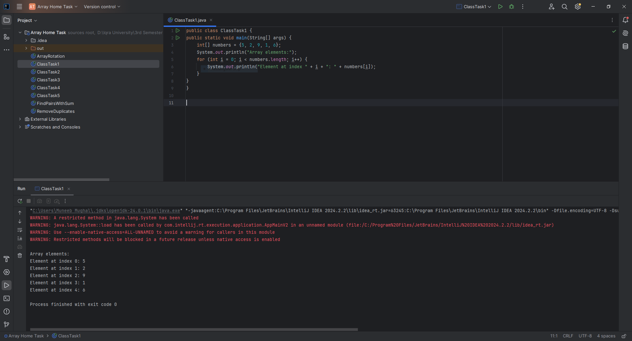

**CLASS TASK 2:**

**CODE:**

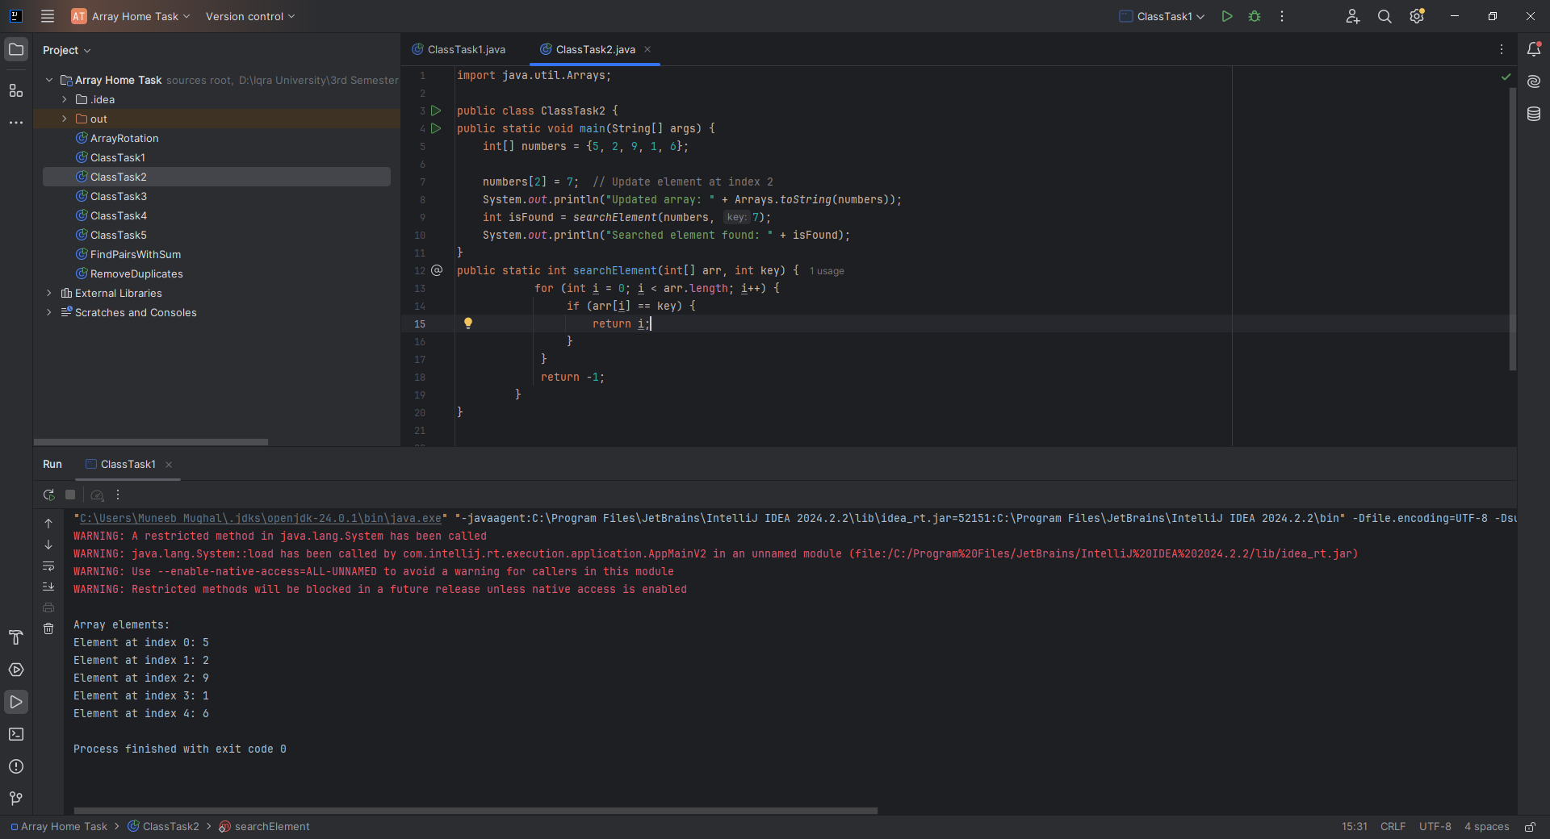import java.util.Arrays;  
  
public class ClassTask2 {  
public static void main(String[] args) {  
 int[] numbers = {5, 2, 9, 1, 6};  
  
 numbers[2] = 7; // Update element at index 2  
 System.*out*.println("Updated array: " + Arrays.*toString*(numbers));  
 int isFound = *searchElement*(numbers, 7);  
 System.*out*.println("Searched element found: " + isFound);  
}  
public static int searchElement(int[] arr, int key) {  
 for (int i = 0; i < arr.length; i++) {  
 if (arr[i] == key) {  
 return i;  
 }  
 }  
 return -1;

}  
}

**CLASS TASK 3:**

**CODE:**

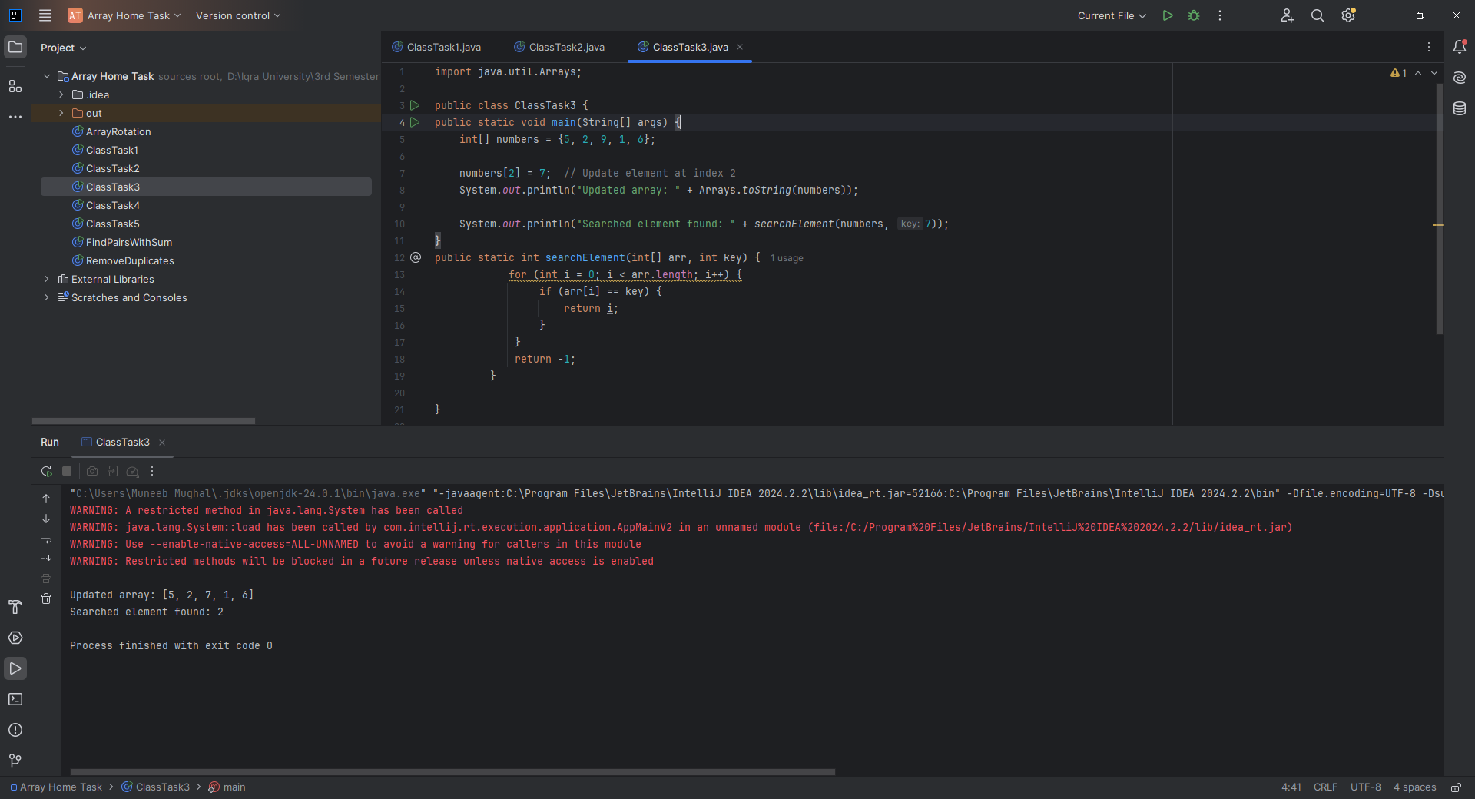import java.util.Arrays;  
  
public class ClassTask3 {  
public static void main(String[] args) {  
 int[] numbers = {5, 2, 9, 1, 6};  
  
 numbers[2] = 7; // Update element at index 2  
 System.*out*.println("Updated array: " + Arrays.*toString*(numbers));  
  
 System.*out*.println("Searched element found: " + *searchElement*(numbers, 7));  
}  
public static int searchElement(int[] arr, int key) {  
 for (int i = 0; i < arr.length; i++) {  
 if (arr[i] == key) {  
 return i;  
 }  
 }  
 return -1;  
 }  
  
}  
**CLASS TASK 4:**

**CODE:**

import java.util.Arrays;  
  
public class ClassTask4 {  
public static void main(String[] args) {  
 int[] numbers = {5, 2, 9, 1, 6};  
  
 System.*out*.println("Max value: " + *findMax*(numbers));  
 System.*out*.println("Find Min: "+ *findMin*(numbers));  
}  
 public static int findMax(int[] arr) {  
 int max = arr[0];  
 for (int i = 1; i < arr.length; i++) {  
 if (arr[i] > max) {  
 max = arr[i];  
 }  
 }  
 return max;  
 }  
 public static int findMin(int[] arr) {  
 int min = arr[0];  
 for (int i = 1; i < arr.length; i++) {  
 if (arr[i] < min) {  
 min = arr[i];  
 }  
 }  
 return min;  
 }  
}

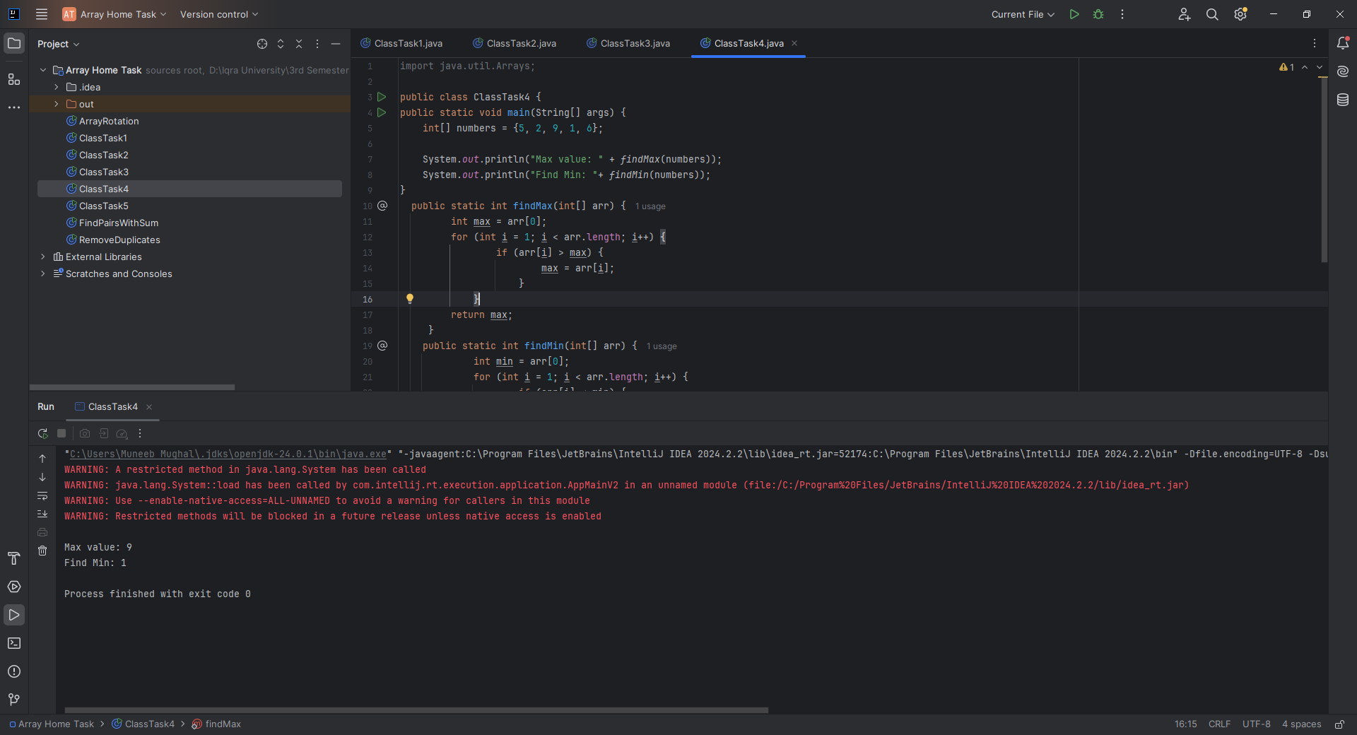

**CLASS TASK 5**

**CODE:**

import java.util.Arrays;  
  
public class ClassTask5 {  
public static void main(String[] args) {  
 int[] grades = {78, 92, 88, 65, 70};  
 Arrays.*sort*(grades);  
 int sum = 0;  
 for (int i = 1; i < grades.length; i++) { // Start from 1 to skip the lowest grade  
 sum += grades[i];  
 }  
 double average = (double) sum / (grades.length - 1);  
 System.*out*.println("Average grade after removing the lowest: " + average);  
  
}  
}

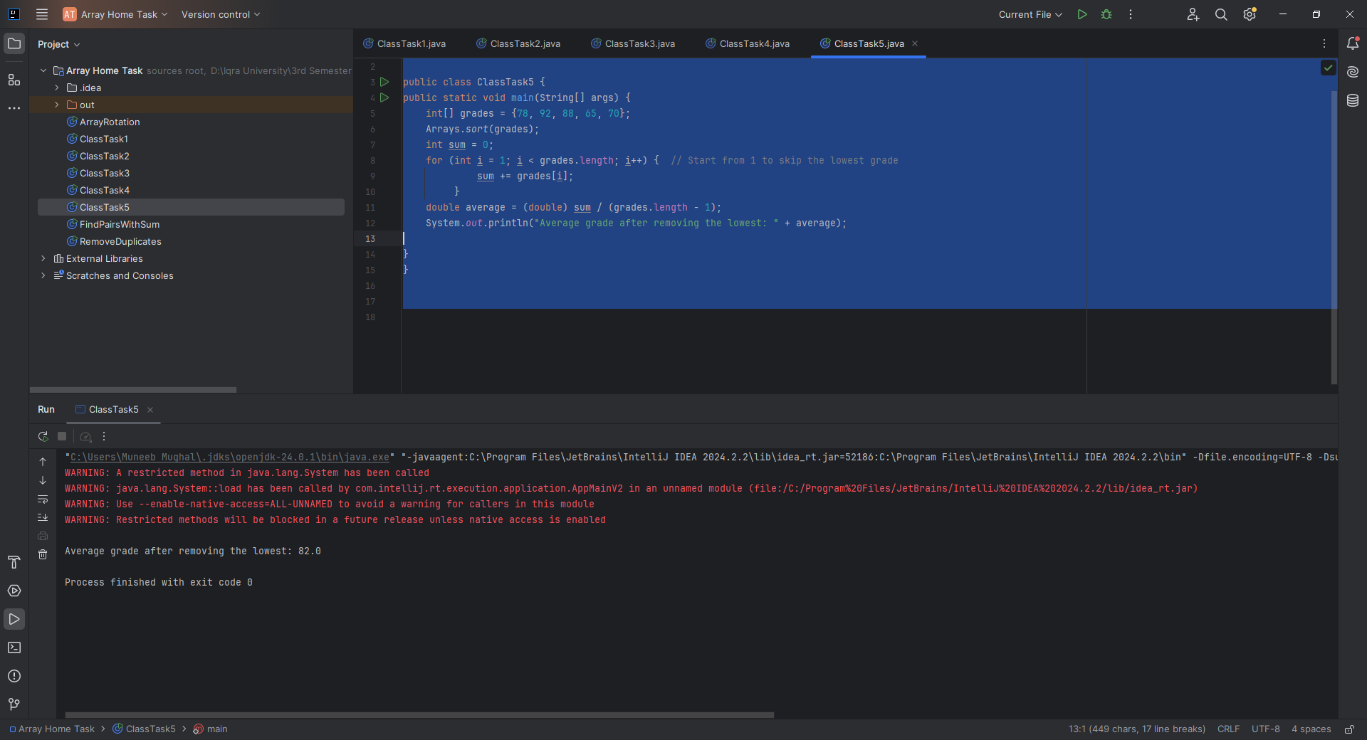

**HOME TASK 1**

**CODE:**

import java.util.Arrays;  
  
public class ArrayRotation {  
 public static int[] rotateArray(int[] arr, int k) {  
 int n = arr.length;  
 k = k % n;  
 int[] result = new int[n];  
  
 for (int i = 0; i < n; i++) {  
 result[(i + k) % n] = arr[i];  
 }  
  
 return result;  
 }  
  
 public static void main(String[] args) {  
 int[] input = {1, 2, 3, 4, 5};  
 int k = 2;  
 int[] output = *rotateArray*(input, k);  
 System.*out*.println("Rotated Array: " + Arrays.*toString*(output));  
 }  
}

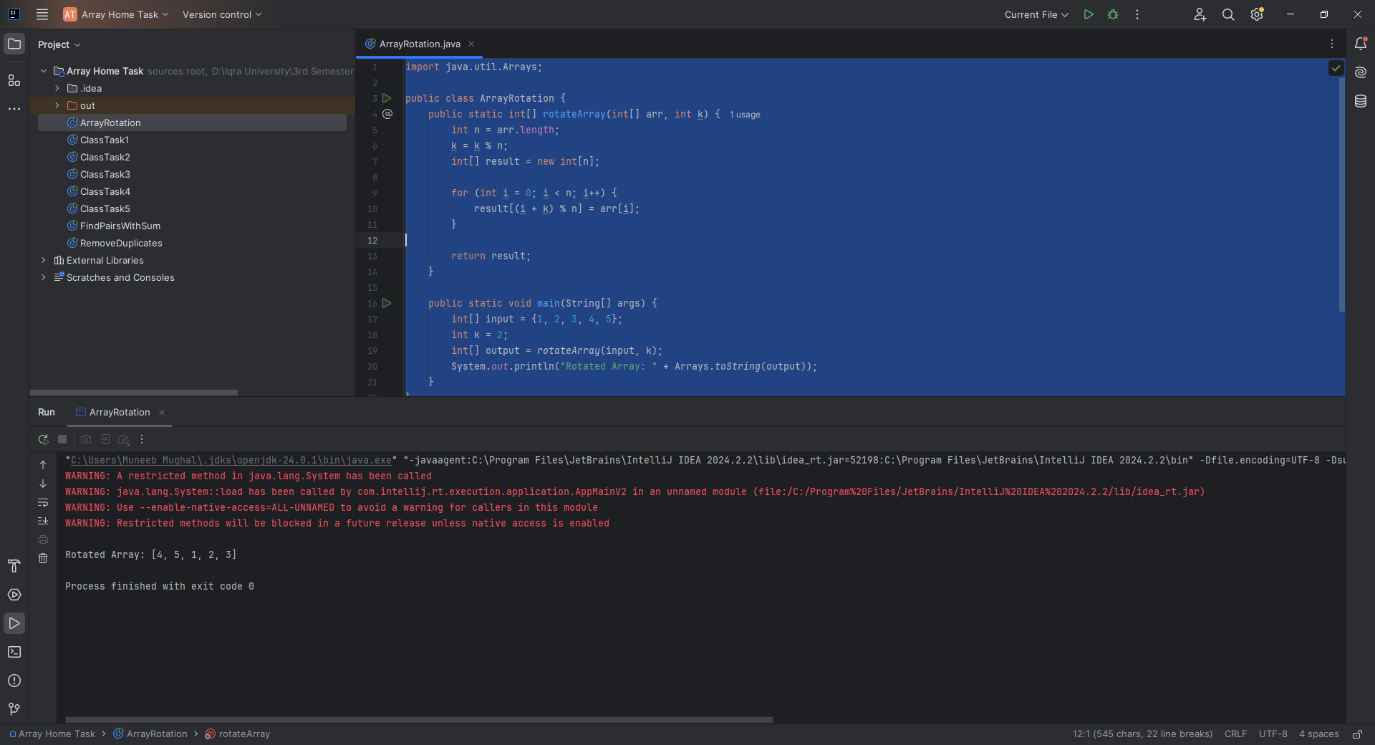

**HOME TASK 2**

**CODE:**public class FindPairsWithSum {  
  
 public static String[] findPairs(int[] arr, int target) {  
 int n = arr.length;  
 String[] tempPairs = new String[n * n]; // max possible size  
 int pairCount = 0;  
  
 for (int i = 0; i < n; i++) {  
 // Check pairs only once  
 for (int j = i + 1; j < n; j++) {  
 if (arr[i] + arr[j] == target) {  
 tempPairs[pairCount++] = "(" + arr[i] + ", " + arr[j] + ")";  
 }  
 }  
 }  
  
 // Copy valid pairs to result array  
 String[] result = new String[pairCount];  
 for (int i = 0; i < pairCount; i++) {  
 result[i] = tempPairs[i];  
 }  
  
 return result;  
 }  
  
 public static void main(String[] args) {  
 int[] input = {1, 2, 3, 4, 5};  
 int target = 6;  
 String[] output = *findPairs*(input, target);  
  
 System.*out*.print("Pairs with sum " + target + ": ");  
 for (String pair : output) {  
 System.*out*.print(pair + " ");  
 }  
 }  
}

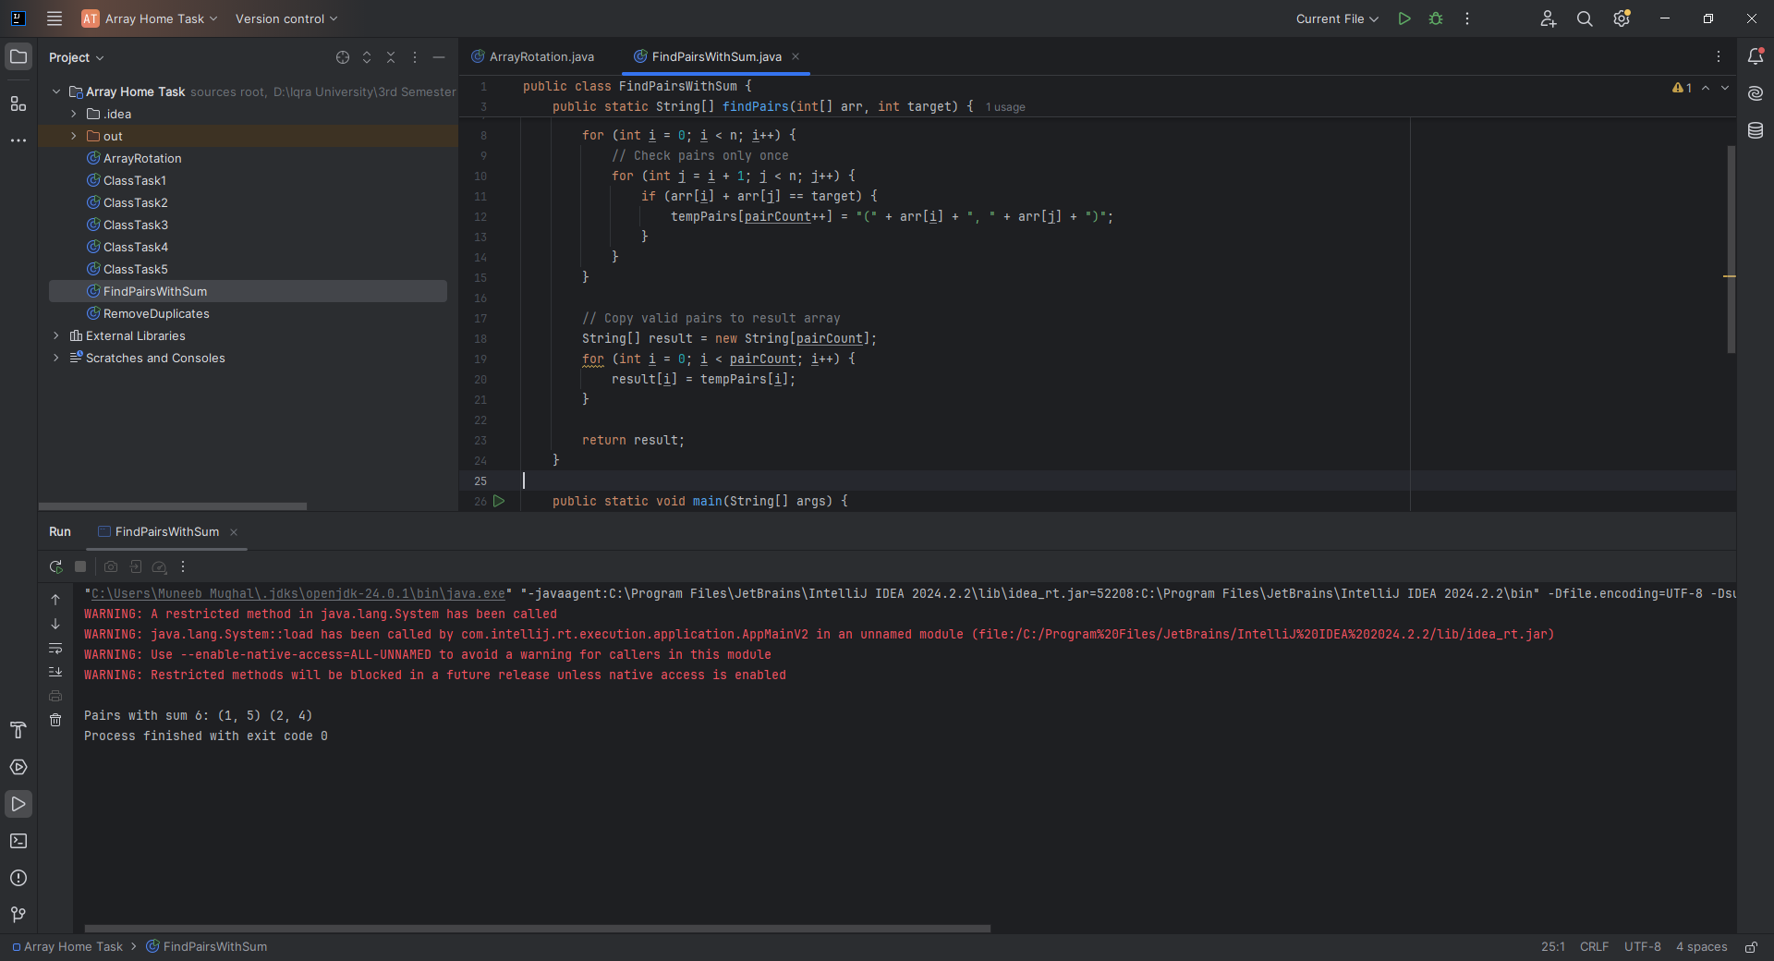

**HOME TASK 3**

**CODE:**

import java.util.Arrays;  
  
public class RemoveDuplicates {  
 public static int[] removeDuplicates(int[] arr) {  
 if (arr.length == 0) return new int[0];  
  
 // First pass: count unique elements  
 int uniqueCount = 1;  
 for (int i = 1; i < arr.length; i++) {  
 if (arr[i] != arr[i - 1]) {  
 uniqueCount++;  
 }  
 }  
  
 // Second pass: store unique elements  
 int[] result = new int[uniqueCount];  
 result[0] = arr[0];  
 int index = 1;  
 for (int i = 1; i < arr.length; i++) {  
 if (arr[i] != arr[i - 1]) {  
 result[index++] = arr[i];  
 }  
 }  
  
 return result;  
 }  
  
 public static void main(String[] args) {  
 int[] input = {1, 2, 2, 3, 4, 4, 5};  
 int[] output = *removeDuplicates*(input);  
 System.*out*.println("Unique Elements: " + Arrays.*toString*(output));  
 }  
}

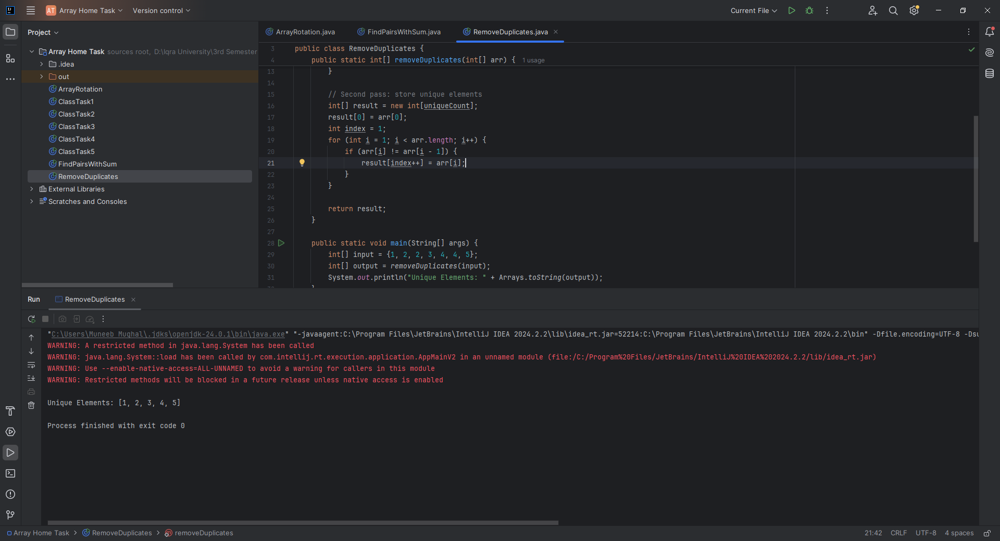

**CLASS TASK 1:**

void Bubble_Sort(int order, int[] arr) {  
 if (order == 1) { // Ascending  
 for (int i = 0; i < arr.length; i++) {  
 for (int j = 0; j < arr.length; j++) {  
 if (arr[j] > arr[i]) {  
 int temp = arr[j];  
 arr[j] = arr[i];  
 arr[i] = temp;  
 }  
 }  
 }  
 } else if (order == -1) { // Descending  
 for (int i = 0; i < arr.length; i++) {  
 for (int j = 0; j < arr.length; j++) {  
 if (arr[j] < arr[i]) {  
 int temp = arr[j];  
 arr[j] = arr[i];  
 arr[i] = temp;  
 }  
 }  
 }  
 } else {  
 throw new RuntimeException("Invalid order");  
 }  
}

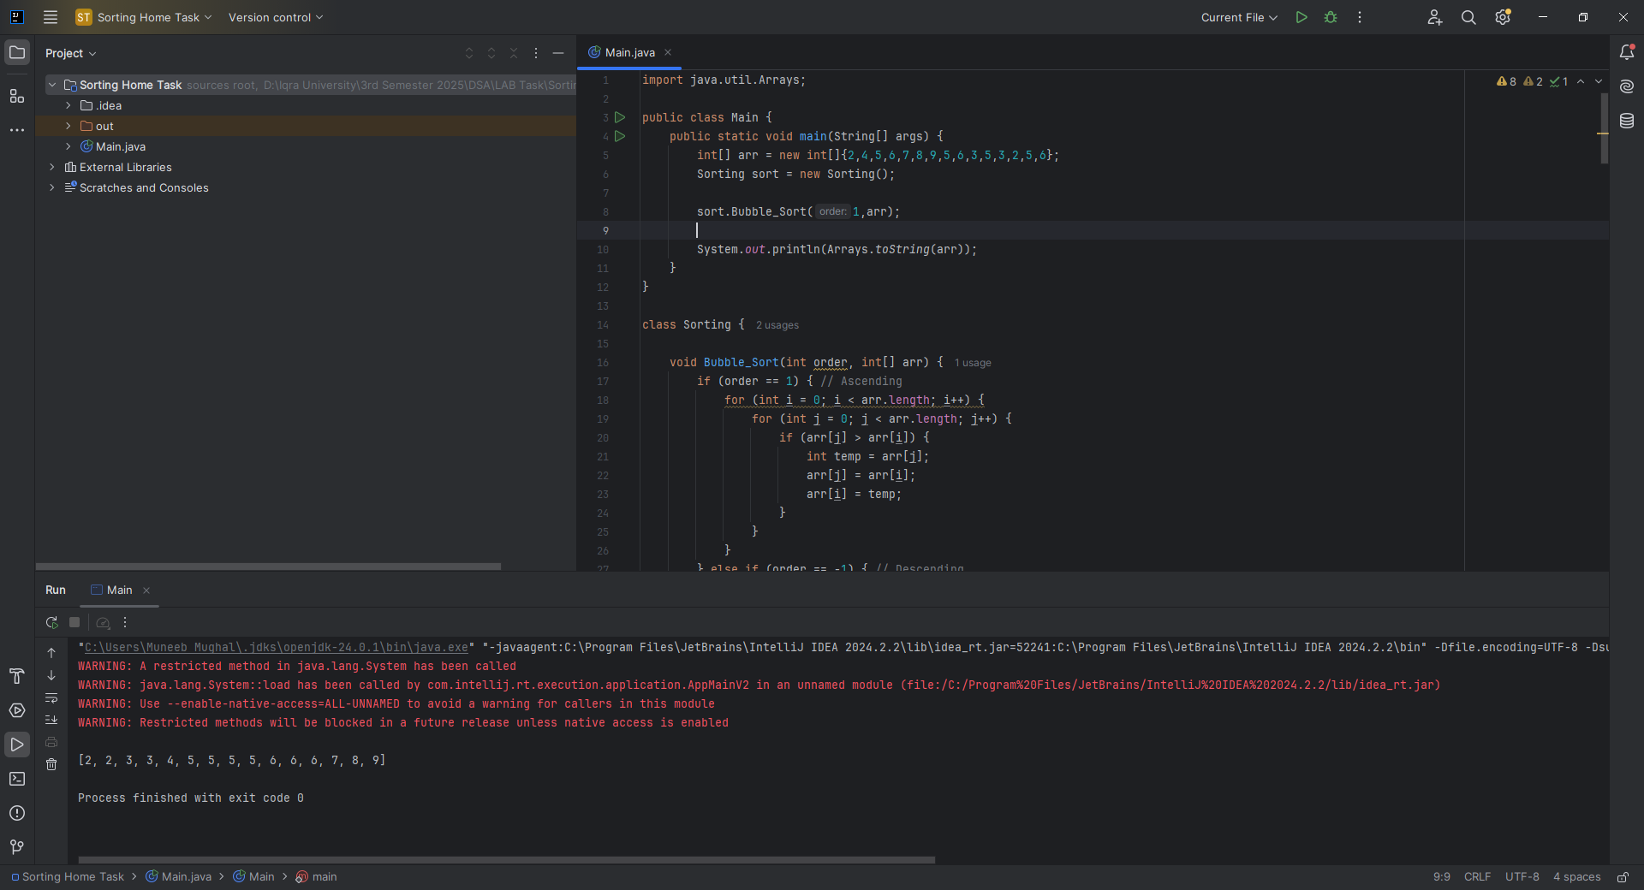

**CLASS TASK 2**

**CODE:**

void selection_Sorting(int order, int[] arr) {  
 for (int i = 0; i < (arr.length - 1); i++) {  
 int min = i;  
 for (int j = i + 1; j < arr.length; j++) {  
 if (arr[j] < arr[min]) {  
 min = j;  
 }  
 }  
 int temp = arr[i];  
 arr[i] = arr[min];  
 arr[min] = temp;  
 }  
}



**CLASS TASK 3**

**CODE:**  
void insertion_sort(int[] arr) {  
 for (int i = 1; i < arr.length; i++) {  
 int key = arr[i];  
 int j = i - 1;  
 while (j >= 0 && arr[j] > key) {  
 arr[j + 1] = arr[j];  
 j--;  
 }  
 arr[j + 1] = key;  
 }  
}



**CLASS TASK 4**

**CODE:**

import java.util.Arrays;  
import java.util.Random;  
  
public class Main {  
 public static void main(String[] args) {  
 Sorting sort = new Sorting();  
 int[] sizes = {10, 100, 1000};  
  
 for(int size : sizes) {  
 System.*out*.println("Array Size: " + size);  
 int[] original = *generateRandomArray*(size, 10000);  
  
 int[] arr1 = *copyArray*(original);  
 int[] arr2 = *copyArray*(original);  
 int[] arr3 = *copyArray*(original);  
  
 long start, end;  
  
 // Bubble Sort timing  
 start = System.*nanoTime*();  
 sort.Bubble_Sort(1,arr1);  
 end = System.*nanoTime*();  
 System.*out*.println("Bubble Sort Time: " + (end - start)/1e6 + " ms");  
  
 // Selection Sort timing  
 start = System.*nanoTime*();  
 sort.selection_Sorting(1,arr2);  
 end = System.*nanoTime*();  
 System.*out*.println("Selection Sort Time: " + (end - start)/1e6 + " ms");  
  
 // Insertion Sort timing  
 start = System.*nanoTime*();  
 sort.insertion_sort(arr3);  
 end = System.*nanoTime*();  
 System.*out*.println("Insertion Sort Time: " + (end - start)/1e6 + " ms");  
  
 System.*out*.println();  
 }  
 }  
  
 public static int[] copyArray(int[] arr) {  
 int[] copy = new int[arr.length];  
 System.*arraycopy*(arr, 0, copy, 0, arr.length);  
 return copy;  
 }  
  
 public static int[] generateRandomArray(int size, int bound) {  
 int[] array = new int[size];  
 Random rand = new Random();  
 for(int i = 0; i < size; i++) {  
 array[i] = rand.nextInt(bound);  
 }  
 return array;  
 }  
}

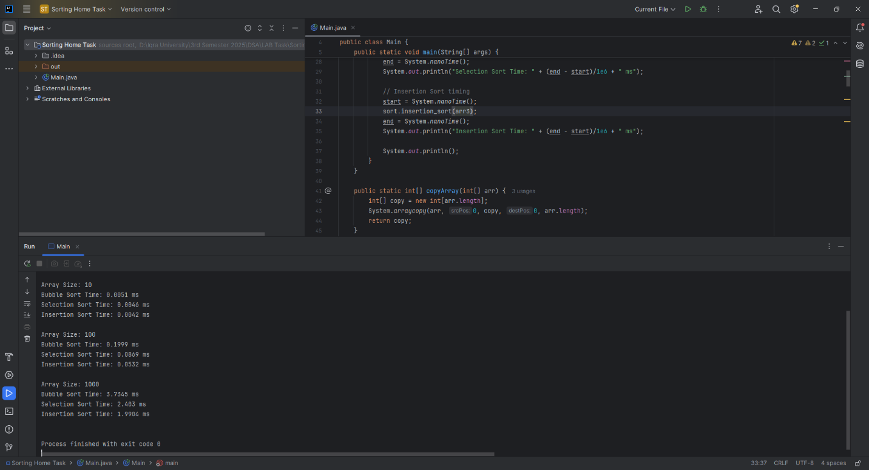

**HOME TASK 1**

**CODE:**

void mergeSort(int[] array) {  
 if (array.length < 2) return;  
  
 int mid = array.length / 2;  
 int[] leftArray = Arrays.*copyOfRange*(array, 0, mid);  
 int[] rightArray = Arrays.*copyOfRange*(array, mid, array.length);  
  
 mergeSort(leftArray);  
 mergeSort(rightArray);  
 merge(array, leftArray, rightArray);  
}  
  
private void merge(int[] array, int[] left, int[] right) {  
 int i = 0, j = 0, k = 0;  
  
 while (i < left.length && j < right.length) {  
 if (left[i] < right[j]) {  
 array[k++] = left[i++];  
 } else {  
 array[k++] = right[j++];  
 }  
 }  
  
 while (i < left.length) array[k++] = left[i++];  
 while (j < right.length) array[k++] = right[j++];  
}



**1. Divide**

The array is divided into two halves:

* If the array has more than one element, it is split into two subarrays of approximately equal size.
* This splitting continues **recursively** until each subarray has **only one element**, which is inherently sorted.

**2. Conquer (Recursively Sort)**

Each pair of one-element arrays is merged into a sorted array.

Merging happens in the reverse order of splitting.

Finally, the two sorted halves are merged.

**Time Complexity Analysis**

Merge Sort’s efficiency comes from how it breaks down and builds up the sorted array:

| **Input Size** | **Merge Sort (n log n)** | **Bubble/Insertion Sort (n²)** |
| --- | --- | --- |
| 10 | ~33 operations | ~100 operations |
| 1000 | ~10,000 operations | ~1,000,000 operations |

**HOME TASK 2**

**CODE:**

void quickSort(int[] arr) {  
 quickSortRecursive(arr, 0, arr.length - 1);  
}  
  
private void quickSortRecursive(int[] arr, int low, int high) {  
 if (low < high) {  
 int pi = quickPartition(arr, low, high);  
 quickSortRecursive(arr, low, pi - 1);  
 quickSortRecursive(arr, pi + 1, high);  
 }  
}  
  
private int quickPartition(int[] arr, int low, int high) {  
 int pivot = arr[high];  
 int i = low - 1;  
 for (int j = low; j < high; j++) {  
 if (arr[j] < pivot) {  
 i++;  
 int temp = arr[i]; arr[i] = arr[j]; arr[j] = temp;  
 }  
 }  
 int temp = arr[i + 1]; arr[i + 1] = arr[high]; arr[high] = temp;  
 return i + 1;  
}



| **Case** | **Time Complexity** | **Reason** |
| --- | --- | --- |
| **Best Case** | O(n log n) | Pivot always splits the array into equal halves. |
| **Average Case** | O(n log n) | Pivot *usually* splits array reasonably well (not perfectly even, but not too unbalanced). |
| **Worst Case** | O(n²) | Pivot is the smallest or largest element every time, leading to highly unbalanced splits. |

**HOME TASK 3**

**CODE:**

void heapSort(int[] arr) {  
 int n = arr.length;  
  
 // Build max heap  
 for (int i = n / 2 - 1; i >= 0; i--) heapify(arr, n, i);  
  
 // Extract elements  
 for (int i = n - 1; i > 0; i--) {  
 int temp = arr[0]; arr[0] = arr[i]; arr[i] = temp;  
 heapify(arr, i, 0);  
 }  
}  
  
private void heapify(int[] arr, int heapSize, int root) {  
 int largest = root;  
 int left = 2 * root + 1;  
 int right = 2 * root + 2;  
  
 if (left < heapSize && arr[left] > arr[largest]) largest = left;  
 if (right < heapSize && arr[right] > arr[largest]) largest = right;  
  
 if (largest != root) {  
 int temp = arr[root];  
 arr[root] = arr[largest]; arr[largest] = temp;  
 heapify(arr, heapSize, largest);  
 }  
}



**Heap Sort** has:

* **Time Complexity:**
  + **O(n log n)** in **best**, **average**, and **worst** cases.
* **Memory Efficiency:**
  + **In-place sorting**: requires **O(1)** extra space (no additional arrays needed).

**Efficient for large datasets** where memory is limited.  
Not stable (doesn't preserve order of equal elements).

**CLASS TASKS**

**CODE:**

public class Main {  
 public static void main(String[] args){  
 LinkedList list = new LinkedList();  
 list.insert_at_start(12);  
 list.insert_at_start(13);  
 list.insert_at_start(14);  
 list.insert_at_start(15);  
 list.insert_at_start(21);  
 list.insert_at_start(22);  
 list.insert_at_start(23);  
 list.insert_at_start(24);  
 list.reverse();  
 list.findMiddle();  
  
 LinkedList.Node temp = list.head;  
 while (temp.next != null){  
 temp = temp.next;  
 }  
 temp.next = list.head.next.next;  
 list.detectAndRemoveCycle();  
 list.traverse();  
 }  
}  
  
class LinkedList{  
Node head = null;  
 class Node {  
 int data;  
 Node next;  
 public Node(int data) {  
 this.data = data;  
 next = null;  
 }  
 }  
 void delete_from_start(){  
 if(head == null){  
 return;  
 }  
 head = head.next;  
 }  
 void delete_from_end(){  
 if(head == null){  
 return;  
 }  
 if (head.next == null) {  
 head = null;  
 return;  
 }  
 Node current = head;  
 while (current.next.next != null) {  
 current = current.next;  
 }  
 current.next = null;  
 }  
 void insert_after(int val , int data){  
 Node newNode = new Node(data);  
 if(head == null){  
 System.*out*.println("List is empty");  
 return;  
 }  
 if(head.data == val){  
 newNode.next = head.next;  
 head.next = newNode;  
 return;  
 }  
 Node current = head.next;  
 while(current.next != null){  
 if(current.data == val){  
 newNode.next = current.next;  
 current.next = newNode;  
 return;  
 }  
 }  
 System.*out*.println(val + " is not in the list");  
 return;  
 }  
 void insert_at_start(int data){  
 Node newNode = new Node(data);  
 if(head == null){  
 head = newNode;  
 return;  
 }  
 newNode.next = head;  
 head = newNode;  
 }  
 void insert_at_end(int data) {  
 Node newNode = new Node(data);  
 if(head == null){  
 head = newNode;  
 return;  
 }  
 Node current = head;  
 while(current.next != null){  
 current = current.next;  
 }  
 current.next = newNode;  
 }  
 void traverse(){  
 if(head == null){  
 System.*out*.println("Empty List");  
 return;  
 }  
 Node current = head;  
 System.*out*.println(current.data);  
 while(current.next != null){  
 current = current.next;  
 System.*out*.println(current.data);  
 }  
 }  
}

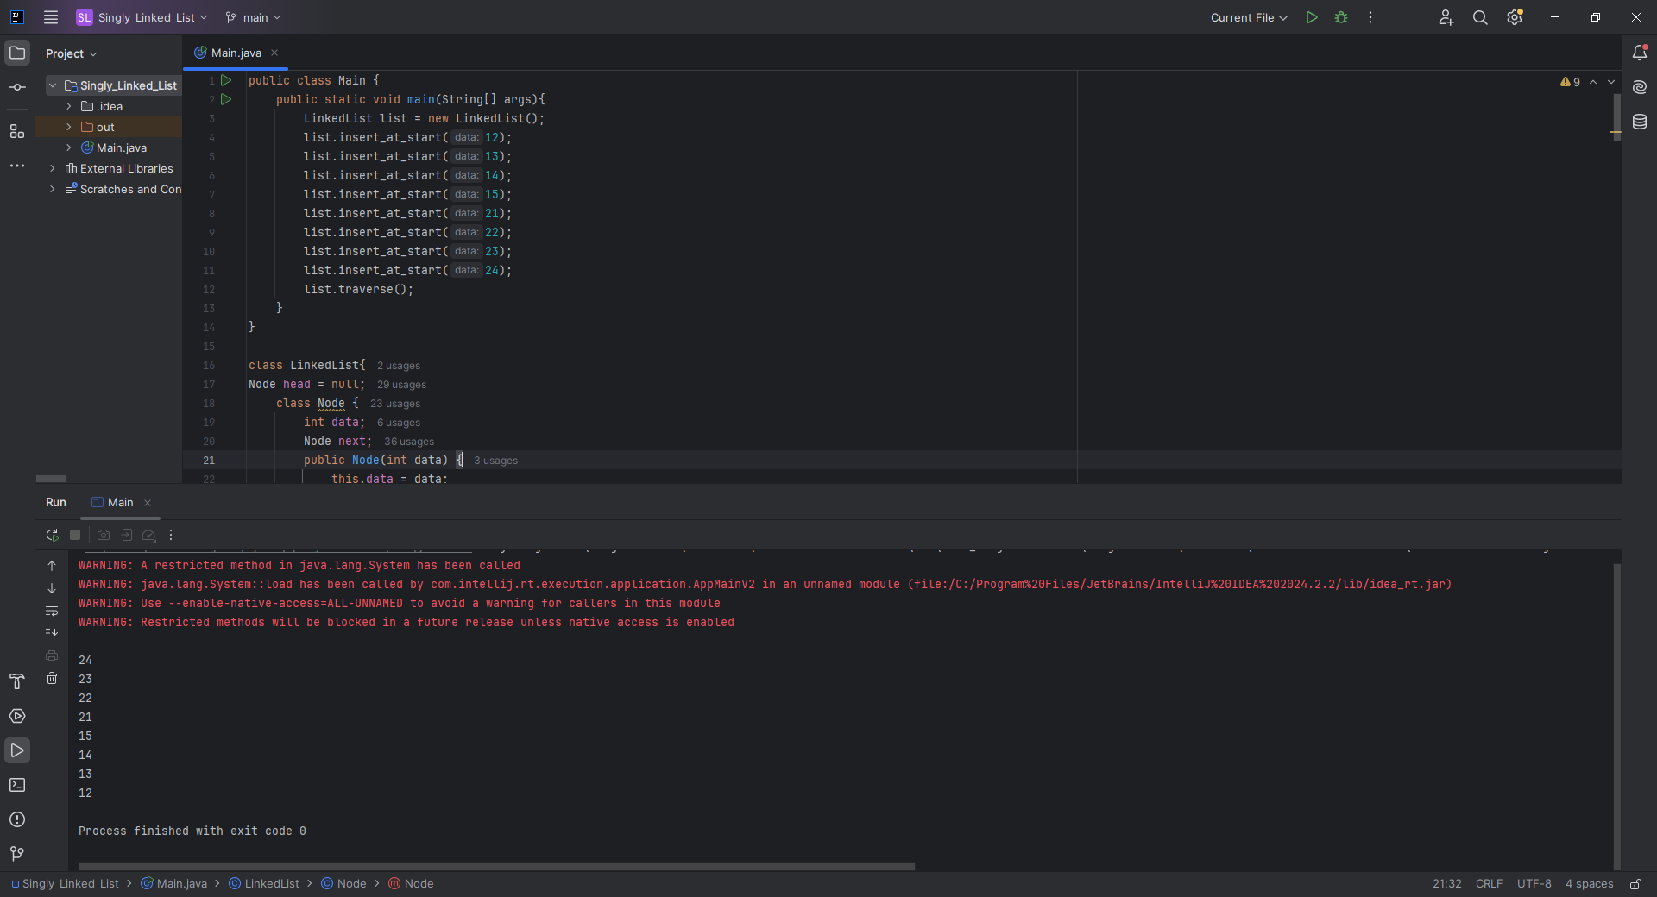

**Home Task 1:** Reverse the Linked List

**CODE:**

void reverse() {  
 Node prev = null;  
 Node curr = head;  
 while (curr != null) {  
 Node next = curr.next;  
 curr.next = prev;  
 prev = curr;  
 curr = next;  
 }  
 head = prev;  
 System.*out*.println("List reversed.");  
}

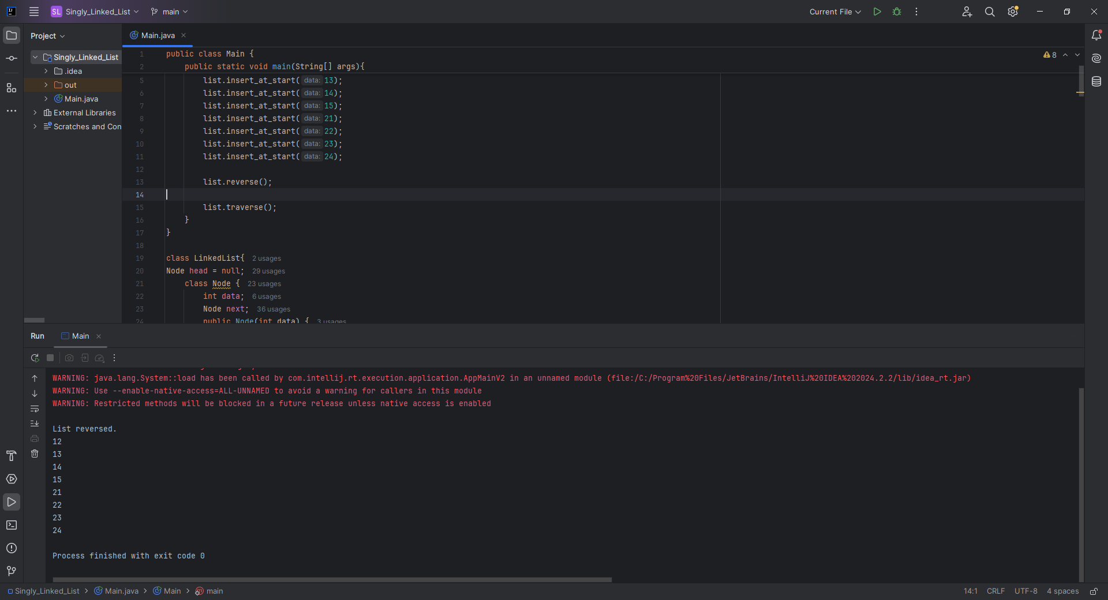

**Home Task 2:** Find the Middle Element of the Linked List

**CODE:**

void findMiddle() {  
 if (head == null) {  
 System.*out*.println("List is empty.");  
 return;  
 }  
 Node slow = head;  
 Node fast = head;  
 while (fast != null && fast.next != null) {  
 slow = slow.next;  
 fast = fast.next.next;  
 }  
 System.*out*.println("Middle Element: " + slow.data);  
}

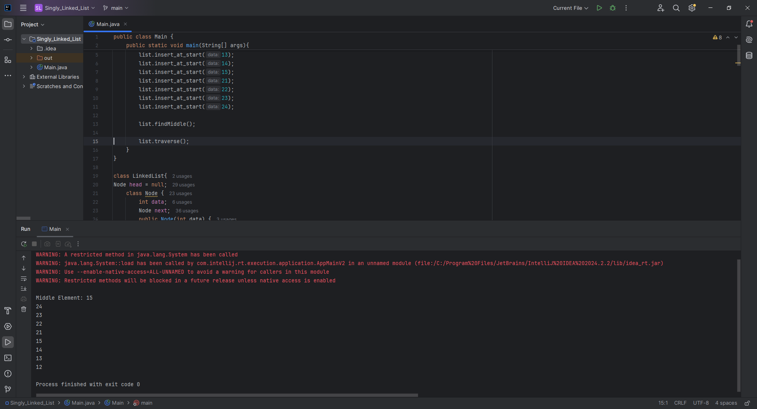

**Home Task 3:** Detect and Remove Cycles in the Linked List

**CODE:**

void detectAndRemoveCycle() {  
 Node slow = head;  
 Node fast = head;  
  
 while (fast != null && fast.next != null) {  
 slow = slow.next;  
 fast = fast.next.next;  
 if (slow == fast) {  
 removeCycle(slow);  
 System.*out*.println("Cycle detected and removed.");  
 return;  
 }  
 }  
 System.*out*.println("No cycle detected.");  
}  
  
private void removeCycle(Node loopNode) {  
 Node ptr1 = head;  
 Node ptr2 = loopNode;  
  
 while (ptr1 != ptr2) {  
 ptr1 = ptr1.next;  
 ptr2 = ptr2.next;  
 }  
  
 Node prev = ptr2;  
 while (prev.next != ptr2) {  
 prev = prev.next;  
 }  
 prev.next = null; // Remove cycle  
}

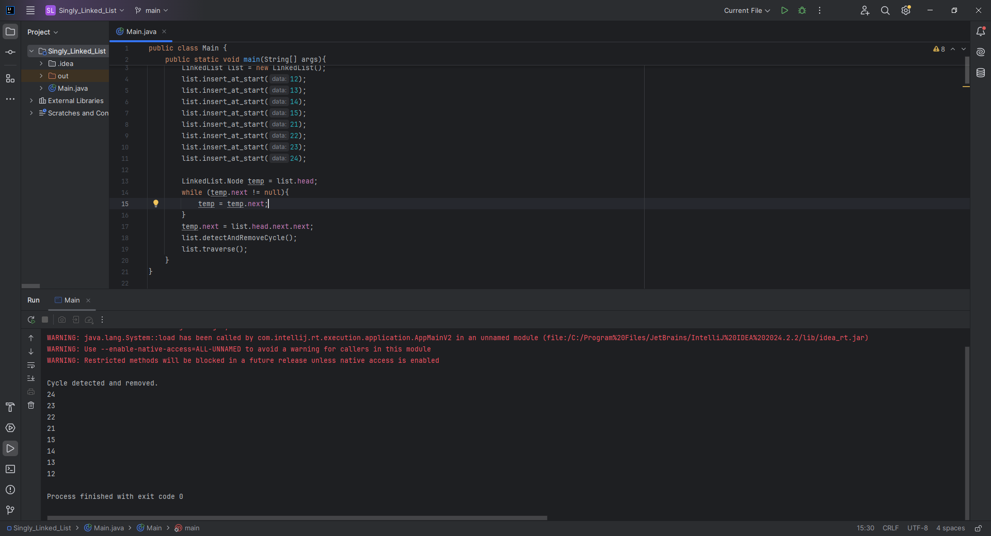

**CLASS TASKS**

**CODE:**

public class Main {  
 public static void main(String[] args){  
 Doubly_Linked_List list = new Doubly_Linked_List();  
 list.insert_at_start(10);  
 list.insert_at_start(11);  
 list.insert_at_start(12);  
 list.insert_at_start(13);  
 list.insert_at_end(15);  
 list.insert_after(10, 15);  
 list.insert_at_position(100,0);  
 list.insert_at_position(100,3);  
 list.sort();  
  
 System.*out*.println("11 found at index "+ list.find(15));  
 System.*out*.println("Occurance of 15 in the list is : "+ list.countOccurrences(15));  
  
 list.traverse(1); // Forward traversal  
 list.traverse(-1); // Reverse traversal  
 }  
}  
  
class Doubly_Linked_List {  
 private Node head = null;  
 private Node tail = null;  
  
 class Node {  
 Node prev;  
 int data;  
 Node next;  
  
 public Node(int data) {  
 this.data = data;  
 }  
 }  
  
 void insert_at_start(int data){  
 Node newNode = new Node(data);  
 if(head == null){  
 head = tail = newNode;  
 } else {  
 newNode.next = head;  
 head.prev = newNode;  
 head = newNode;  
 }  
 }  
  
 void insert_at_end(int data) {  
 Node newNode = new Node(data);  
 if(tail == null){  
 head = tail = newNode;  
 } else {  
 tail.next = newNode;  
 newNode.prev = tail;  
 tail = newNode;  
 }  
 }  
  
 void insert_after(int val, int data){  
 if(head == null){  
 System.*out*.println("List is empty");  
 return;  
 }  
 Node current = head;  
 while(current != null){  
 if(current.data == val){  
 Node newNode = new Node(data);  
 newNode.next = current.next;  
 newNode.prev = current;  
 if(current.next != null){  
 current.next.prev = newNode;  
 } else {  
 // We're inserting at the end  
 tail = newNode;  
 }  
 current.next = newNode;  
 return;  
 }  
 current = current.next;  
 }  
 System.*out*.println(val + " is not in the list");  
 }  
  
 void delete_from_start(){  
 if(head == null){  
 return;  
 }  
 head = head.next;  
 if(head != null){  
 head.prev = null;  
 } else {  
 tail = null;  
 }  
 }  
  
 void delete_from_end(){  
 if(tail == null){  
 return;  
 }  
 tail = tail.prev;  
 if(tail != null){  
 tail.next = null;  
 } else {  
 head = null;  
 }  
 }  
  
 void traverse(int order){  
 if(head == null){  
 System.*out*.println("Empty List");  
 return;  
 }  
  
 if(order == 1){  
 System.*out*.println("Forward Traversal:");  
 Node current = head;  
 while(current != null){  
 System.*out*.print(current.data + " ");  
 current = current.next;  
 }  
 System.*out*.println();  
 } else if (order == -1){  
 System.*out*.println("Reverse Traversal:");  
 Node current = tail;  
 while(current != null){  
 System.*out*.print(current.data + " ");  
 current = current.prev;  
 }  
 System.*out*.println();  
 } else {  
 System.*out*.println("Invalid traversal order. Use 1 (forward) or -1 (reverse).");  
 }  
 }  
}

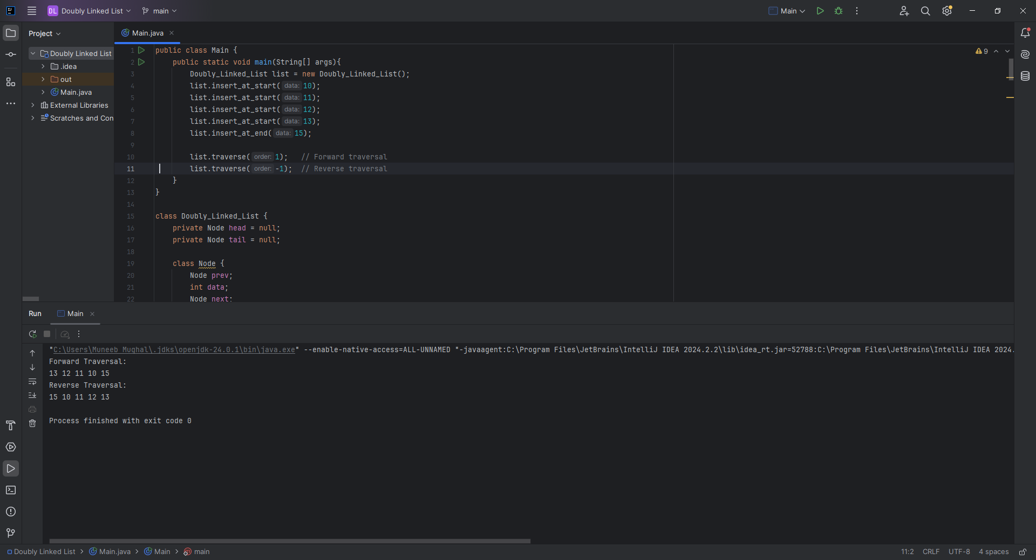

**Home Task 1:** Inserting at a Specific Position

**CODE:**

void insert_at_position(int data, int position) {  
 if (position < 0) {  
 System.*out*.println("Invalid position");  
 return;  
 }  
 if (position == 0) {  
 insert_at_start(data);  
 return;  
 }  
 Node newNode = new Node(data);  
 Node current = head;  
 int index = 0;  
  
 while (current != null && index < position - 1) {  
 current = current.next;  
 index++;  
 }  
  
 if (current == null) {  
 System.*out*.println("Position out of bounds");  
 return;  
 }  
  
 newNode.next = current.next;  
 newNode.prev = current;  
  
 if (current.next != null) {  
 current.next.prev = newNode;  
 } else {  
 tail = newNode; // If inserted at the end  
 }  
 current.next = newNode;  
}

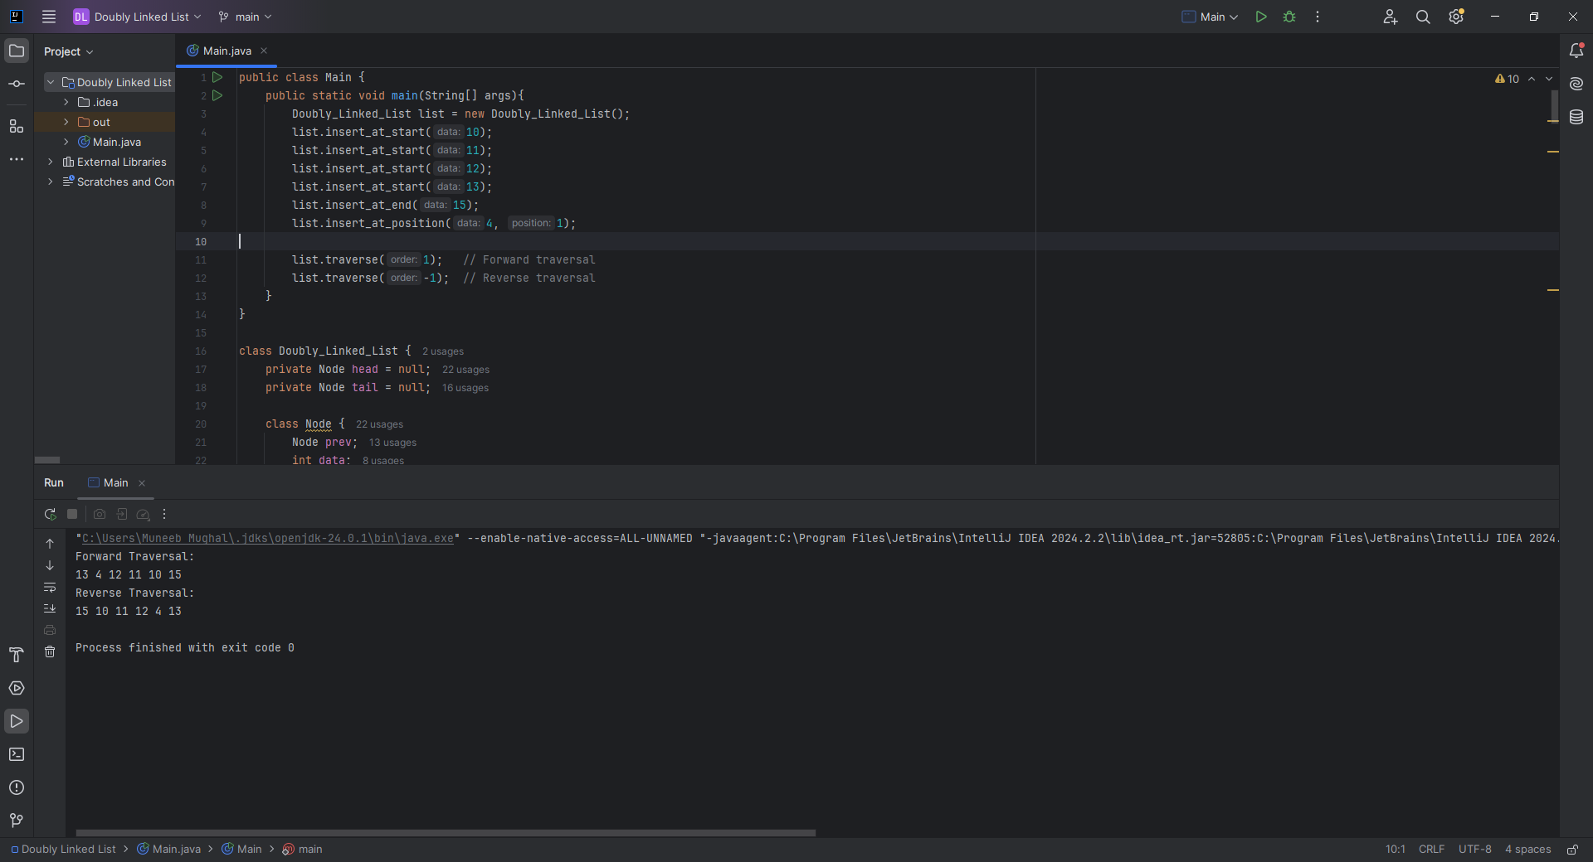

**Home Task 2:** Finding and Counting Elements

**CODE:**

int find(int value) {  
 Node current = head;  
 int position = 0;  
 while (current != null) {  
 if (current.data == value) {  
 return position;  
 }  
 current = current.next;  
 position++;  
 }  
 return -1; // Not found  
}  
  
int countOccurrences(int value) {  
 Node current = head;  
 int count = 0;  
 while (current != null) {  
 if (current.data == value) {  
 count++;  
 }  
 current = current.next;  
 }  
 return count;  
}

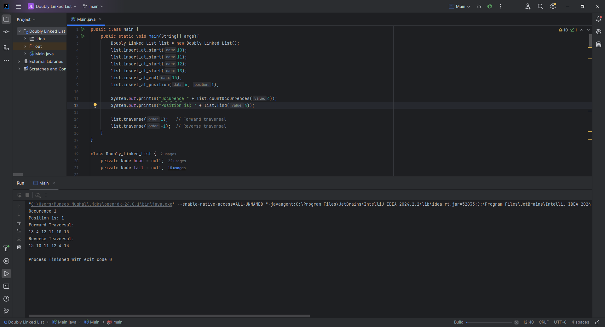

**Home Task 3:** Sorting the Doubly Linked List

**CODE:**

void sort() {  
 if (head == null) return;  
  
 boolean swapped;  
 do {  
 swapped = false;  
 Node current = head;  
  
 while (current.next != null) {  
 if (current.data > current.next.data) {  
 // Swap nodes by rearranging pointers (not just data)  
 Node nextNode = current.next;  
 Node prevNode = current.prev;  
 Node nextNext = nextNode.next;  
  
 // Re-link previous node to nextNode  
 if (prevNode != null) {  
 prevNode.next = nextNode;  
 } else {  
 head = nextNode;  
 }  
 nextNode.prev = prevNode;  
  
 // Link nextNode and current node  
 nextNode.next = current;  
 current.prev = nextNode;  
  
 // Link current node to nextNext node  
 current.next = nextNext;  
 if (nextNext != null) {  
 nextNext.prev = current;  
 } else {  
 tail = current;  
 }  
  
 swapped = true;  
 } else {  
 current = current.next;  
 }  
 }  
 } while (swapped);  
}

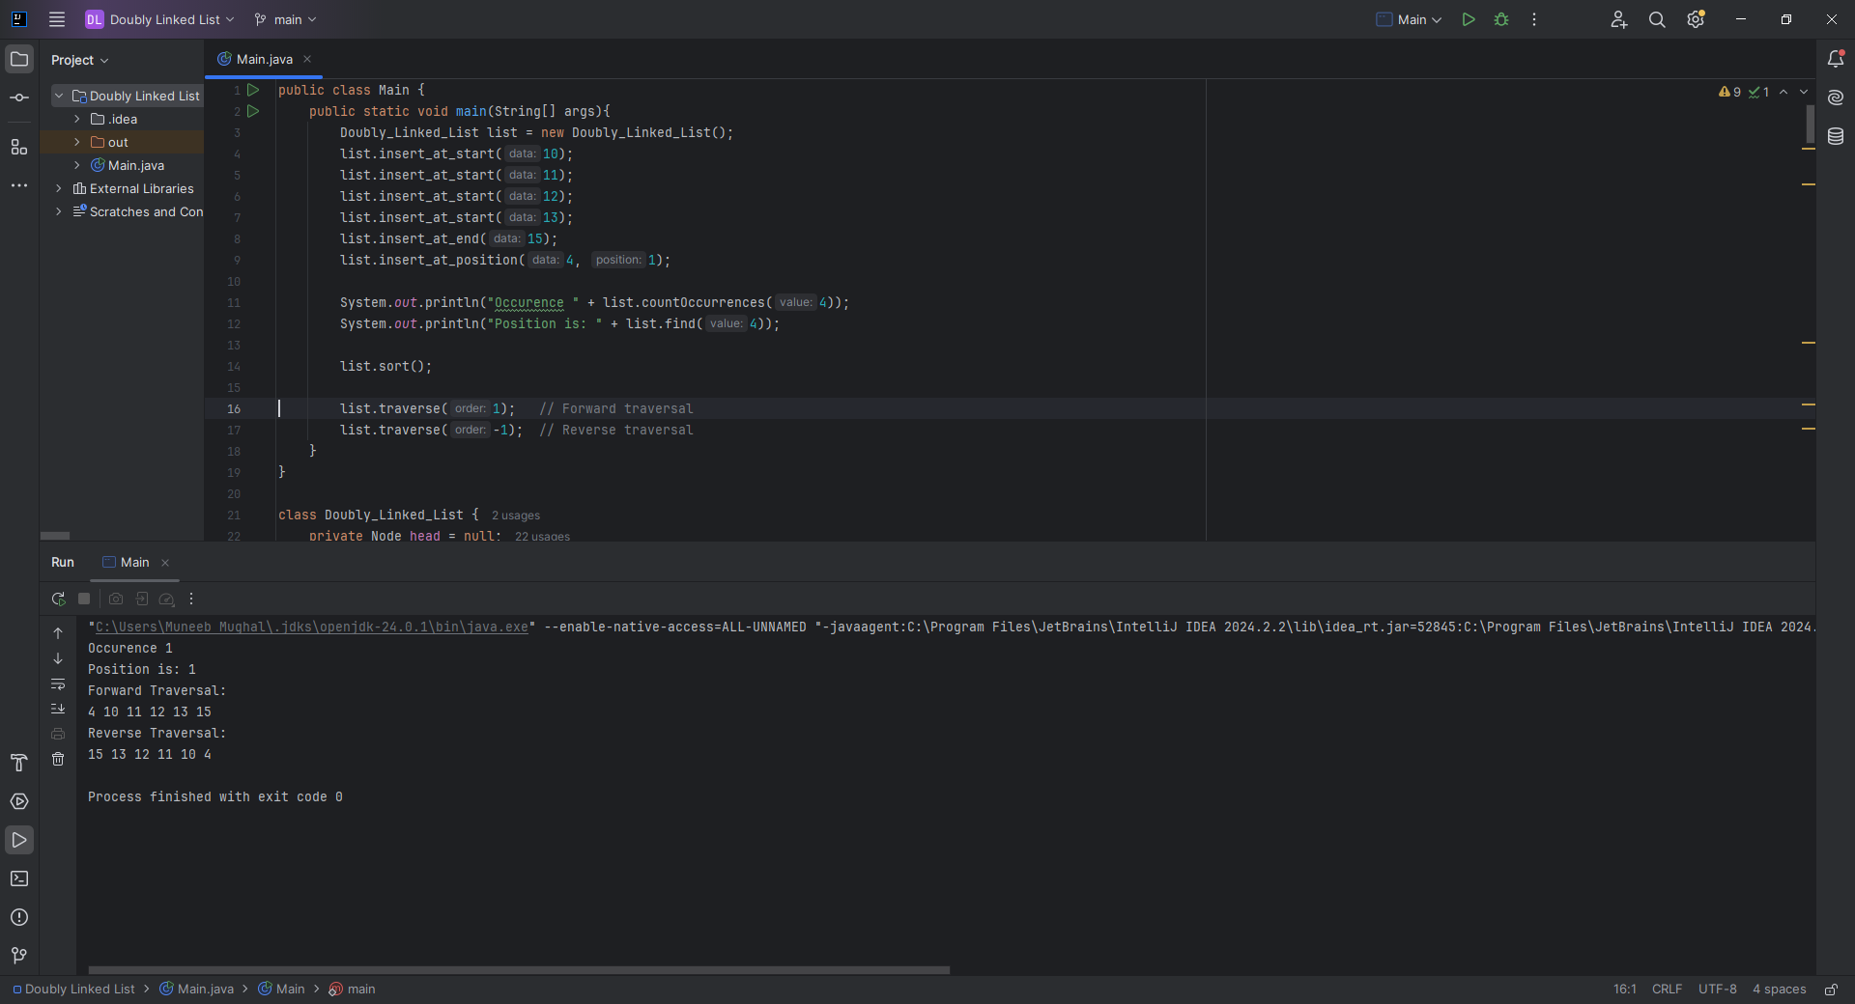

**CLASS TASK 1 & 2:**

**CODE:**

import java.util.EmptyStackException;  
  
class Main{

public static void main(String[] args){  
 Stack stack = new Stack(5);  
  
 stack.push(20);  
 stack.push(21);  
 stack.push(25);  
  
 try{  
 System.*out*.println("Popped value of the stack is : "+stack.pop());  
 }catch (Exception e){  
 System.*out*.println("Stack is "+ e.getMessage());  
 }  
  
 try{  
 System.*out*.println("Peeked value of the stack is : "+stack.peek());  
 }catch (Exception e){  
 System.*out*.println("Stack is "+ e.getMessage());  
 }  
}

}  
  
class Stack{  
 private int length = -1;  
 private final int max_length;  
 private final int[] arr;  
  
 Stack(int max_length){  
 this.max_length = max_length;  
 arr = new int[max_length];  
 }  
 void push(int val){  
 if(isFull()){  
 System.*out*.println("Stack is Full.");  
 return;  
 }  
 length++;  
 arr[length] = val;  
 }  
  
 int pop(){  
 if(isEmpty()){  
 throw new EmptyStackException();  
 }  
 int val = arr[length];  
 length--;  
 return val;  
 }  
  
 Object peek(){  
 if(isEmpty()){  
 throw new EmptyStackException();  
 }  
 return arr[length];  
 }  
 Boolean isEmpty(){  
 return length == -1;  
 }  
 Boolean isFull(){  
 return length == (max_length-1);  
 }  
}

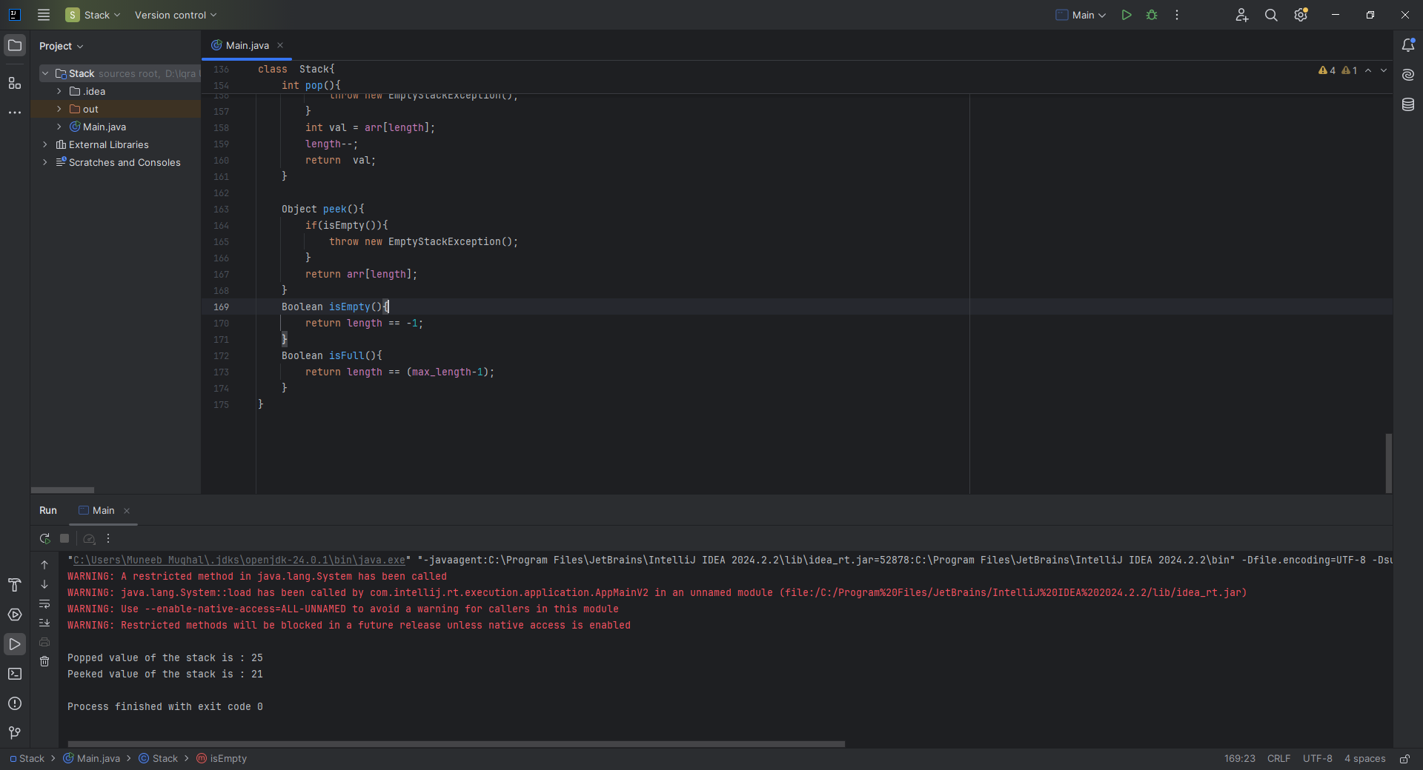

**CLASS TASK 3:** (Reversing a String)

**CODE:**

static void reverseString(){  
 Stack stack = new Stack(5);  
 Stack stack2 = new Stack(5);

String str = "Hello";  
 for (int i = 0; i < str.length(); i++)  
 {  
 stack.push(str.charAt(i));  
 }  
 for (int i = 0; i < str.length(); i++){  
 stack2.push(stack.pop());  
 }  
 System.*out*.println("String reversed.");  
  
}

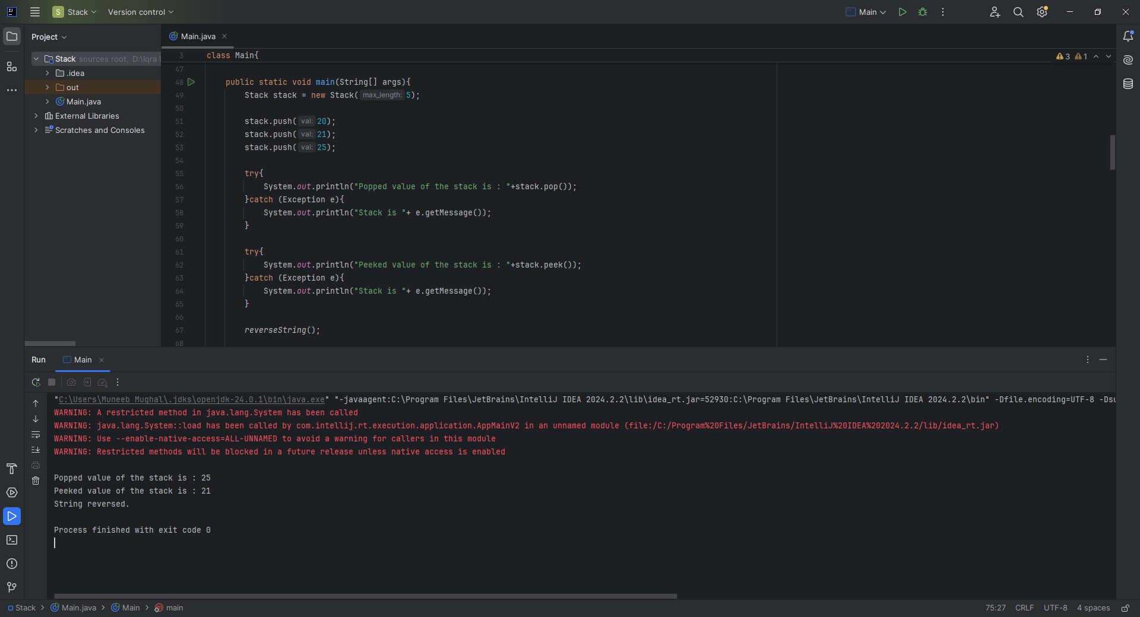

**CLASS TASK 4:**

**Structure:**

* Base case: Stops recursion (if (n == 0)).
* Recursive case: Function calls itself with a smaller value (n - 1).

**CODE:**

int factorial(int n) {

if (n == 0) return 1; // Base case

return n * factorial(n - 1); // Recursive call

}

**CLASS TASK 5:**

**STRUCTURE:**

* Starts with: 0, 1, 1, 2, 3, 5, 8, ...
* Each term: fibonacci(n) = fibonacci(n - 1) + fibonacci(n - 2)
* Base cases:
  + fibonacci(0) = 0
  + fibonacci(1) = 1

**CODE:**

int fibonacci(int n) {

if (n == 0) return 0;

if (n == 1) return 1;

return fibonacci(n - 1) + fibonacci(n - 2);

}

**Home Task 1:** Balancing Parentheses Using Stack

**CODE:**

public static boolean isBalanced(String expression) {  
 Stack stack = new Stack(expression.length());  
  
 for (char ch : expression.toCharArray()) {  
 int mapped = *mapBracket*(ch);  
  
 if (mapped > 0) {  
 stack.push(mapped); // Opening bracket  
 } else if (mapped < 0) {  
 if (stack.isEmpty()) return false;  
  
 int top = stack.pop();  
 if (top + mapped != 0) return false; // Mismatched brackets  
 }  
 }  
  
 return stack.isEmpty(); // Must be empty if balanced  
}

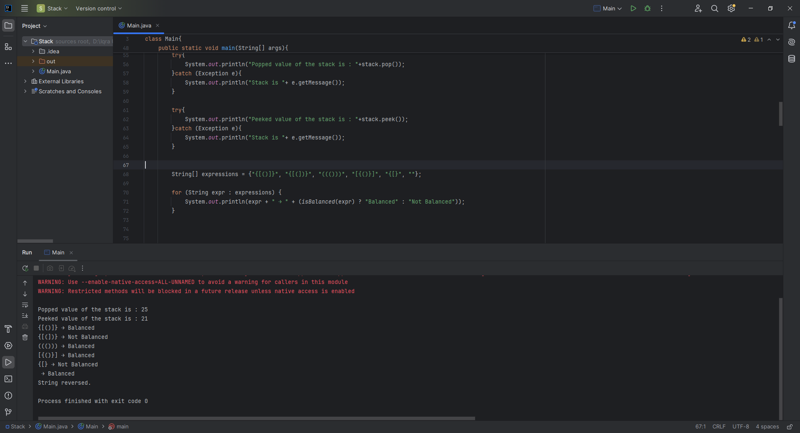

**Home Task 2:** Recursive Solution for Power Calculation

**CODE:**

public static double power(double base, int exponent) {  
 // Base case: anything to the power 0 is 1  
 if (exponent == 0) return 1;  
  
 // If exponent is negative, use reciprocal  
 if (exponent < 0) return 1 / *power*(base, -exponent);  
  
 // Recursive step  
 return base * *power*(base, exponent - 1);  
}

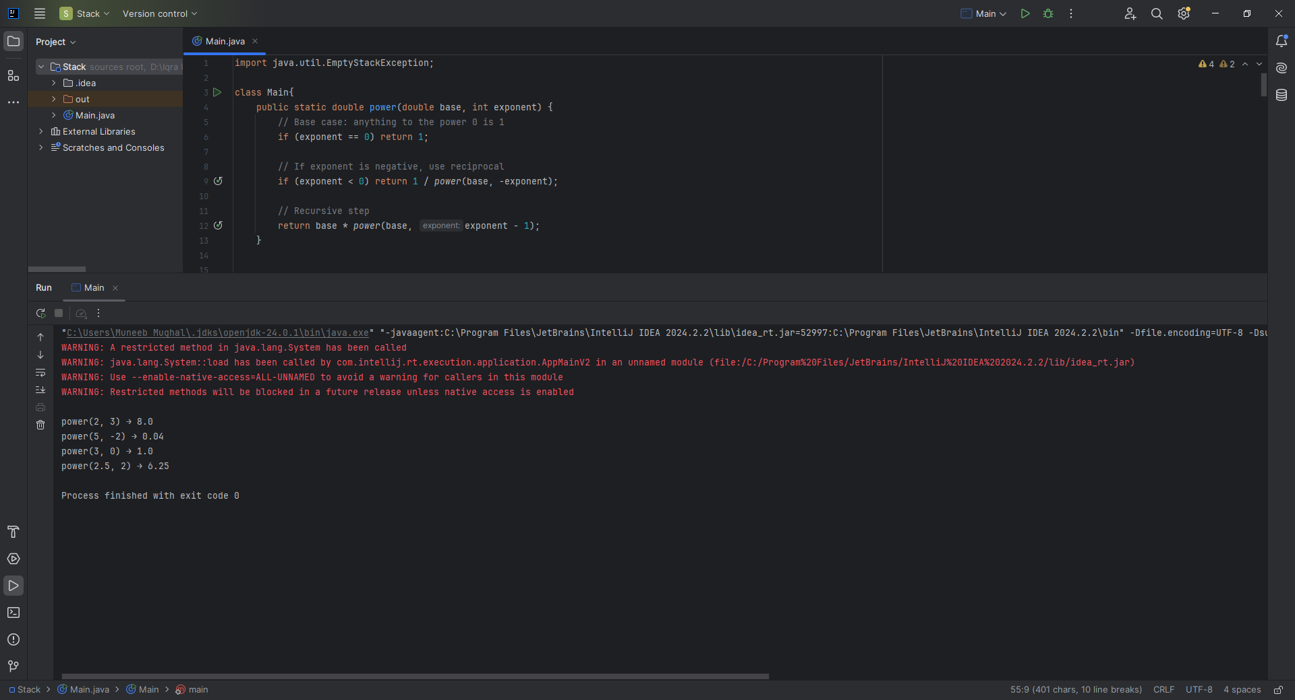

**Home Task 3:** Implementing Tower of Hanoi with Recursion

**CODE:**

static void Hanoi_Problem() {  
 int numDisks = 3;  
  
 Stack A = new Stack(5); // source  
 Stack B = new Stack(5); // auxiliary  
 Stack C = new Stack(5); // target  
  
 // Push disks in reverse order (largest at bottom)  
 for (int i = numDisks; i >= 1; i--) {  
 A.push(i);  
 }  
  
 *moveDisks*(numDisks, A, C, B, 'A', 'C', 'B');  
  
 System.*out*.println("Hanoi Problem solved.");  
}  
  
static void moveDisks(int n, Stack source, Stack target, Stack auxiliary, char from, char to, char via) {  
 if (n == 1) {  
 int disk = source.pop();  
 target.push(disk);  
 System.*out*.println("Move disk " + disk + " from " + from + " to " + to);  
 return;  
 }  
  
 *moveDisks*(n - 1, source, auxiliary, target, from, via, to);  
 int disk = source.pop();  
 target.push(disk);  
 System.*out*.println("Move disk " + disk + " from " + from + " to " + to);  
 *moveDisks*(n - 1, auxiliary, target, source, via, to, from);  
}

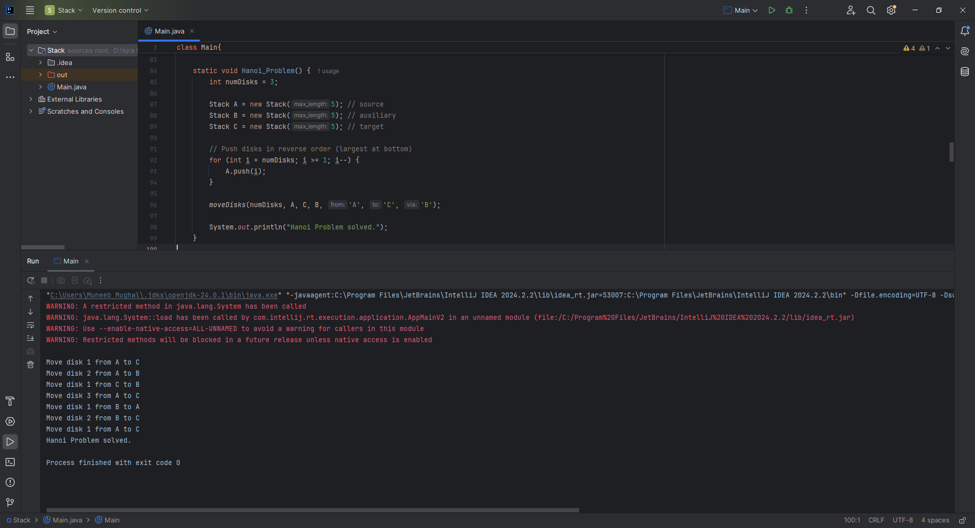

**CLASS TASK 1 & 2:**

**CODE:**  
class Queue{  
 int front = -1;  
 int rear = -1;  
 int[] queue;  
 int size;  
  
 Queue(int size){  
 queue = new int[size];  
 this.size = size;  
 }  
  
 void enqueue(int data){  
 if(isFull()){  
 System.*out*.println("Queue is full");  
 front = rear = -1;  
 }else{  
 if(isEmpty()){  
 front = 0;  
 }  
 rear++;  
 queue[rear] = data;  
 }  
 }  
  
 int peek(){  
 if(isEmpty()){  
 front = rear = -1;  
 throw new RuntimeException("Queue is empty");  
 }  
 return queue[front];  
 }  
  
 int dequeue(){  
 if(isEmpty()){  
 front = rear = -1;  
 throw new RuntimeException("Queue is empty");  
 }  
 int data = queue[front];  
 front++;  
 return data;  
  
 }  
  
 boolean isEmpty(){  
 return front == -1 || front > rear;  
 }  
  
 boolean isFull(){  
 return rear == size-1;  
 }  
  
}

public class Main {  
 public static void main(String[] args) {  
 Queue q = new Queue(5);  
 q.enqueue(1);  
 q.enqueue(2);  
 q.enqueue(3);  
 q.enqueue(4);  
 q.enqueue(5);  
  
 try{  
 System.*out*.println( "Dequeued Value of the queue : " +q.dequeue());  
 System.*out*.println( "Dequeued Value of the queue : " +q.dequeue());  
 System.*out*.println( "Dequeued Value of the queue : " +q.dequeue());  
 }  
 catch(RuntimeException e){  
 System.*out*.println(e.getMessage());  
 }  
  
 try {  
 System.*out*.println("Peeked Value of the queue : "+q.peek());  
 } catch (RuntimeException e) {  
 System.*out*.println(e.getMessage());  
 }  
 }

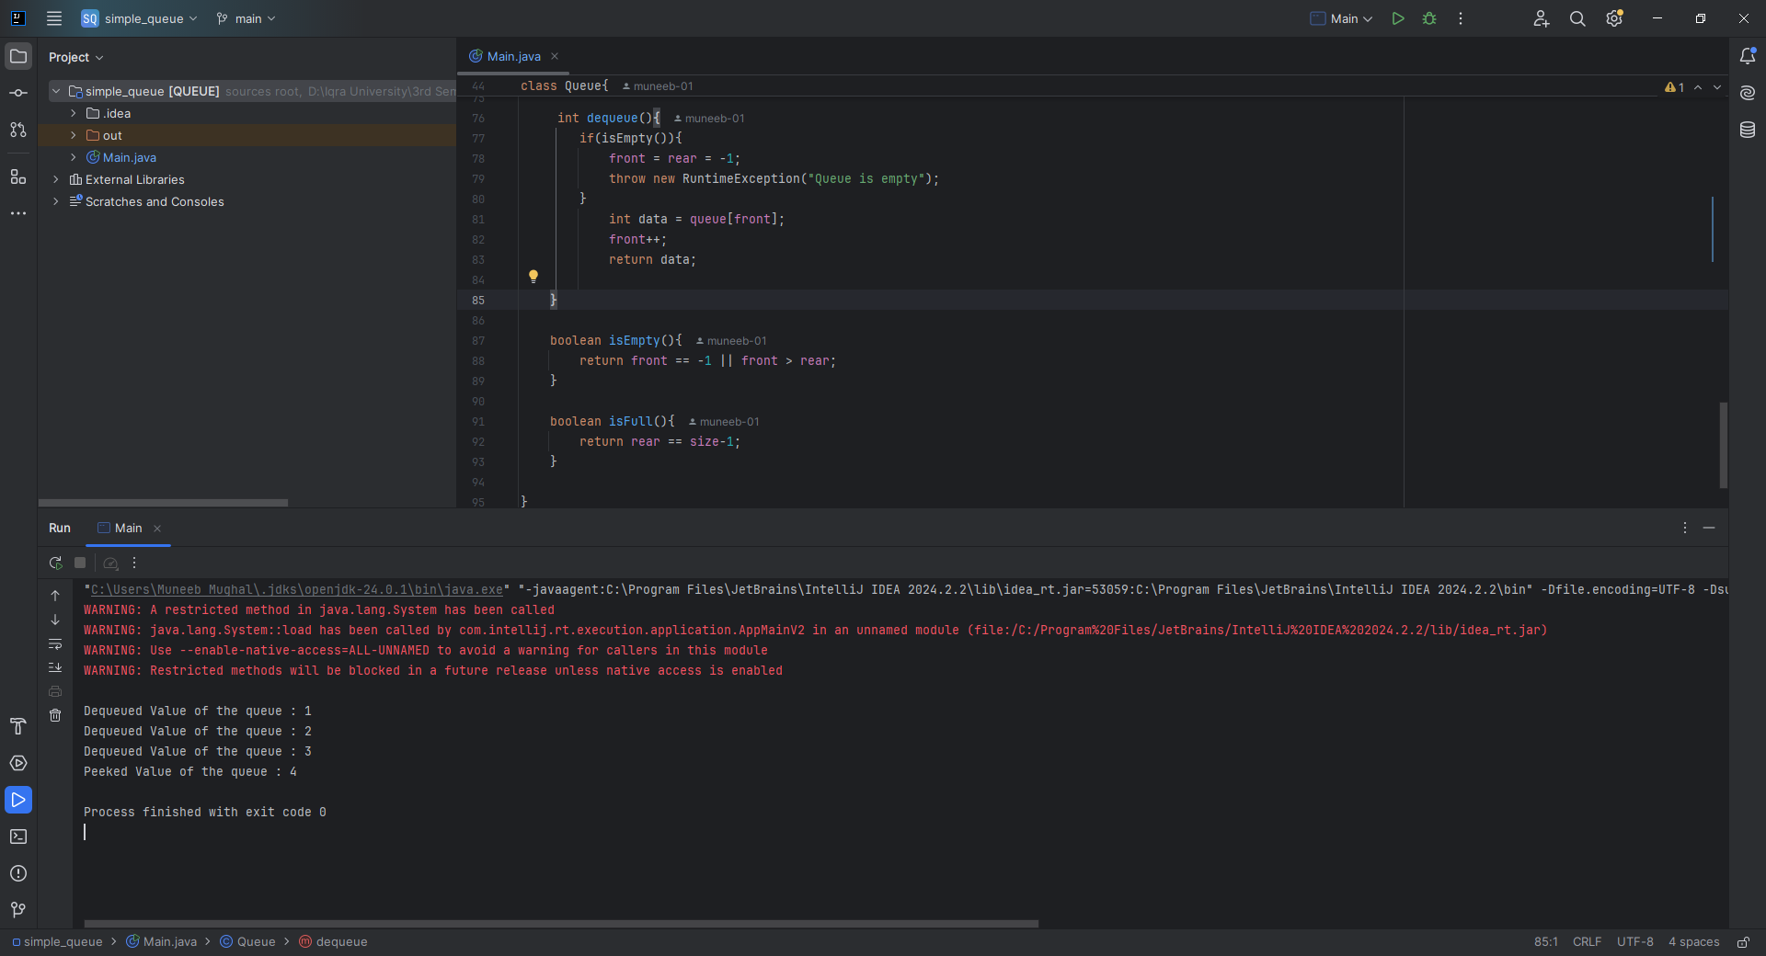

**CLASS TASK 3:**

**CODE:**

class Circular_Queue{  
 int front, rear, size,capacity;  
 int[] arr;  
  
 Circular_Queue(int capacity){  
 this.capacity = capacity;  
 arr = new int[capacity];  
 front = 0;  
 rear = -1;  
 size = 0;  
 }  
  
 boolean isEmpty(){  
 return size == 0;  
 }  
 boolean isFull(){  
 return size == capacity;  
 }  
 void enqueue(int value){  
 if(isFull()){  
 throw new RuntimeException("Queue is full");  
 }  
 else{  
 rear = (rear + 1) % capacity;  
 arr[rear] = value;  
 size++;  
 }  
 }  
 int dequeue(){  
 if(isEmpty()){  
 throw new RuntimeException("Queue is empty");  
 }  
 else{  
 int value = arr[front];  
 front = (front + 1) % capacity;  
 size--;  
 return value;  
 }  
 }  
 int peek(){  
 if(isEmpty()){  
 throw new RuntimeException("Queue is empty");  
 }  
 else{  
 return arr[front];  
 }  
 }  
 int getSize(){  
 return size;  
 }  
}

public class Main {  
 public static void main(String[] args) {  
 Circular_Queue cq = new Circular_Queue(5);  
 try{  
 cq.enqueue(1);  
 cq.enqueue(2);  
 cq.enqueue(3);  
 cq.enqueue(4);  
 cq.enqueue(5);  
 cq.enqueue(6);  
 }  
 catch (RuntimeException e){  
 System.*out*.println(e.getMessage());  
 }  
  
 try{  
 System.*out*.println(cq.dequeue());  
 System.*out*.println(cq.dequeue());  
 System.*out*.println(cq.dequeue());  
 System.*out*.println(cq.dequeue());  
 System.*out*.println(cq.dequeue());  
 System.*out*.println(cq.dequeue());  
 } catch (RuntimeException e) {  
 System.*out*.println(e.getMessage());  
 }  
  
 cq.enqueue(78);  
 try{  
 System.*out*.println(cq.peek());  
 }catch (RuntimeException e){  
 System.*out*.println(e.getMessage());  
 }  
  
 System.*out*.println(cq.getSize());  
 }  
}

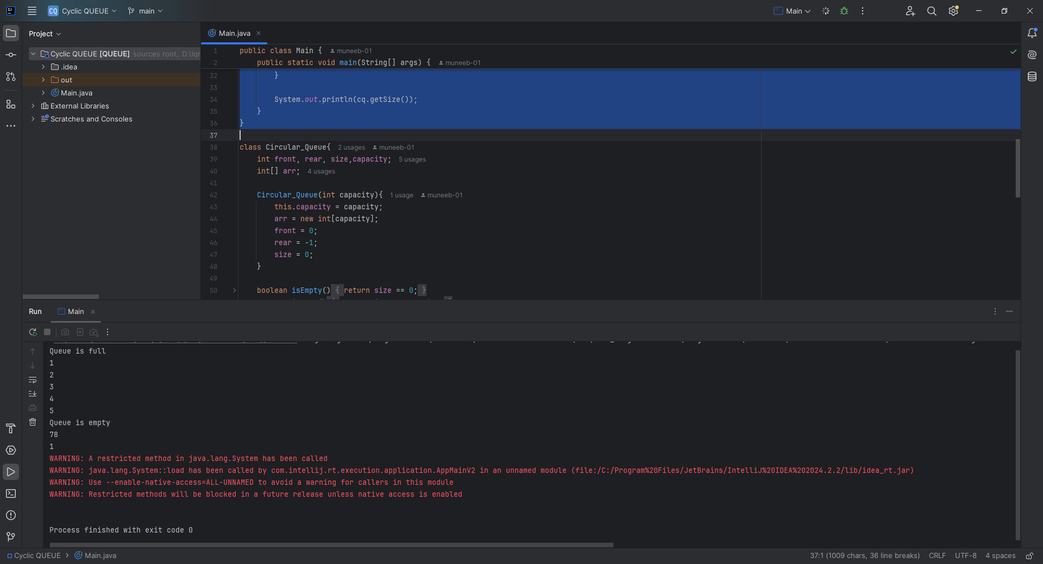

**CLASS TASK 4**

**CODE:**

public static void simulatePrinterQueue() {  
 Queue printerQueue = new Queue(5);  
 // Enqueue jobs  
 printerQueue.enqueue(101);  
 printerQueue.enqueue(102);  
 printerQueue.enqueue(103);  
  
 // Process jobs  
 while (!printerQueue.isEmpty()) {  
 System.*out*.println("Processing job ID: " + printerQueue.dequeue());  
 }  
 }  
  
}

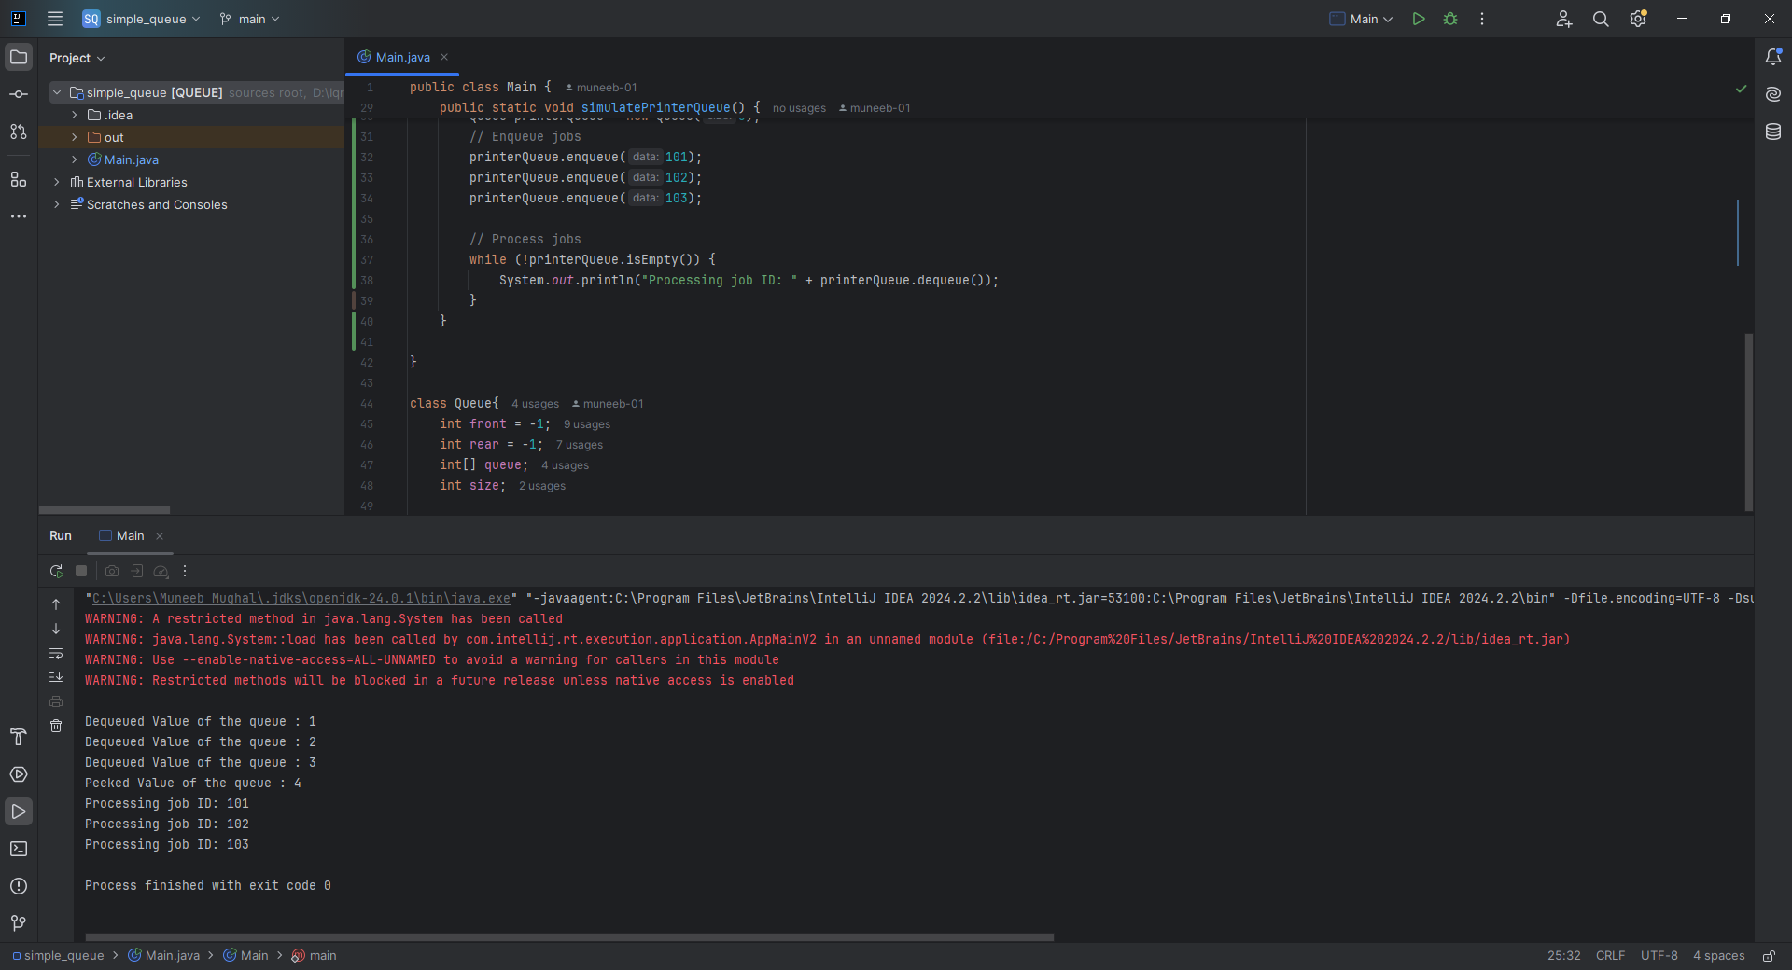

**HOME TASK 1:** Implementing a Queue Using Linked List

**CODE:**

public class Main {  
 public static void main(String[] args) {  
 Queue queue = new Queue();  
 queue.enqueue(1);  
 queue.enqueue(2);  
 queue.enqueue(3);  
 queue.enqueue(4);  
 queue.enqueue(5);  
 *reverseQueue*(queue);  
 queue.printQueue();  
 try{  
 System.*out*.println(queue.peek());  
 }catch(RuntimeException e){  
 System.*out*.println(e.getMessage());  
 }

class Queue {  
 static class Node {  
 int data;  
 Node next;  
 Node(int data) {  
 this.data = data;  
 next = null;  
 }  
 }  
 Node front, rear;  
  
 Queue() {  
 front = rear = null;  
 }  
  
 void enqueue(int data) {  
 Node newNode = new Node(data);  
 if (front == null) {  
 front = rear = newNode;  
 }  
 else {  
 rear.next = newNode;  
 rear = newNode;  
 }  
 }  
  
 int dequeue() {  
 if (front == null) {  
 throw new RuntimeException("Queue is empty");  
 }  
 int value = front.data;  
 front = front.next;  
 return value;  
 }  
  
 int peek(){  
 if (front == null) {  
 throw new RuntimeException("Queue is empty");  
 }  
 return front.data;  
 }  
 void printQueue() {  
 Node current = front;  
 while (current != null) {  
 System.*out*.print(current.data + " -> ");  
 current = current.next;  
 }  
 System.*out*.println("null");  
 }  
}

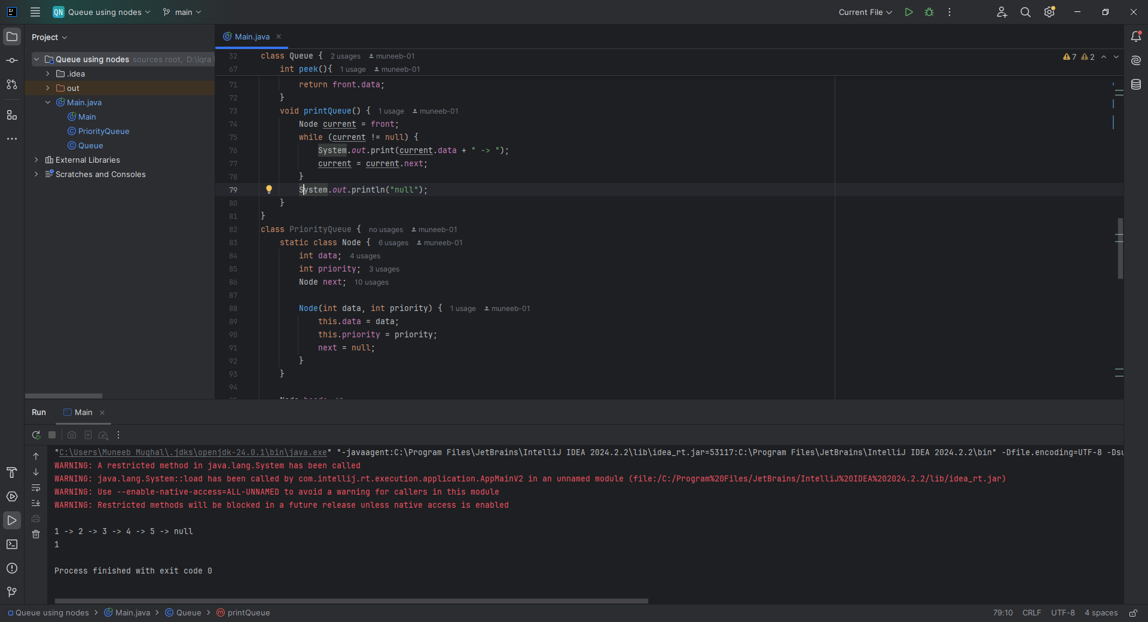

**HOME TASK 2:** Implement a Priority Queue

**CODE:**

public class PriorityQueue {  
 public static void main(String[] args) {  
 PQueue pQueue = new PQueue();  
 pQueue.enqueue(12, 1);  
 pQueue.enqueue(5, 2);  
 pQueue.enqueue(1, -1);  
  
 System.*out*.print("Priority Queue (high priority first): ");  
 pQueue.printQueue();  
 }  
  
 }  
  
  
// Recursively reverse the normal queue  
class PQueue {  
 static class Node {  
 int data, priority;  
 Node next;  
  
 Node(int data, int priority) {  
 this.data = data;  
 this.priority = priority;  
 }  
 }  
  
 Node head;  
  
 void enqueue(int data, int priority) {  
 Node newNode = new Node(data, priority);  
  
 // Insert at the correct position based on priority  
 if (head == null || priority > head.priority) {  
 newNode.next = head;  
 head = newNode;  
 } else {  
 Node temp = head;  
 while (temp.next != null && temp.next.priority >= priority) {  
 temp = temp.next;  
 }  
 newNode.next = temp.next;  
 temp.next = newNode;  
 }  
 }  
  
 int dequeue() {  
 if (isEmpty()) throw new RuntimeException("Priority Queue is empty");  
 int value = head.data;  
 head = head.next;  
 return value;  
 }  
  
 int peek() {  
 if (isEmpty()) throw new RuntimeException("Priority Queue is empty");  
 return head.data;  
 }  
  
 boolean isEmpty() {  
 return head == null;  
 }  
  
 void printQueue() {  
 Node current = head;  
 while (current != null) {  
 System.*out*.print(current.data + "(" + current.priority + ") -> ");  
 current = current.next;  
 }  
 System.*out*.println("null");  
 }  
}

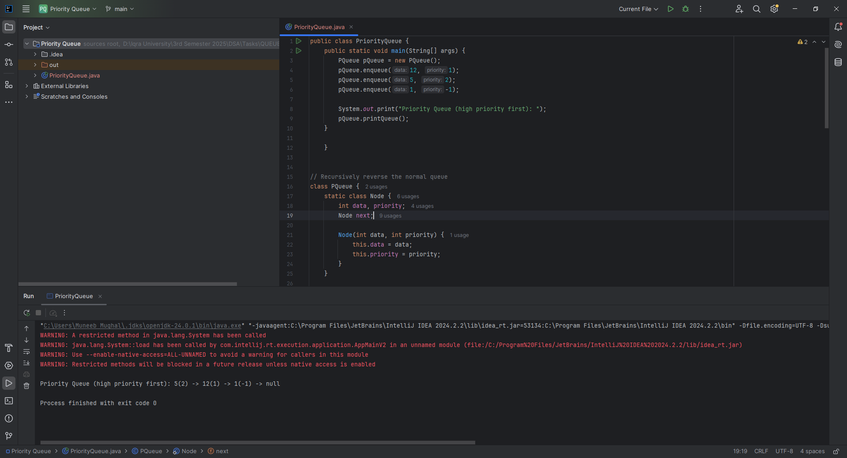

**Home Task 3:** Implement Recursive Queue Reversal

**CODE:**

static void reverseQueue(Queue q) {  
 if (q.front == null) return;  
  
 int frontData = q.dequeue();  
 *reverseQueue*(q); // Recursive call  
 q.enqueue(frontData); // Put dequeued item back at rear  
}

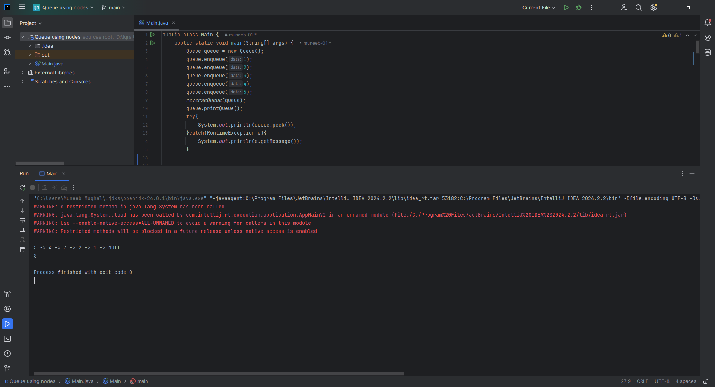

**CLASS TASK 1: Max Heap**

**CODE:**

class MaxHeap {  
 private int[] heapArray;  
 private int maxSize;  
 private int size;  
  
 // Constructor to initialize the heap  
 public MaxHeap(int maxSize) {  
 this.maxSize = maxSize;  
 this.size = 0;  
 this.heapArray = new int[maxSize];  
 }  
  
 // Get index of parent, left child, and right child  
 private int parent(int i) { return (i - 1) / 2; }  
 private int leftChild(int i) { return 2 * i + 1; }  
 private int rightChild(int i) { return 2 * i + 2; }

}

NO OUTPUT:

**CLASS TASK 2**

**CODE:**

public class Main {  
 public static void main(String[] args) {  
 MaxHeap maxHeap = new MaxHeap(10);  
  
 // Inserting elements  
 maxHeap.insert(20);  
 maxHeap.insert(15);  
 maxHeap.insert(30);  
 maxHeap.insert(5);  
 maxHeap.insert(10);  
  
 System.*out*.println("Max Heap after insertions:");  
 maxHeap.printHeap();  
  
 }  
}  
  
class MaxHeap {  
 private int[] heapArray;  
 private int maxSize;  
 private int size;  
  
 // Constructor to initialize the heap  
 public MaxHeap(int maxSize) {  
 this.maxSize = maxSize;  
 this.size = 0;  
 this.heapArray = new int[maxSize];  
 }  
  
 // Get index of parent, left child, and right child  
 private int parent(int i) { return (i - 1) / 2; }  
 private int leftChild(int i) { return 2 * i + 1; }  
 private int rightChild(int i) { return 2 * i + 2; }  
  
 // Insert an element into the heap  
 public void insert(int element) {  
 if (size >= maxSize) {  
 System.*out*.println("Heap is full. Cannot insert.");  
 return;  
 }  
  
 heapArray[size] = element;  
 int current = size;  
 size++;  
  
 // Heapify-up  
 while (current > 0 && heapArray[current] > heapArray[parent(current)]) {  
 swap(current, parent(current));  
 current = parent(current);  
 }  
 }  
  
 // Swap elements  
 private void swap(int i, int j) {  
 int temp = heapArray[i];  
 heapArray[i] = heapArray[j];  
 heapArray[j] = temp;  
 }  
  
 // Print the heap (for testing)  
 public void printHeap() {  
 for (int i = 0; i < size; i++) {  
 System.*out*.print(heapArray[i] + " ");  
 }  
 System.*out*.println();  
 }  
}

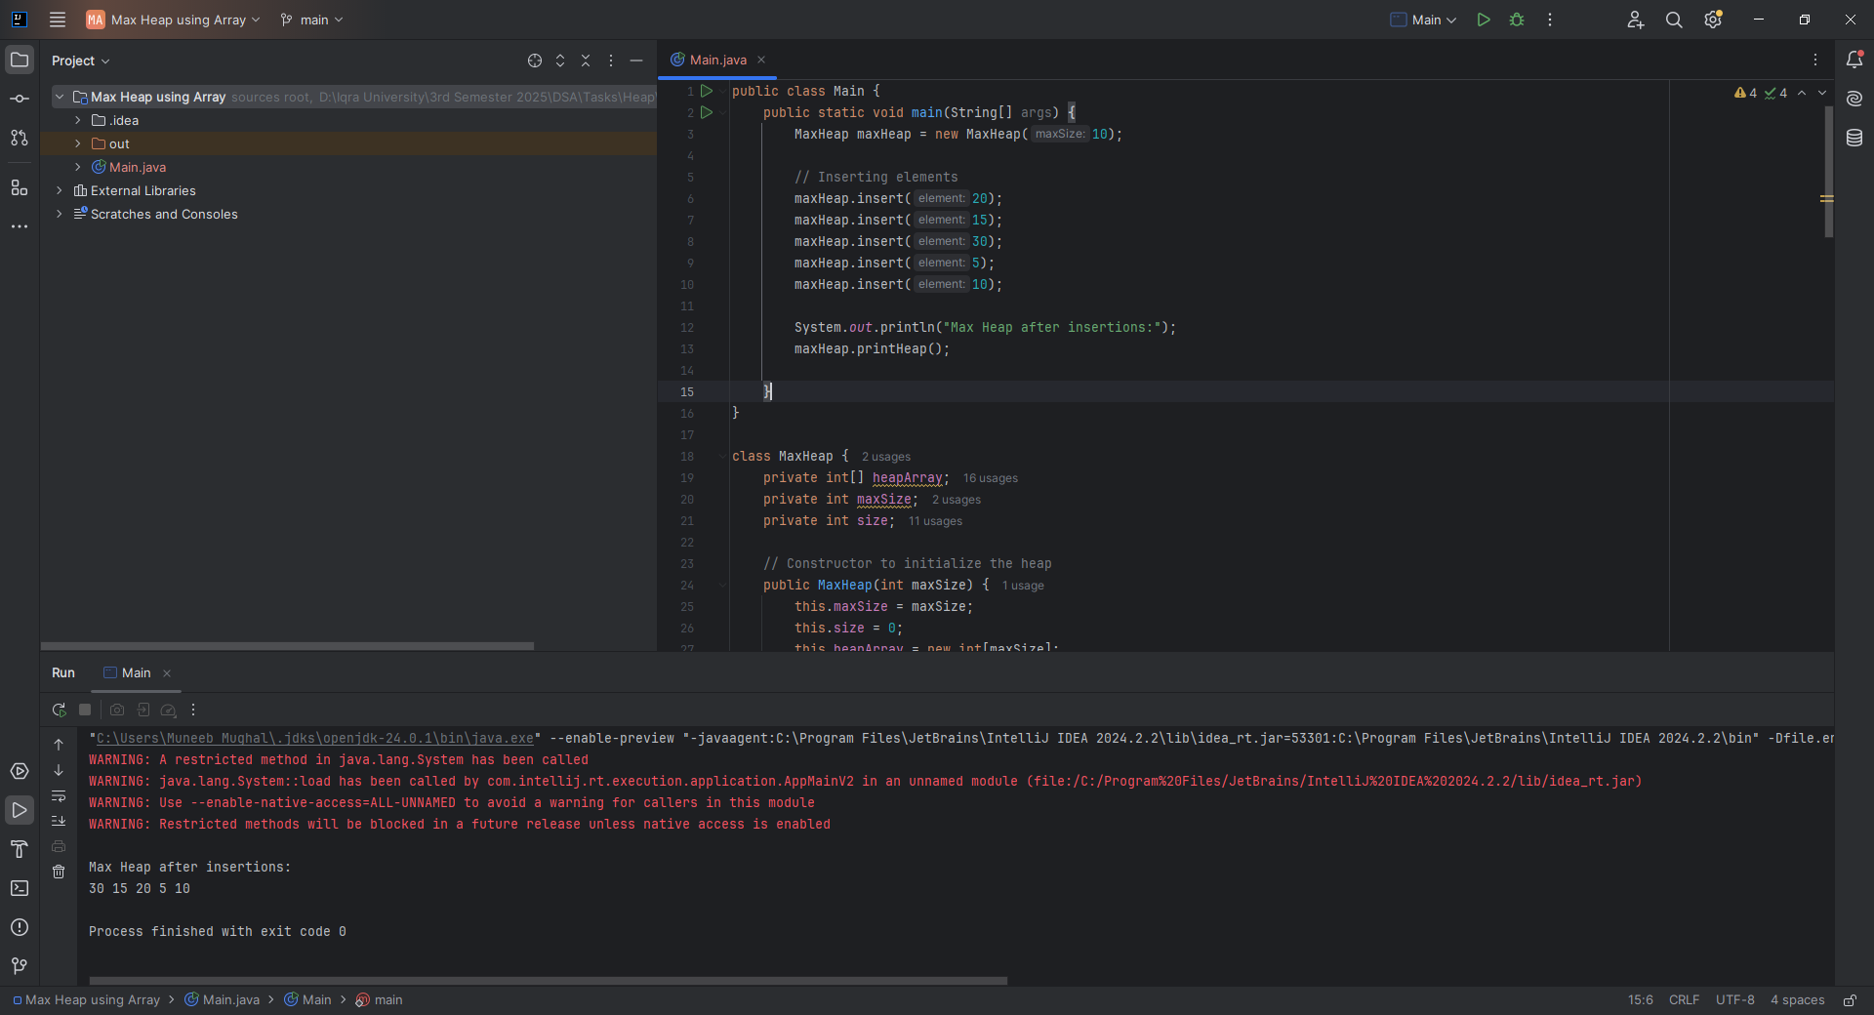

**CLASS TASK 3: Removing a max element**

**CODE:**

public int removeMax() {  
 if (size == 0) {  
 throw new IllegalStateException("Heap is empty");  
 }  
  
 int max = heapArray[0];  
 heapArray[0] = heapArray[size - 1];  
 size--;  
  
 // Heapify-down  
 heapify(0);  
  
 return max;  
}  
  
// Heapify-down method  
private void heapify(int i) {  
 int largest = i;  
 int left = leftChild(i);  
 int right = rightChild(i);  
  
 if (left < size && heapArray[left] > heapArray[largest]) {  
 largest = left;  
 }  
  
 if (right < size && heapArray[right] > heapArray[largest]) {  
 largest = right;  
 }  
  
 if (largest != i) {  
 swap(i, largest);  
 heapify(largest);  
 }  
}  
  
// Swap elements  
private void swap(int i, int j) {  
 int temp = heapArray[i];  
 heapArray[i] = heapArray[j];  
 heapArray[j] = temp;  
}

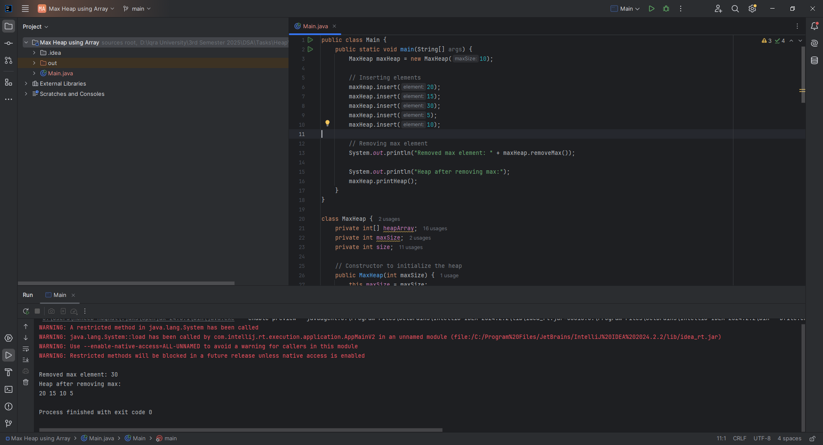

**CLASS TASK 5:** Implementing a Priority Queue with Max Heap

**CODE:**

class PQueue {  
 private MaxHeap heap;  
  
 // Constructor: initialize PQueue with a max size  
 public PQueue(int capacity) {  
 this.heap = new MaxHeap(capacity);  
 }  
  
 // Insert an element into the priority queue  
 public void enqueue(int element) {  
 heap.insert(element);  
 }  
  
 // Remove and return the highest priority element  
 public int dequeue() {  
 return heap.removeMax();  
 }  
  
 // Peek at the highest priority element without removing  
 public int peek() {  
 if (heap.getSize() == 0) {  
 throw new IllegalStateException("Priority Queue is empty");  
 }  
 return heap.getMax();  
 }  
  
 // Check if the priority queue is empty  
 public boolean isEmpty() {  
 return heap.getSize() == 0;  
 }  
  
 // Get current size of the priority queue  
 public int size() {  
 return heap.getSize();  
 }  
}

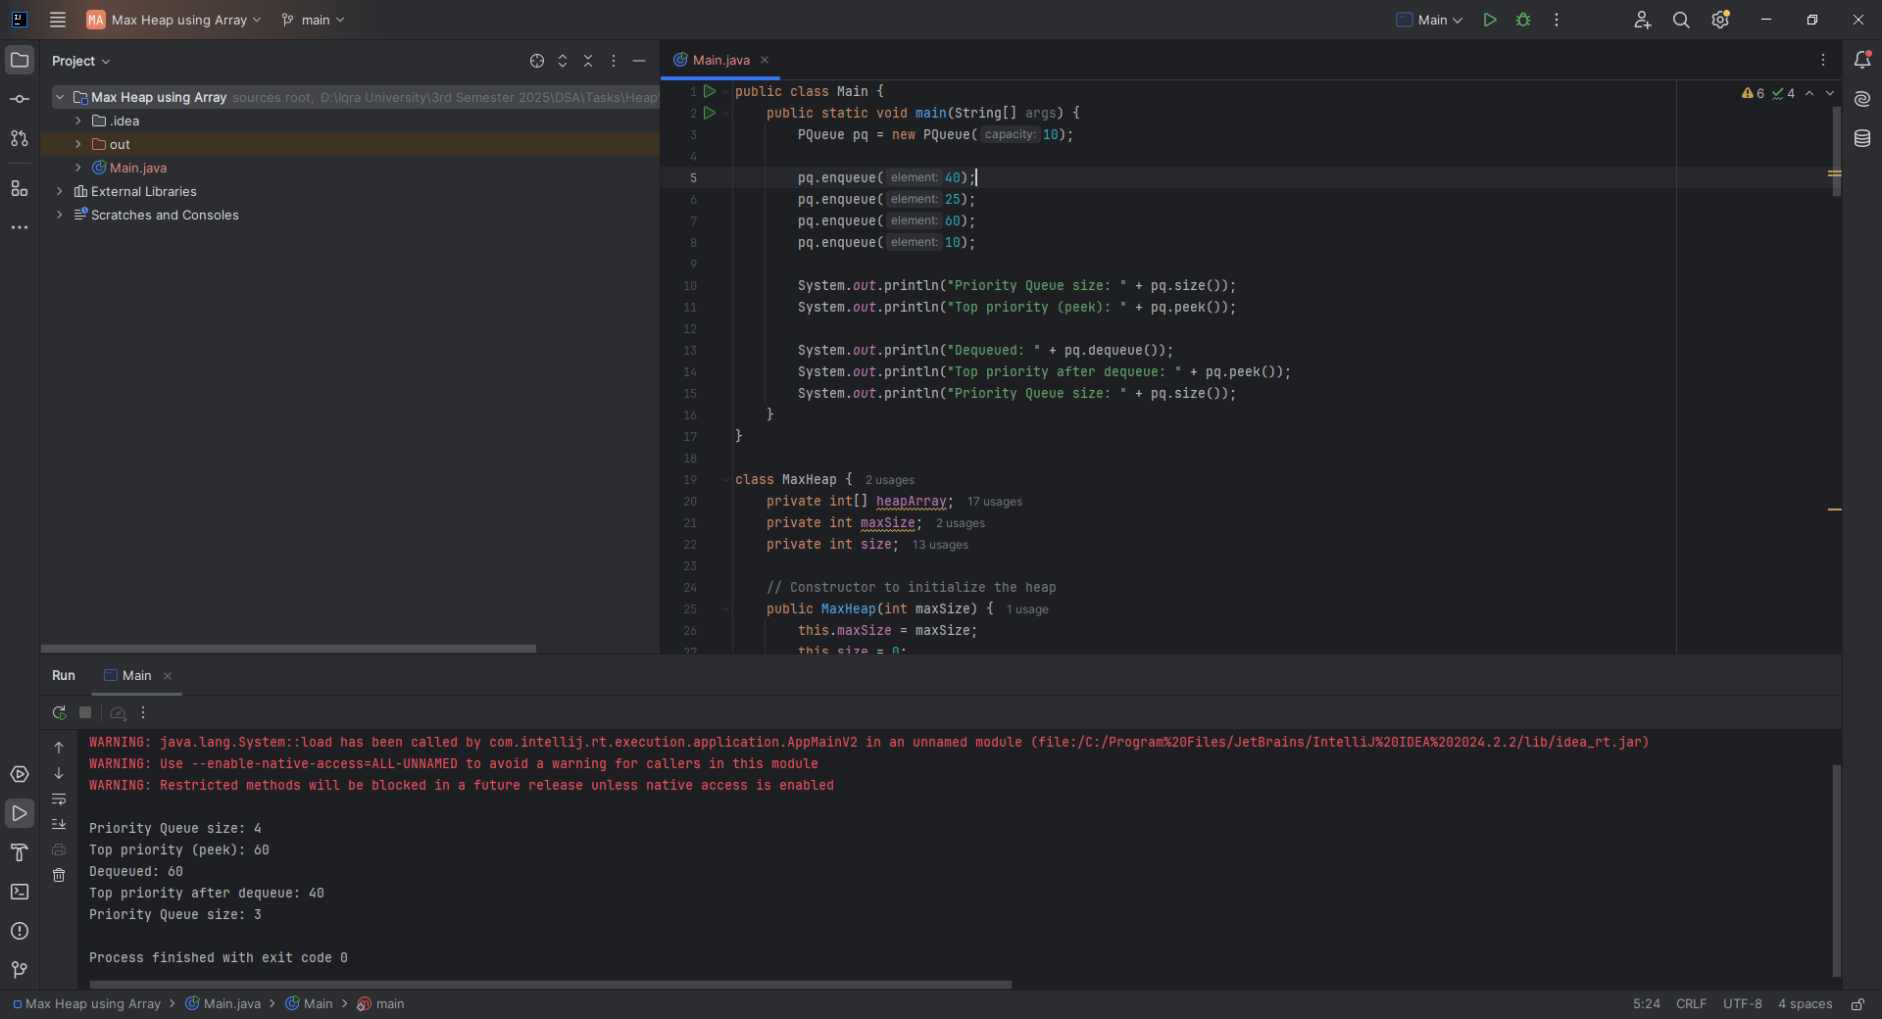

**HOME TASK 1:**

**CODE:**

public class Main {  
 public static void main(String[] args) {  
 MinHeap minHeap = new MinHeap(10);  
  
 minHeap.insert(30);  
 minHeap.insert(10);  
 minHeap.insert(20);  
  
 System.*out*.print("Heap after insertions: ");  
 minHeap.printHeap(); // Expected: [10, 30, 20] or [10, 20, 30] depending on heap structure  
  
 int removed = minHeap.removeMin();  
 System.*out*.println("Removed Min: " + removed);  
  
 System.*out*.print("Heap after removeMin: ");  
 minHeap.printHeap(); // Expected: [20, 30]  
 }  
}  
  
  
class MinHeap {  
 private int[] heap;  
 private int maxSize;  
 private int size;  
  
 // Constructor to initialize heap  
 public MinHeap(int maxSize) {  
 this.maxSize = maxSize;  
 this.size = 0;  
 this.heap = new int[maxSize];  
 }  
  
 // Index helpers  
 private int parent(int i) { return (i - 1) / 2; }  
 private int leftChild(int i) { return 2 * i + 1; }  
 private int rightChild(int i) { return 2 * i + 2; }  
  
 // Swap elements  
 private void swap(int i, int j) {  
 int tmp = heap[i];  
 heap[i] = heap[j];  
 heap[j] = tmp;  
 }  
  
 // Insert a new element into the heap  
 public void insert(int element) {  
 if (size >= maxSize) {  
 System.*out*.println("Heap is full. Cannot insert.");  
 return;  
 }  
  
 heap[size] = element;  
 heapifyUp(size);  
 size++;  
 }  
  
 // Remove and return the minimum element (root)  
 public int removeMin() {  
 if (size == 0) {  
 throw new IllegalStateException("Heap is empty");  
 }  
  
 int min = heap[0];  
 heap[0] = heap[size - 1];  
 size--;  
  
 heapifyDown(0);  
 return min;  
 }  
  
 // Maintain min-heap by moving the element up  
 private void heapifyUp(int index) {  
 while (index > 0 && heap[index] < heap[parent(index)]) {  
 swap(index, parent(index));  
 index = parent(index);  
 }  
 }  
  
 // Maintain min-heap by moving the element down  
 private void heapifyDown(int index) {  
 int smallest = index;  
 int left = leftChild(index);  
 int right = rightChild(index);  
  
 if (left < size && heap[left] < heap[smallest]) {  
 smallest = left;  
 }  
  
 if (right < size && heap[right] < heap[smallest]) {  
 smallest = right;  
 }  
  
 if (smallest != index) {  
 swap(index, smallest);  
 heapifyDown(smallest);  
 }  
 }  
  
 // Print the heap  
 public void printHeap() {  
 System.*out*.print("[");  
 for (int i = 0; i < size; i++) {  
 System.*out*.print(heap[i]);  
 if (i < size - 1) System.*out*.print(", ");  
 }  
 System.*out*.println("]");  
 }  
}

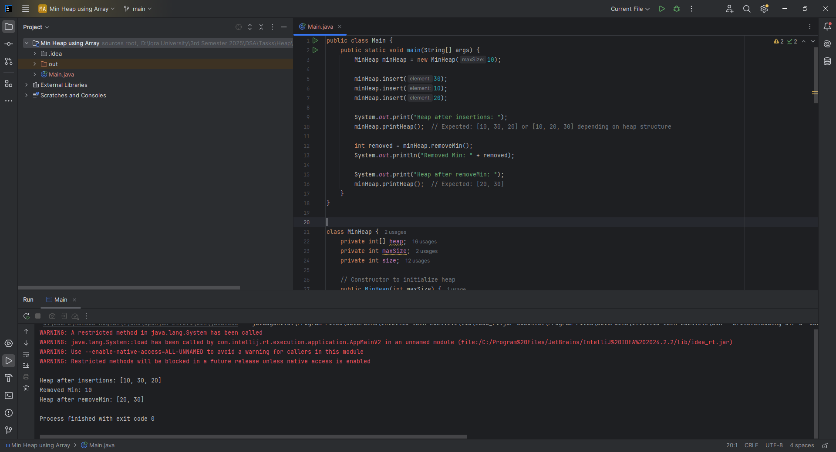

**HOME TASK 2**

**CODE:**

public class Main {  
 public static void main(String[] args) {  
 int[] arr = {12, 11, 13, 5, 6, 7};  
  
 System.*out*.print("Input Array : ");  
 *print_arr*(arr);  
  
 *heapSort*(arr);  
 System.*out*.print("Sorted Array : ");  
 *print_arr*(arr);  
  
 }  
  
 static void print_arr(int[] arr){  
 for(int i=0; i<arr.length; i++){  
 System.*out*.print(arr[i] + " ");  
 }  
 System.*out*.println();  
 }  
  
 static void heapSort(int[] arr) {  
 int n = arr.length;  
  
 // Build max heap  
 for (int i = n / 2 - 1; i >= 0; i--) *heapify*(arr, n, i);  
  
 // Extract elements  
 for (int i = n - 1; i > 0; i--) {  
 int temp = arr[0]; arr[0] = arr[i]; arr[i] = temp;  
 *heapify*(arr, i, 0);  
 }  
 }  
  
 static void heapify(int[] arr, int heapSize, int root) {  
 int largest = root;  
 int left = 2 * root + 1;  
 int right = 2 * root + 2;  
  
 if (left < heapSize && arr[left] > arr[largest]) largest = left;  
 if (right < heapSize && arr[right] > arr[largest]) largest = right;  
  
 if (largest != root) {  
 int temp = arr[root];  
 arr[root] = arr[largest]; arr[largest] = temp;  
 *heapify*(arr, heapSize, largest);  
 }  
 }  
}

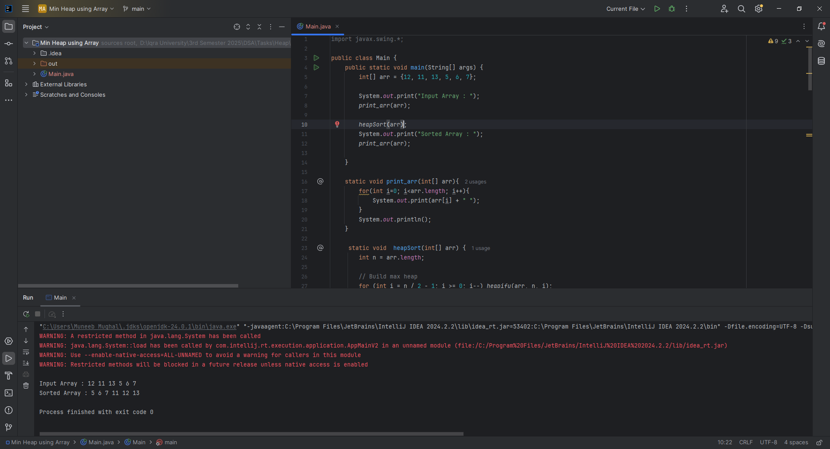

**CLASS TASK All:**

**CODE:**

public class Main {  
 public static void main(String[] args) {  
 Hash_Table table = new Hash_Table();  
 table.insert(53);  
 table.insert(54);  
 table.insert(73);  
 table.insert(102);  
 table.remove(53);  
 table.traverse();  
  
 System.*out*.println("Search 73: " + table.search(73)); // true  
 System.*out*.println("Search 100: " + table.search(100)); // false  
 System.*out*.println("Get 74: " + table.get_val(74));  
 System.*out*.println("Get 54: " + table.get_val(54));  
 }  
}  
  
  
class Hash_Table {  
 int table_length = 10;  
 LinkedList[] table;  
  
 Hash_Table(int table_length){  
 this.table_length = table_length;  
 table = new LinkedList[table_length];  
 for(int i = 0; i < table_length; i++){  
 table[i] = new LinkedList();  
 }  
 }  
  
 Hash_Table(){  
 table = new LinkedList[table_length];  
 for(int i = 0; i < table_length; i++){  
 table[i] = new LinkedList();  
 }  
 }  
  
 void insert(int val){  
 int key = val % table_length;  
 table[key].insert_at_end(val);  
 }  
  
 boolean search(int val){  
 int key = val % table_length;  
 return table[key].search(val);  
 }  
  
 void traverse(){  
 for(int i = 0; i < table_length; i++){  
 System.*out*.print("Bucket " + (i+1) + " : ");  
 table[i].traverse();  
 }  
 }  
 Integer get_val(int val){  
 int key = val % table_length;  
 return table[key].get(val);  
 }  
  
 void remove(int val) {  
 int key = val % table_length;  
 table[key].remove(val);  
 }  
  
  
 class LinkedList {  
 Node head = null;  
  
 class Node {  
 int data;  
 Node next;  
 public Node(int data) {  
 this.data = data;  
 next = null;  
 }  
 }  
  
 void insert_at_end(int data) {  
 Node newNode = new Node(data);  
 if(head == null){  
 head = newNode;  
 return;  
 }  
 Node current = head;  
 while(current.next != null){  
 current = current.next;  
 }  
 current.next = newNode;  
 }  
  
 void traverse(){  
 if(head == null){  
 System.*out*.println("Empty List");  
 return;  
 }  
 Node current = head;  
 while(current != null){  
 System.*out*.print(current.data + " ");  
 current = current.next;  
 }  
 System.*out*.println();  
 }  
 void remove(int val) {  
 if (head == null) return;  
  
 if (head.data == val) {  
 head = head.next;  
 return;  
 }  
  
 Node current = head;  
 while (current.next != null && current.next.data != val) {  
 current = current.next;  
 }  
  
 if (current.next != null) {  
 current.next = current.next.next;  
 }  
 }  
 // 🔍 New method for searching a value in the linked list  
 boolean search(int val){  
 Node current = head;  
 while(current != null){  
 if(current.data == val){  
 return true;  
 }  
 current = current.next;  
 }  
 return false;  
 }  
 Integer get(int val){  
 Node current = head;  
 while(current != null){  
 if(current.data == val){  
 return current.data;  
 }  
 current = current.next;  
 }  
 return null; // value not found  
 }  
 }  
}

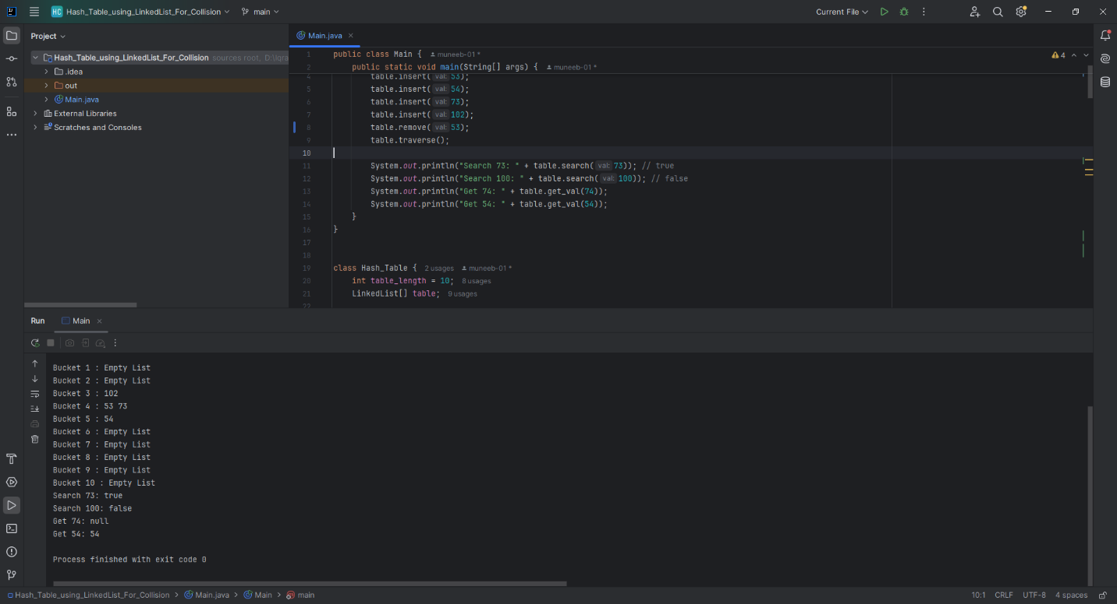

**Home Task 2:** Counting Word Frequencies Using a Hash Table

**CODE:**

import java.util.Scanner;  
  
public class Main {  
 public static void main(String[] args) {  
 Scanner scanner = new Scanner(System.*in*);  
  
 System.*out*.print("Input: ");  
 String input = scanner.nextLine().toLowerCase();  
  
 String[] words = input.split("\\s+"); // split by spaces  
  
 WordHashTable table = new WordHashTable();  
  
 for (String word : words) {  
 table.insert(word);  
 }  
  
 System.*out*.println("Output: " + table);  
 }  
}  
  
class WordHashTable {  
 private static final int *SIZE* = 100;  
 private WordNode[] table;  
  
 public WordHashTable() {  
 table = new WordNode[*SIZE*];  
 }  
  
 private int hash(String key) {  
 return Math.*abs*(key.hashCode()) % *SIZE*;  
 }  
  
 public void insert(String word) {  
 int index = hash(word);  
 WordNode current = table[index];  
  
 while (current != null) {  
 if (current.word.equals(word)) {  
 current.count++;  
 return;  
 }  
 current = current.next;  
 }  
  
 WordNode newNode = new WordNode(word);  
 newNode.next = table[index];  
 table[index] = newNode;  
 }  
  
 @Override  
 public String toString() {  
 StringBuilder sb = new StringBuilder("{");  
 boolean first = true;  
  
 for (int i = 0; i < *SIZE*; i++) {  
 WordNode current = table[i];  
 while (current != null) {  
 if (!first) sb.append(", ");  
 sb.append(current.word).append("=").append(current.count);  
 first = false;  
 current = current.next;  
 }  
 }  
  
 sb.append("}");  
 return sb.toString();  
 }  
  
 static class WordNode {  
 String word;  
 int count;  
 WordNode next;  
  
 public WordNode(String word) {  
 this.word = word;  
 this.count = 1;  
 this.next = null;  
 }  
 }  
}

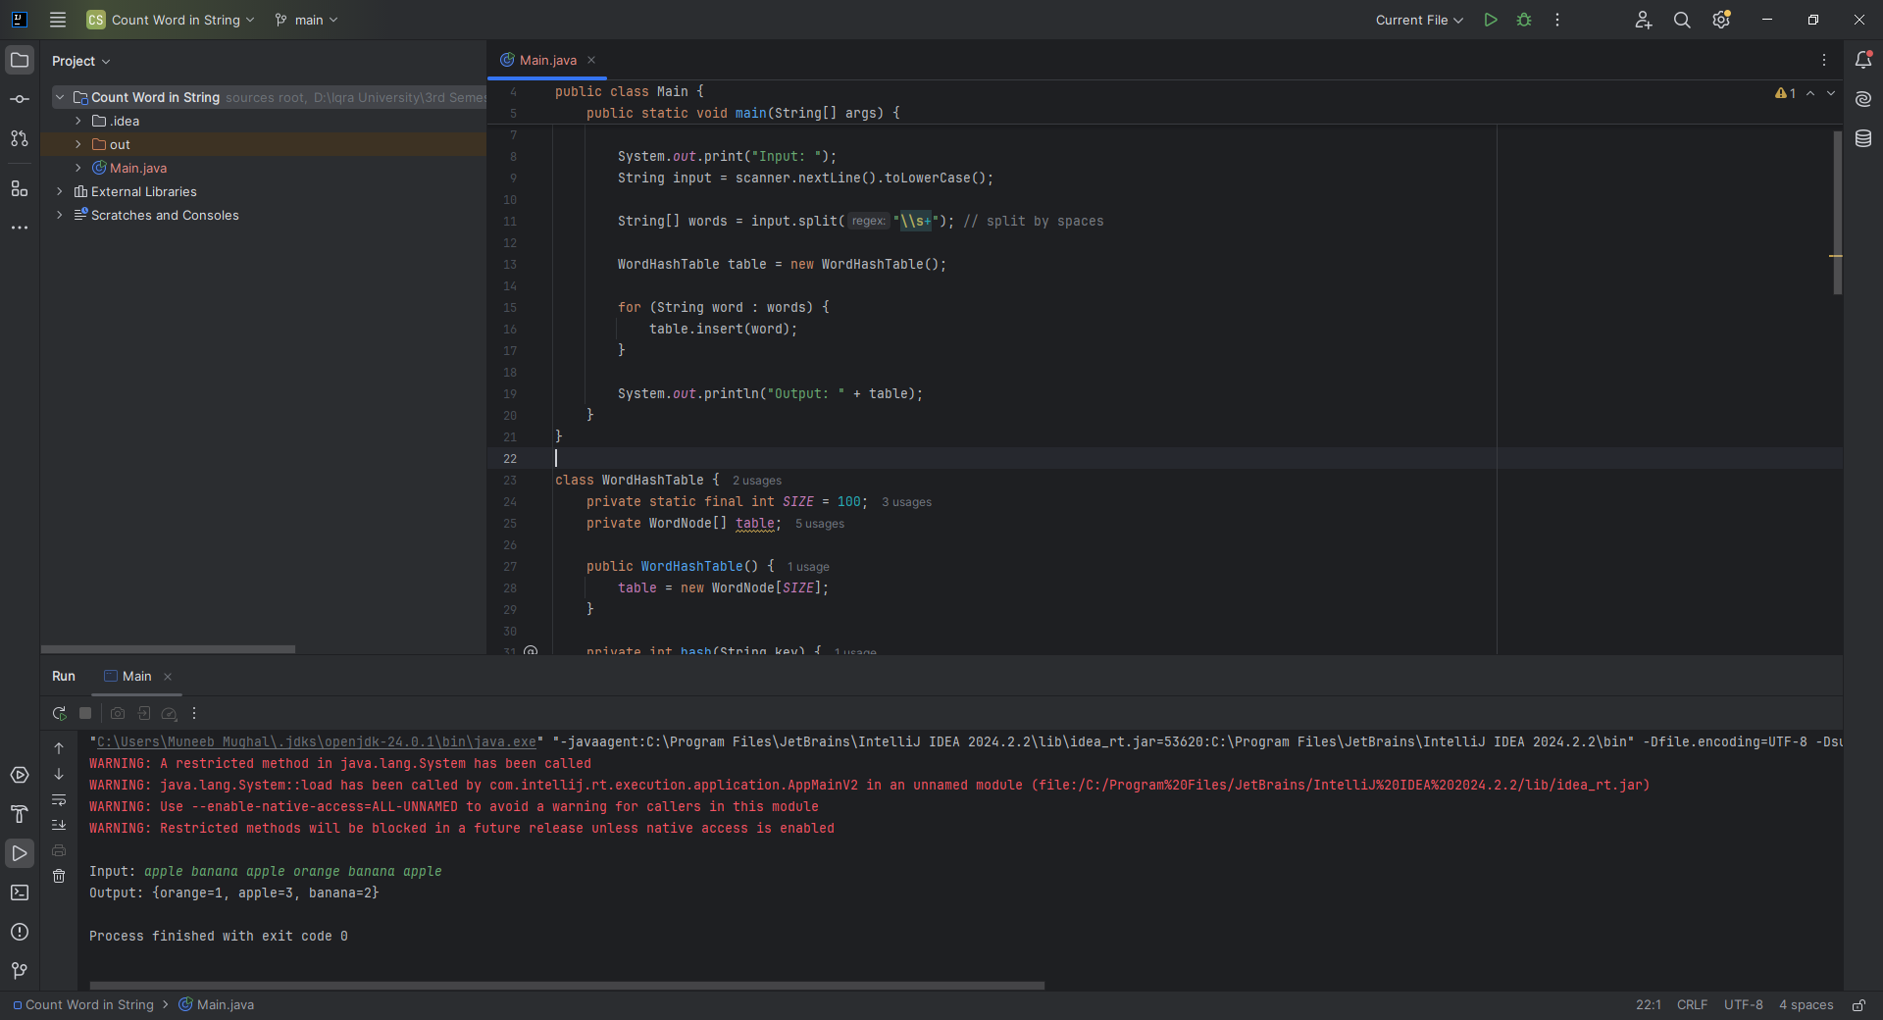

**Home Task 3:** Implementing a Hash Table for Storing Student Records

**CODE:**

public class Main {  
 public static void main(String[] args) {  
 StudentHashTable studentTable = new StudentHashTable();  
  
 // Adding Students  
 studentTable.addStudent(new Student(101, "John", "A"));  
 studentTable.addStudent(new Student(201, "Alice", "B"));  
 studentTable.addStudent(new Student(103, "Bob", "C"));  
  
 // Retrieve a Student  
 Student student = studentTable.getStudent(101);  
 if (student != null) {  
 System.*out*.println("Retrieve Student: For ID 101, output Name: " + student.name + ", Grade: " + student.grade);  
 } else {  
 System.*out*.println("Student with ID 101 not found.");  
 }  
  
 // Remove a Student  
 studentTable.removeStudent(102);  
  
 // Try to retrieve removed student  
 Student removed = studentTable.getStudent(102);  
 System.*out*.println(removed == null ? "Student with ID 102 was removed." : "Removal failed.");  
 }  
}  
  
class Student {  
 int id;  
 String name;  
 String grade;  
  
 public Student(int id, String name, String grade) {  
 this.id = id;  
 this.name = name;  
 this.grade = grade;  
 }  
}  
  
class StudentHashTable {  
 private static final int *SIZE* = 100;  
 private Node[] table;  
  
 public StudentHashTable() {  
 table = new Node[*SIZE*];  
 }  
  
 private int hash(int id) {  
 return id % *SIZE*;  
 }  
  
 public void addStudent(Student student) {  
 int index = hash(student.id);  
 Node head = table[index];  
  
 // Check if ID already exists, update  
 Node current = head;  
 while (current != null) {  
 if (current.student.id == student.id) {  
 current.student = student; // Update existing  
 return;  
 }  
 current = current.next;  
 }  
  
 // Else insert at beginning  
 Node newNode = new Node(student);  
 newNode.next = head;  
 table[index] = newNode;  
  
 System.*out*.println("Add Student: ID: " + student.id + ", Name: " + student.name + ", Grade: " + student.grade);  
 }  
  
 public void removeStudent(int id) {  
 int index = hash(id);  
 Node current = table[index];  
 Node prev = null;  
  
 while (current != null) {  
 if (current.student.id == id) {  
 if (prev == null) {  
 table[index] = current.next;  
 } else {  
 prev.next = current.next;  
 }  
 return;  
 }  
 prev = current;  
 current = current.next;  
 }  
 }  
  
 public Student getStudent(int id) {  
 int index = hash(id);  
 Node current = table[index];  
  
 while (current != null) {  
 if (current.student.id == id) {  
 return current.student;  
 }  
 current = current.next;  
 }  
 return null;  
 }  
  
 private static class Node {  
 Student student;  
 Node next;  
  
 public Node(Student student) {  
 this.student = student;  
 this.next = null;  
 }  
 }  
}

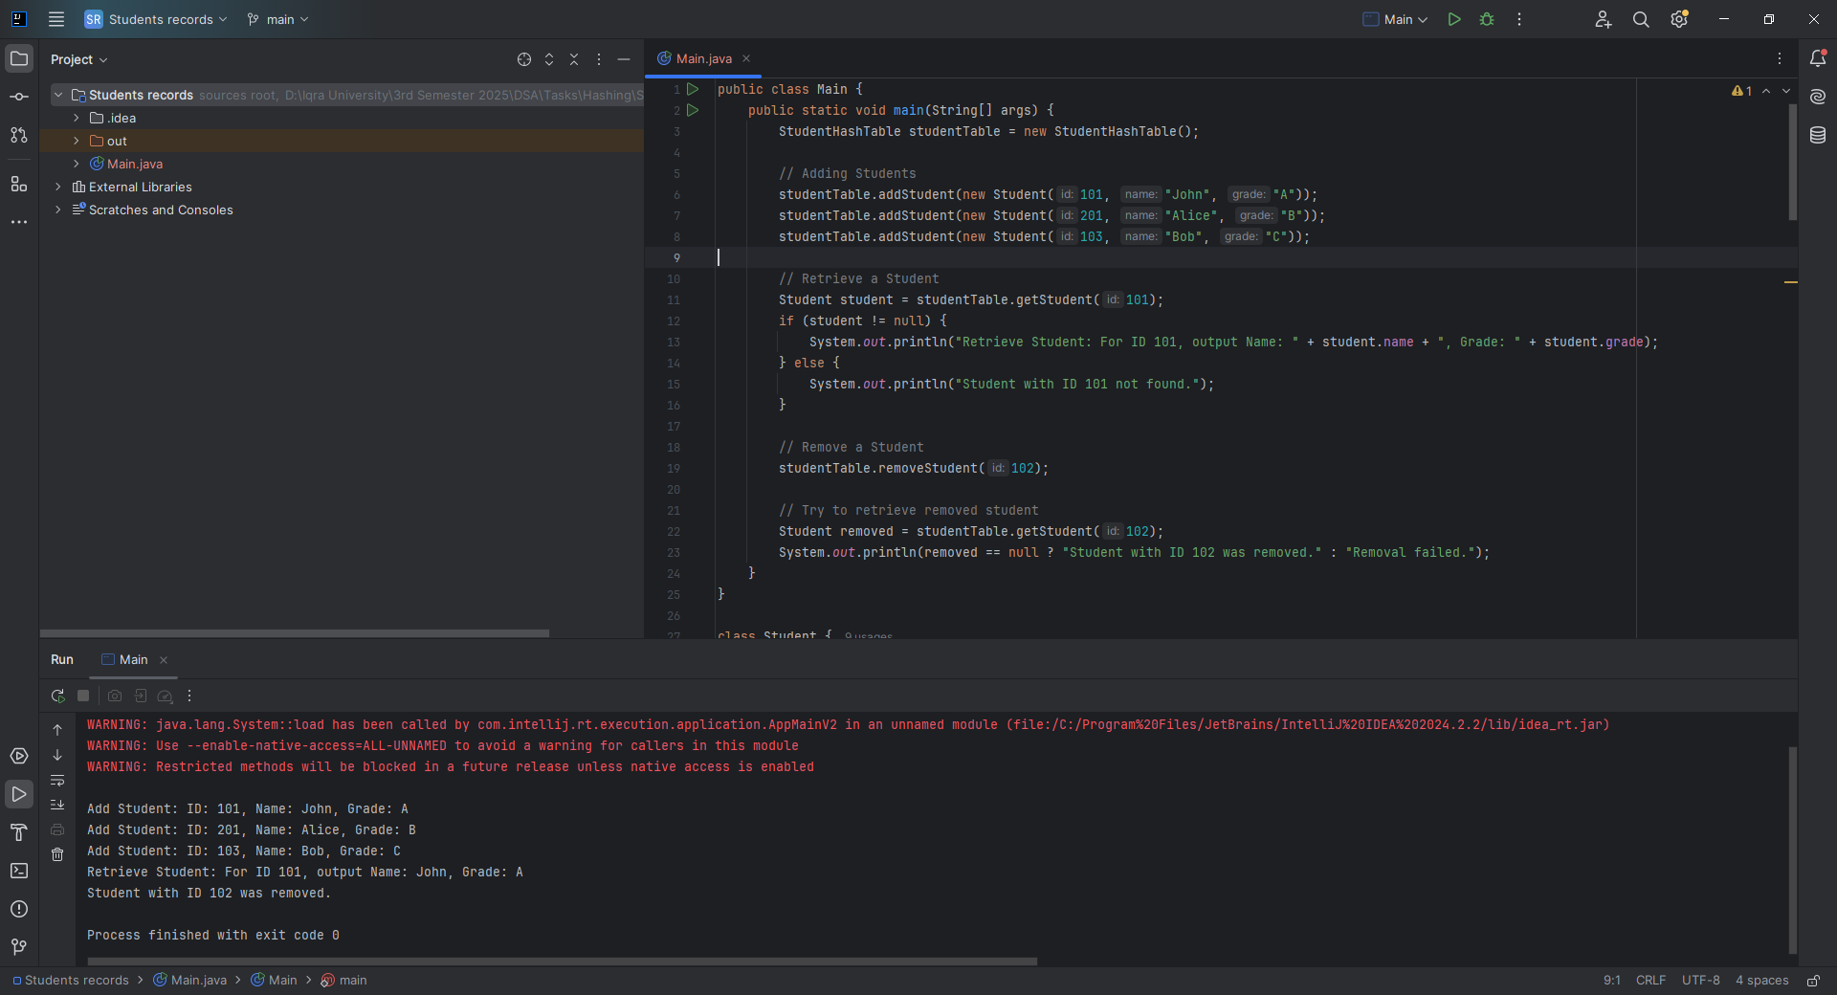

**CLASS TASK All:**

**CODE:**

public class Main {  
 public static void main(String[] args) {  
 BinaryTree tree = new BinaryTree();  
  
 tree.insert(2);  
 tree.insert(1);  
 tree.insert(5);  
 tree.insert(3);  
 tree.insert(6);  
  
 tree.delete(1);  
 }  
}  
  
// Node class for each element in the tree  
  
  
// Binary Tree class  
class BinaryTree {  
 private class Node {  
 int data;  
 Node left, right;  
  
 Node(int value) {  
 data = value;  
 left = right = null;  
 }  
 }  
 Node root;  
  
 void insert(int value) {  
 root = insertRec(root, value);  
 }  
  
 // Recursive BST insert logic  
 Node insertRec(Node root, int value) {  
 if (root == null) {  
 return new Node(value);  
 }  
 if (value < root.data)  
 root.left = insertRec(root.left, value);  
 else if (value > root.data)  
 root.right = insertRec(root.right, value);  
 return root;  
 }  
  
 // Inorder traversal: Left → Root → Right  
 void inorder() {  
 inorderRec(root);  
 System.*out*.println();  
 }  
  
 void inorderRec(Node node) {  
 if (node != null) {  
 inorderRec(node.left);  
 System.*out*.print(node.data + " ");  
 inorderRec(node.right);  
 }  
 }  
  
 // Preorder traversal: Root → Left → Right  
 void preorder() {  
 preorderRec(root);  
 System.*out*.println();  
 }  
  
 void preorderRec(Node node) {  
 if (node != null) {  
 System.*out*.print(node.data + " ");  
 preorderRec(node.left);  
 preorderRec(node.right);  
 }  
 }  
  
 // Postorder traversal: Left → Right → Root  
 void postorder() {  
 postorderRec(root);  
 System.*out*.println();  
 }  
  
 void postorderRec(Node node) {  
 if (node != null) {  
 postorderRec(node.left);  
 postorderRec(node.right);  
 System.*out*.print(node.data + " ");  
 }  
 }  
 void delete(int value) {  
 root = deleteRec(root, value);  
 }  
  
 Node deleteRec(Node root, int value) {  
 if (root == null) return null;  
  
 if (value < root.data) {  
 root.left = deleteRec(root.left, value);  
 } else if (value > root.data) {  
 root.right = deleteRec(root.right, value);  
 } else {  
 // Node to be deleted found  
  
 // Case 1: No child  
 if (root.left == null && root.right == null) {  
 return null;  
 }  
  
 // Case 2: One child  
 if (root.left == null) return root.right;  
 if (root.right == null) return root.left;  
  
 // Case 3: Two children  
 Node successor = findMin(root.right);  
 root.data = successor.data;  
 root.right = deleteRec(root.right, successor.data);  
 }  
  
 return root;  
 }  
  
 Node findMin(Node node) {  
 while (node.left != null) {  
 node = node.left;  
 }  
 return node;  
 }  
  
}

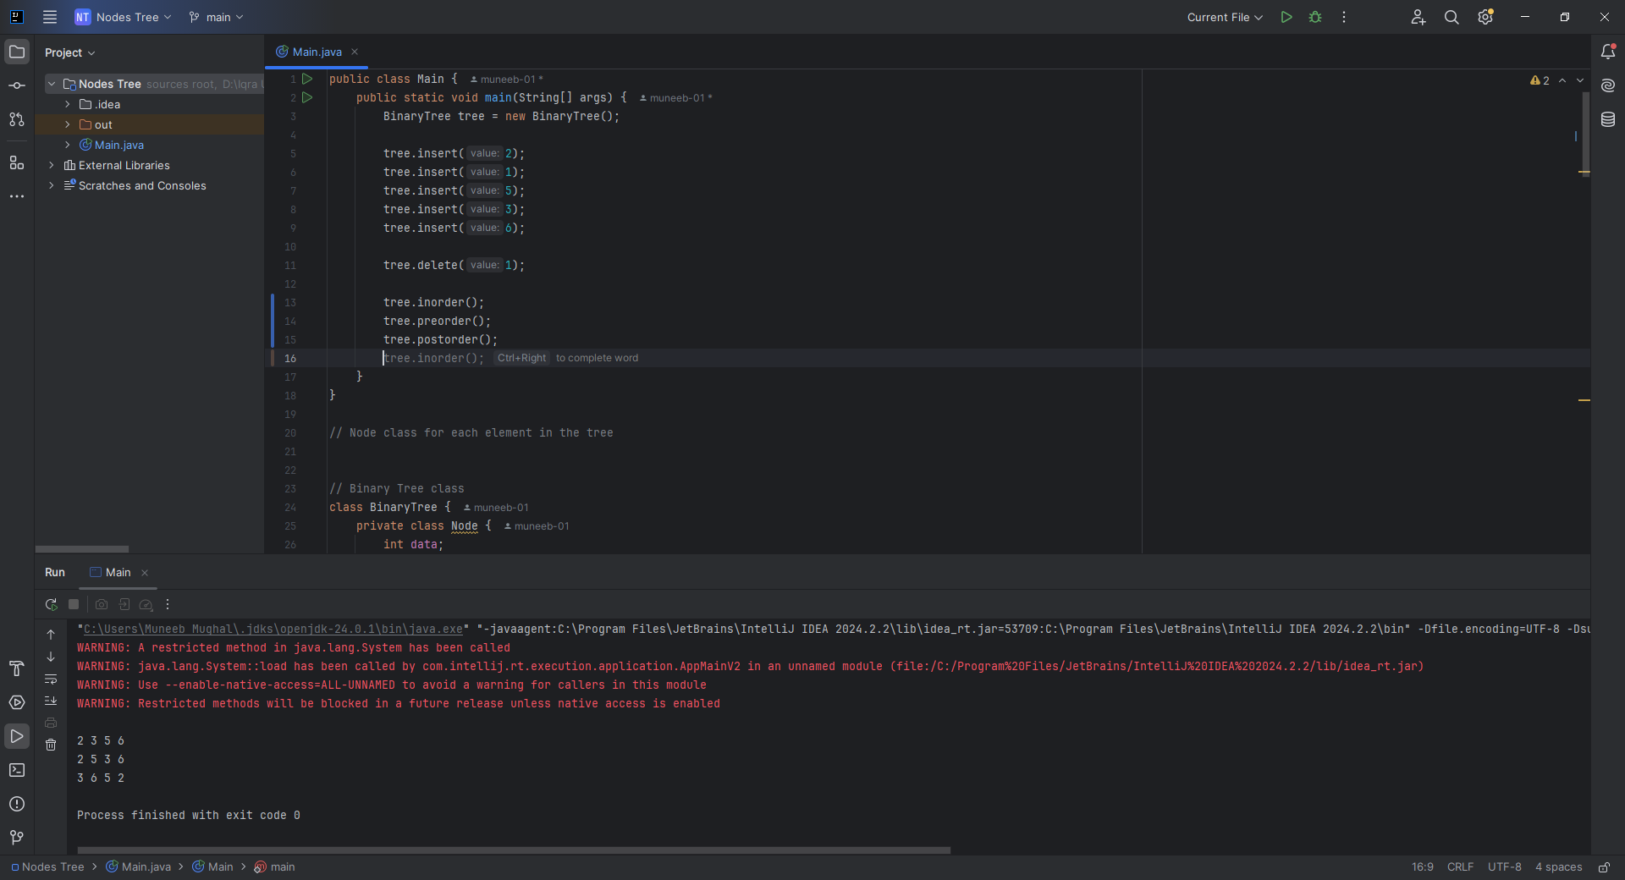

**Home Task 1:** Checking if a Tree is a BST

**CODE:**

boolean isBST() {  
 return isBSTUtil(root, Integer.*MIN_VALUE*, Integer.*MAX_VALUE*);  
}  
  
private boolean isBSTUtil(Node node, int min, int max) {  
 if (node == null) return true;  
 if (node.data <= min || node.data >= max) return false;  
 return isBSTUtil(node.left, min, node.data) && isBSTUtil(node.right, node.data, max);  
}

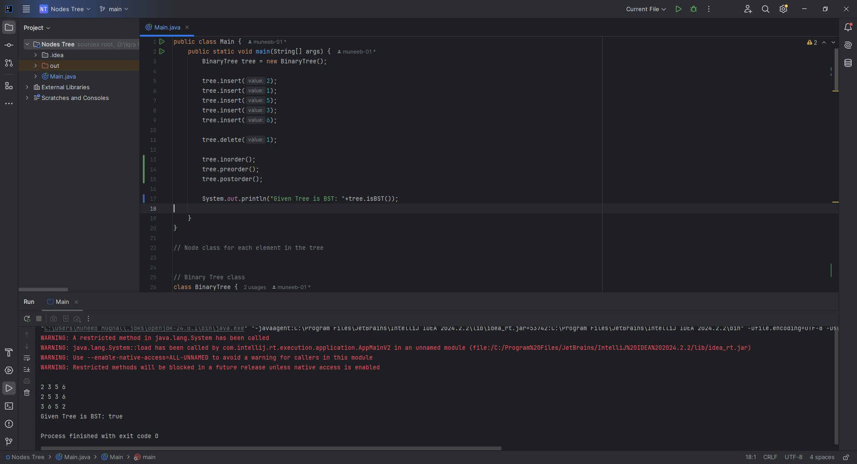

**Home Task 2:** Finding the Lowest Common Ancestor

**CODE:**

int findLCA(int n1, int n2) {  
 Node lcaNode = findLCARec(root, n1, n2);  
 return lcaNode != null ? lcaNode.data : -1; // Return -1 if no LCA found  
}  
  
private Node findLCARec(Node node, int n1, int n2) {  
 if (node == null) return null;  
  
 // If both n1 and n2 are smaller, LCA lies in left  
 if (n1 < node.data && n2 < node.data) {  
 return findLCARec(node.left, n1, n2);  
 }  
  
 // If both n1 and n2 are greater, LCA lies in right  
 if (n1 > node.data && n2 > node.data) {  
 return findLCARec(node.right, n1, n2);  
 }  
  
 // Otherwise, this node is the LCA  
 return node;

}

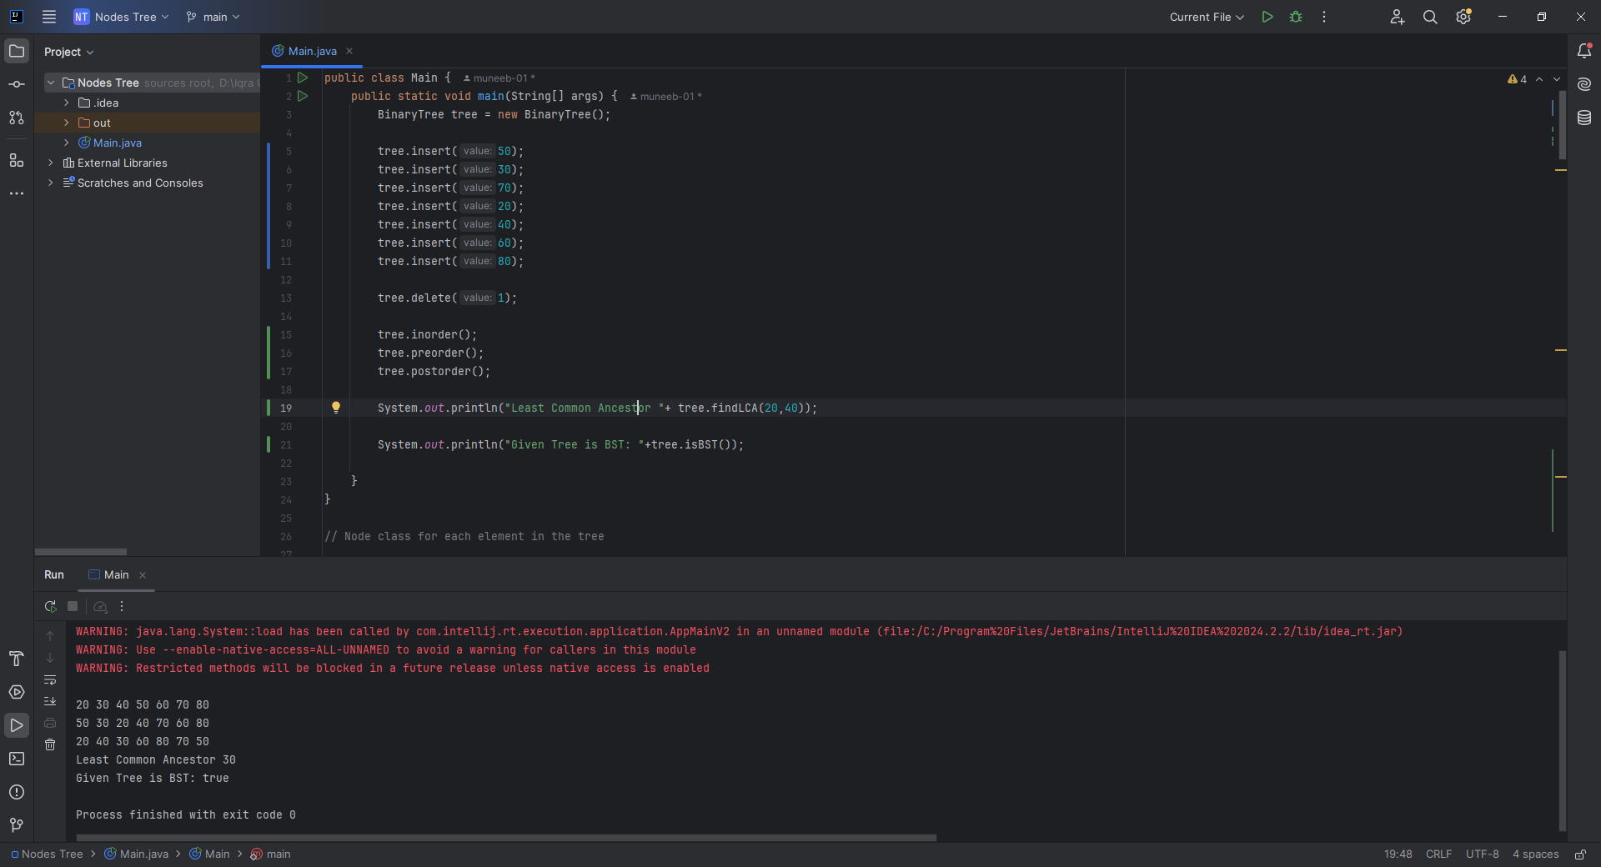

**Home Task 3: BST TO DLL**

**CODE:**

class BinaryTree {  
 public class Node { // <-- make public here  
 int data;  
 Node left, right;  
  
 Node(int value) {  
 data = value;  
 left = right = null;  
 }  
 }  
 Node root;  
  
 private Node head = null;  
 private Node prev = null;  
  
 public Node bstToDoublyLinkedList() {  
 head = null;  
 prev = null;  
 convertBSTtoDLL(root);  
 return head;  
 }  
  
 private void convertBSTtoDLL(Node curr) {  
 if (curr == null) return;  
  
 convertBSTtoDLL(curr.left);  
  
 if (prev == null) {  
 head = curr;  
 } else {  
 prev.right = curr;  
 curr.left = prev;  
 }  
 prev = curr;  
  
 convertBSTtoDLL(curr.right);  
 }  
  
 public void printDoublyLinkedList(Node head) {  
 Node curr = head;  
 while (curr != null) {  
 System.*out*.print(curr.data);  
 if (curr.right != null) System.*out*.print(" <-> ");  
 curr = curr.right;  
 }  
 System.*out*.println();  
 }  
  
 public void insert(int val) {  
 root = insertRec(root, val);  
 }  
  
 private Node insertRec(Node node, int val) {  
 if (node == null) return new Node(val);  
 if (val < node.data) node.left = insertRec(node.left, val);  
 else if (val > node.data) node.right = insertRec(node.right, val);  
 return node;  
 }  
}  
  
public class Main {  
 public static void main(String[] args) {  
 BinaryTree tree = new BinaryTree();  
 int[] values = {10, 5, 15, 2, 8, 12, 20};  
 for (int v : values) {  
 tree.insert(v);  
 }  
  
 BinaryTree.Node head = tree.bstToDoublyLinkedList();  
 tree.printDoublyLinkedList(head);  
 }  
}

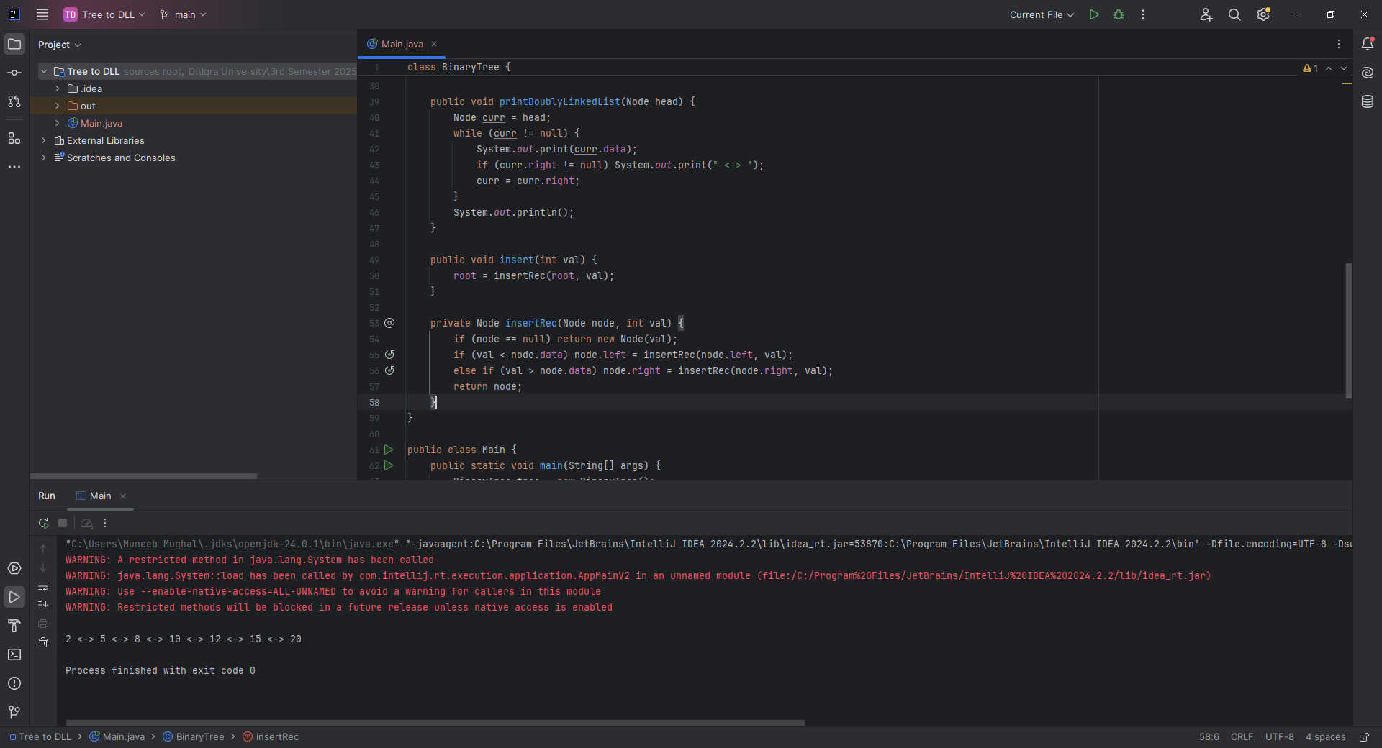

**CLASS TASK All:**

**CODE:**

// AVLTree.java  
class AVLTree {  
 class Node {  
 int data, height;  
 Node left, right;  
  
 public Node(int data) {  
 this.data = data;  
 this.height = 1;  
 }  
 }  
  
 Node root;  
  
 // Utility method to get height of node  
 private int height(Node node) {  
 return node == null ? 0 : node.height;  
 }  
  
 // Utility method to get balance factor  
 private int getBalance(Node node) {  
 return node == null ? 0 : height(node.left) - height(node.right);  
 }  
  
 // Right Rotation  
 private Node rightRotate(Node y) {  
 Node x = y.left;  
 Node T2 = x.right;  
  
 // Perform rotation  
 x.right = y;  
 y.left = T2;  
  
 // Update heights  
 y.height = Math.*max*(height(y.left), height(y.right)) + 1;  
 x.height = Math.*max*(height(x.left), height(x.right)) + 1;  
  
 return x;  
 }  
  
 // Left Rotation  
 private Node leftRotate(Node x) {  
 Node y = x.right;  
 Node T2 = y.left;  
  
 // Perform rotation  
 y.left = x;  
 x.right = T2;  
  
 // Update heights  
 x.height = Math.*max*(height(x.left), height(x.right)) + 1;  
 y.height = Math.*max*(height(y.left), height(y.right)) + 1;  
  
 return y;  
 }  
  
 // Insert node into AVL tree  
 public Node insert(Node node, int data) {  
 if (node == null) return new Node(data);  
  
 if (data < node.data) node.left = insert(node.left, data);  
 else if (data > node.data) node.right = insert(node.right, data);  
 else return node; // Duplicates not allowed  
  
 node.height = 1 + Math.*max*(height(node.left), height(node.right));  
  
 int balance = getBalance(node);  
  
 // Left Left Case  
 if (balance > 1 && data < node.left.data)  
 return rightRotate(node);  
  
 // Right Right Case  
 if (balance < -1 && data > node.right.data)  
 return leftRotate(node);  
  
 // Left Right Case  
 if (balance > 1 && data > node.left.data) {  
 node.left = leftRotate(node.left);  
 return rightRotate(node);  
 }  
  
 // Right Left Case  
 if (balance < -1 && data < node.right.data) {  
 node.right = rightRotate(node.right);  
 return leftRotate(node);  
 }  
  
 return node;  
 }  
  
 // In-order traversal  
 public void inOrder(Node node) {  
 if (node != null) {  
 inOrder(node.left);  
 System.*out*.print(node.data + " ");  
 inOrder(node.right);  
 }  
 }  
}  
  
// Main.java  
public class Main {  
 public static void main(String[] args) {  
 AVLTree tree = new AVLTree();  
 int[] values = {30, 20, 40, 10, 25, 50, 5};  
  
 for (int val : values) {  
 tree.root = tree.insert(tree.root, val);  
 }  
  
 System.*out*.println("In-order traversal of AVL tree:");  
 tree.inOrder(tree.root);  
 }  
}

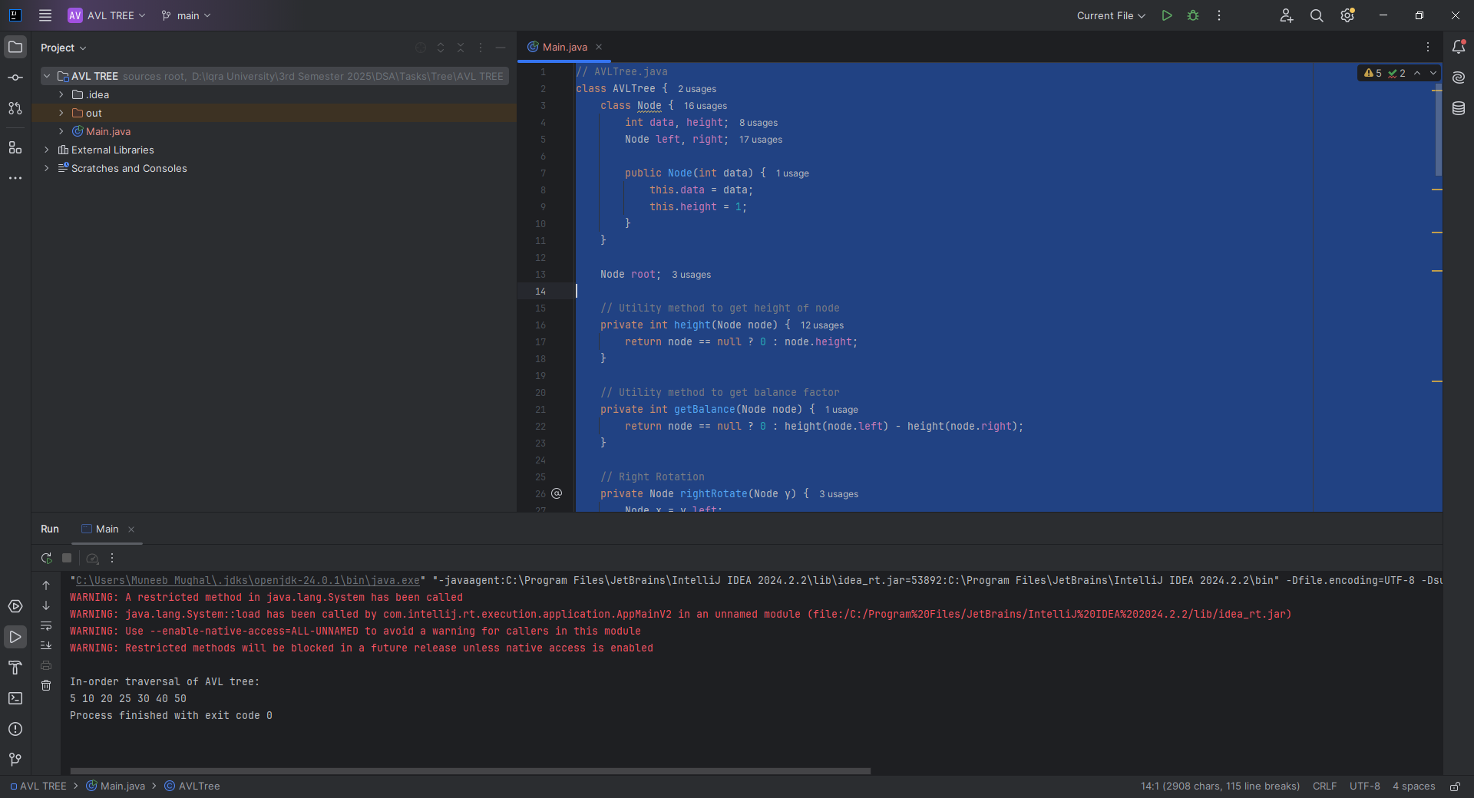

**Home Task 1:**

**CODE:**

public Node delete(Node root, int key) {  
 if (root == null) return root;  
  
 if (key < root.data) root.left = delete(root.left, key);  
 else if (key > root.data) root.right = delete(root.right, key);  
 else {  
 if ((root.left == null) || (root.right == null)) {  
 Node temp = (root.left != null) ? root.left : root.right;  
 if (temp == null) {  
 root = null;  
 } else {  
 root = temp;  
 }  
 } else {  
 Node temp = minValueNode(root.right);  
 root.data = temp.data;  
 root.right = delete(root.right, temp.data);  
 }  
 }  
  
 if (root == null) return root;  
  
 root.height = Math.*max*(height(root.left), height(root.right)) + 1;  
 int balance = getBalance(root);  
  
 // Rebalancing  
 if (balance > 1 && getBalance(root.left) >= 0) return rightRotate(root);  
 if (balance > 1 && getBalance(root.left) < 0) {  
 root.left = leftRotate(root.left);  
 return rightRotate(root);  
 }  
 if (balance < -1 && getBalance(root.right) <= 0) return leftRotate(root);  
 if (balance < -1 && getBalance(root.right) > 0) {  
 root.right = rightRotate(root.right);  
 return leftRotate(root);  
 }  
  
 return root;  
}  
  
private Node minValueNode(Node node) {  
 Node current = node;  
 while (current.left != null) current = current.left;  
 return current;  
}

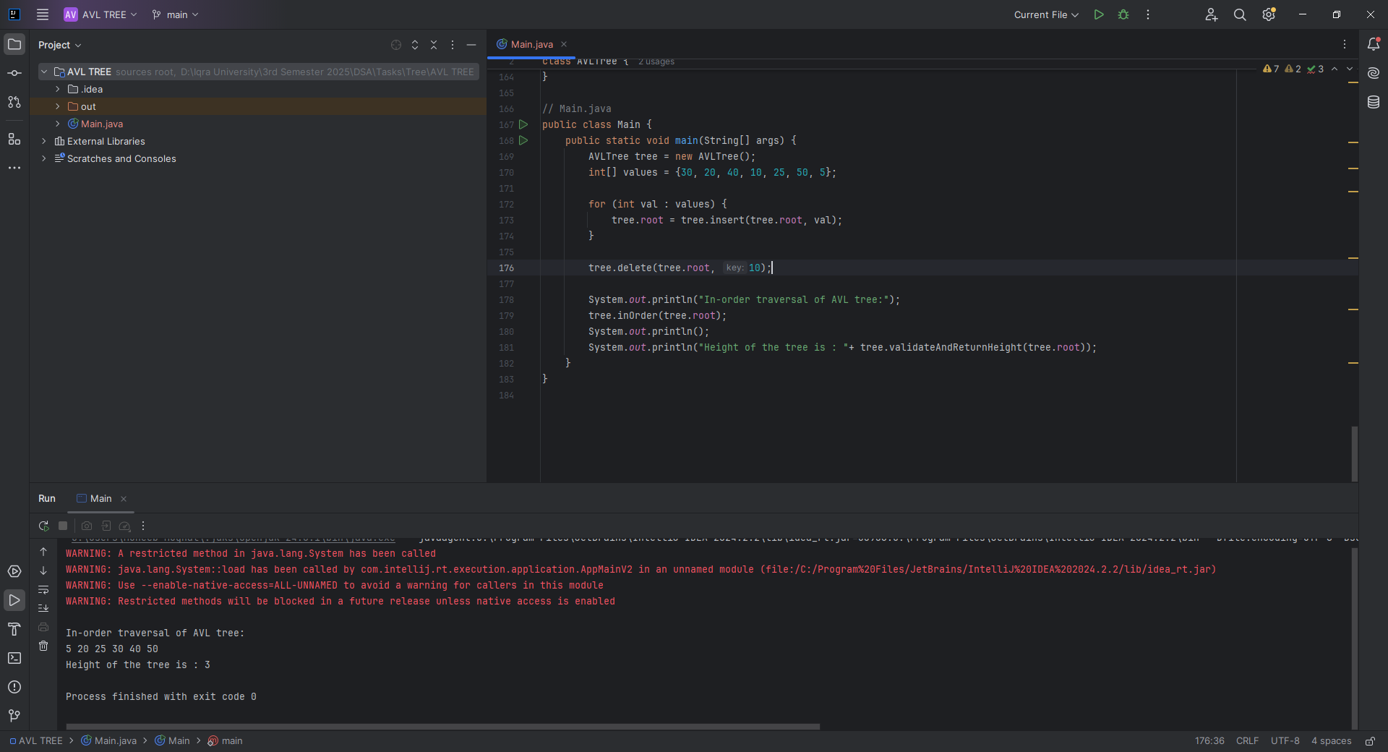

**Home Task 2:** Finding the Height of the AVL Tree

**CODE:**

public int validateAndReturnHeight(Node node) {  
 if (node == null) return 0;  
  
 int left = validateAndReturnHeight(node.left);  
 int right = validateAndReturnHeight(node.right);  
 int expectedHeight = 1 + Math.*max*(left, right);  
  
 if (node.height != expectedHeight) {  
 System.*out*.println("Height mismatch at node " + node.data +  
 ": Expected " + expectedHeight + ", Found " + node.height);  
 }  
  
 return expectedHeight;  
}



**CLASS TASK All:**

**CODE:**

import java.util.*;  
  
public class main {  
 public static void main(String[] args) {  
 Graph graph = new Graph(6); // Create a graph with 5 vertices  
  
 graph.addEdge(5, 2);  
 graph.addEdge(5, 3);  
 graph.addEdge(4, 0);  
 graph.addEdge(4, 1);  
 graph.addEdge(2, 3);  
  
  
  
 int[] path = graph.shortestPath(1);  
 System.*out*.println(Arrays.*toString*(path));  
 List<Integer> topologi = graph.topologicalSort();  
 System.*out*.println(topologi);  
  
 GraphMatrix graph1 = new GraphMatrix(5); // 5 vertices  
  
 graph1.addEdge(0, 1);  
 graph1.addEdge(0, 4);  
 graph1.addEdge(1, 2);  
 graph1.addEdge(1, 3);  
 graph1.addEdge(1, 4);  
 graph1.addEdge(2, 3);  
 graph1.addEdge(3, 4);  
  
 graph1.DFS(3);  
 graph1.BFS(3);  
  
 }  
}  
  
class Graph {  
 private int vertices; // Number of vertices  
 private List<List<Integer>> adjacencyList; // Adjacency list representation  
  
 // Constructor to initialize the graph  
 public Graph(int vertices) {  
 this.vertices = vertices;  
 adjacencyList = new ArrayList<>(vertices);  
  
 // Initialize each vertex with an empty LinkedList  
 for (int i = 0; i < vertices; i++) {  
 adjacencyList.add(new LinkedList<>());  
 }  
 }  
  
 // Method to add an edge between two vertices  
 public void addEdge(int src, int dest) {  
 adjacencyList.get(src).add(dest); // Add destination to source's list  
// adjacencyList.get(dest).add(src); // Add source to destination's list (undirected)  
 }  
  
 // Optional: Display the graph  
 public void printGraph() {  
 for (int i = 0; i < vertices; i++) {  
 System.*out*.print("Vertex " + i + ": ");  
 for (Integer neighbor : adjacencyList.get(i)) {  
 System.*out*.print(neighbor + " ");  
 }  
 System.*out*.println();  
 }  
 }  
 // Public method to start DFS from a given vertex  
 public void DFS(int startVertex) {  
 boolean[] visited = new boolean[vertices]; // Track visited vertices  
 DFSRecursive(startVertex, visited); // Call the recursive helper  
 System.*out*.println(); // New line after traversal  
 }  
  
 // Private recursive helper for DFS  
 private void DFSRecursive(int vertex, boolean[] visited) {  
 visited[vertex] = true; // Mark the current vertex as visited  
 System.*out*.print(vertex + " "); // Print the vertex  
  
 // Visit all unvisited adjacent vertices  
 for (int adjVertex : adjacencyList.get(vertex)) {  
 if (!visited[adjVertex]) {  
 DFSRecursive(adjVertex, visited); // Recursively visit the neighbor  
 }  
 }  
 }  
  
 public void BFS(int startVertex) {  
 boolean[] visited = new boolean[vertices];  
 Queue<Integer> queue = new LinkedList<>();  
  
 visited[startVertex] = true;  
 queue.offer(startVertex);  
  
 while (!queue.isEmpty()) {  
 int current = queue.poll();  
 System.*out*.print(current + " ");  
  
 for (int neighbor : adjacencyList.get(current)) {  
 if (!visited[neighbor]) {  
 visited[neighbor] = true;  
 queue.offer(neighbor);  
 }  
 }  
 }  
  
 System.*out*.println();  
 }  
}  
  
class GraphMatrix {  
 private int vertices; // Number of vertices  
 private int[][] adjacencyMatrix; // Adjacency matrix representation  
  
 // Constructor to initialize the graph  
 public GraphMatrix(int vertices) {  
 this.vertices = vertices;  
 adjacencyMatrix = new int[vertices][vertices];  
 }  
  
 // Method to add an undirected edge  
 public void addEdge(int src, int dest) {  
 adjacencyMatrix[src][dest] = 1;  
 adjacencyMatrix[dest][src] = 1; // Since the graph is undirected  
 }  
  
 // Method to print the adjacency matrix  
 public void printMatrix() {  
 System.*out*.println("Adjacency Matrix:");  
 for (int i = 0; i < vertices; i++) {  
 for (int j = 0; j < vertices; j++) {  
 System.*out*.print(adjacencyMatrix[i][j] + " ");  
 }  
 System.*out*.println();  
 }  
 }  
 public void DFS(int startVertex) {  
 boolean[] visited = new boolean[vertices];  
 DFSRecursive(startVertex, visited);  
 System.*out*.println();  
 }  
  
 private void DFSRecursive(int vertex, boolean[] visited) {  
 visited[vertex] = true;  
 System.*out*.print(vertex + " ");  
  
 for (int i = 0; i < vertices; i++) {  
 if (adjacencyMatrix[vertex][i] == 1 && !visited[i]) {  
 DFSRecursive(i, visited);  
 }  
 }  
 }  
 public void BFS(int startVertex) {  
 boolean[] visited = new boolean[vertices];  
 Queue<Integer> queue = new LinkedList<>();  
  
 visited[startVertex] = true;  
 queue.offer(startVertex);  
  
 while (!queue.isEmpty()) {  
 int current = queue.poll();  
 System.*out*.print(current + " ");  
  
 for (int i = 0; i < vertices; i++) {  
 if (adjacencyMatrix[current][i] == 1 && !visited[i]) {  
 visited[i] = true;  
 queue.offer(i);  
 }  
 }  
 }  
  
 System.*out*.println();  
 }  
}

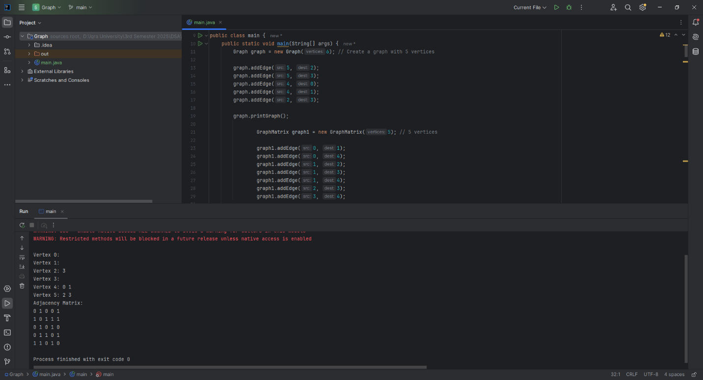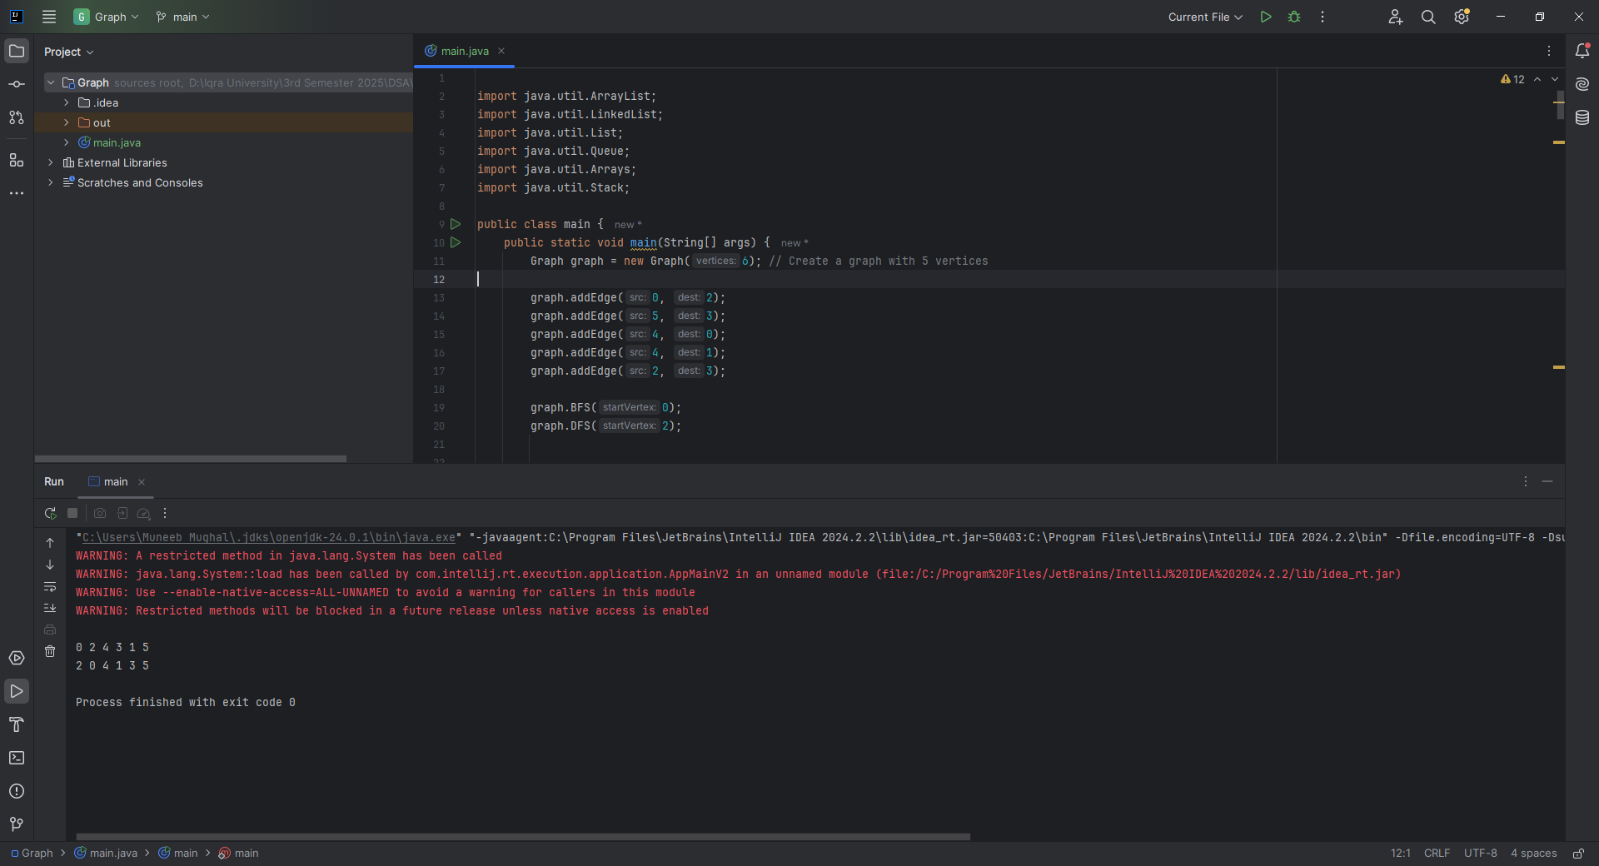

**Home Task 1:** : Detecting a Cycle in an Undirected Graph

**CODE:**

public boolean isCyclic() {  
 boolean[] visited = new boolean[vertices];  
  
 for (int i = 0; i < vertices; i++) {  
 if (!visited[i]) {  
 if (isCyclicDFS(i, visited, -1)) {  
 return true; // Cycle found  
 }  
 }  
 }  
  
 return false; // No cycle found  
}  
  
// DFS helper for cycle detection  
private boolean isCyclicDFS(int current, boolean[] visited, int parent) {  
 visited[current] = true;  
  
 for (int neighbor : adjacencyList.get(current)) {  
 if (!visited[neighbor]) {  
 if (isCyclicDFS(neighbor, visited, current)) {  
 return true;  
 }  
 } else if (neighbor != parent) {  
 // Visited and not coming from the parent → Cycle detected  
 return true;  
 }  
 }  
  
 return false;  
}

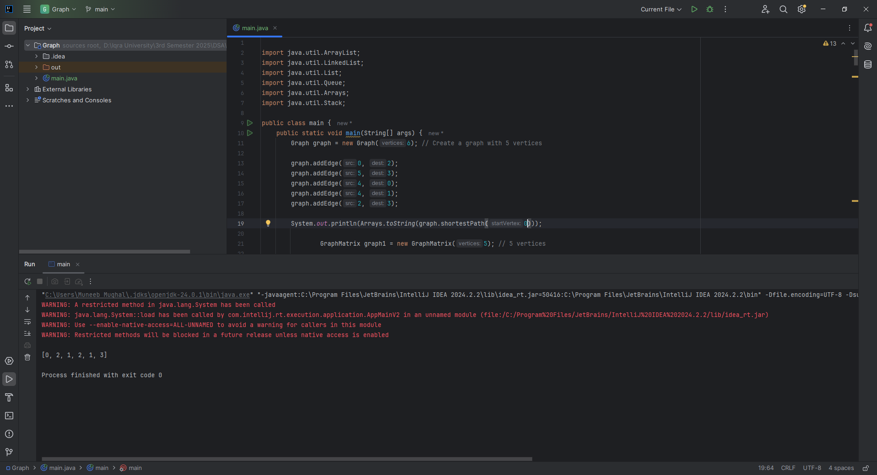

**Home Task 2:** Finding the Shortest Path Using BFS

**CODE:**

public int[] shortestPath(int startVertex) {  
 int[] distance = new int[vertices];  
 boolean[] visited = new boolean[vertices];  
 Queue<Integer> queue = new LinkedList<>();  
  
 // Initialize all distances to -1 (meaning unreachable initially)  
 Arrays.*fill*(distance, -1);  
  
 queue.offer(startVertex);  
 visited[startVertex] = true;  
 distance[startVertex] = 0;  
  
 while (!queue.isEmpty()) {  
 int current = queue.poll();  
  
 for (int neighbor : adjacencyList.get(current)) {  
 if (!visited[neighbor]) {  
 visited[neighbor] = true;  
 distance[neighbor] = distance[current] + 1;  
 queue.offer(neighbor);  
 }  
 }  
 }  
  
 return distance;  
}

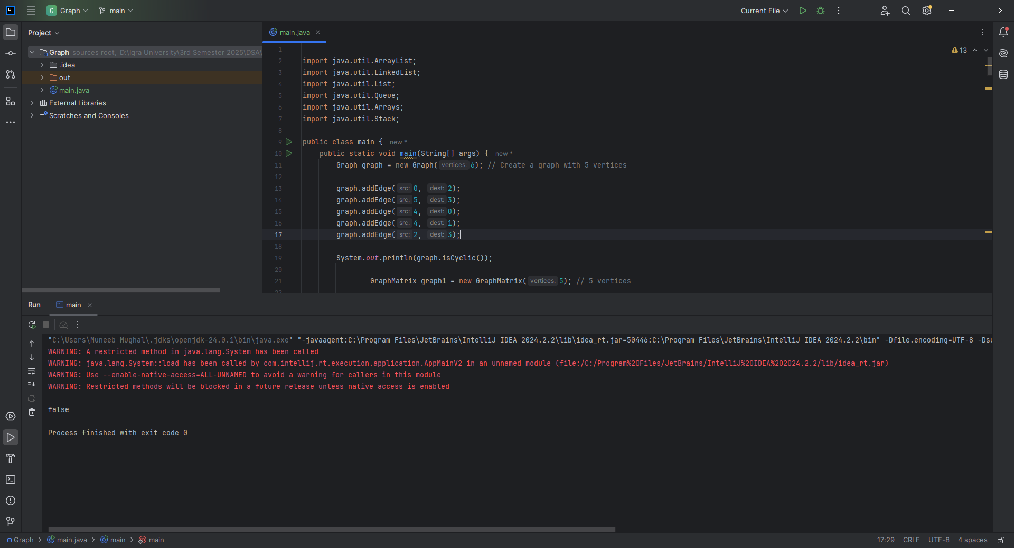

**Home Task 3:** Topological Sorting of a Directed Acyclic Graph (DAG)

**CODE:**

public List<Integer> topologicalSort() {  
 boolean[] visited = new boolean[vertices];  
 Stack<Integer> stack = new Stack<>();  
  
 for (int i = 0; i < vertices; i++) {  
 if (!visited[i]) {  
 topologicalSortDFS(i, visited, stack);  
 }  
 }  
  
 List<Integer> sortedList = new ArrayList<>();  
 while (!stack.isEmpty()) {  
 sortedList.add(stack.pop());  
 }  
  
 return sortedList;  
}  
  
private void topologicalSortDFS(int vertex, boolean[] visited, Stack<Integer> stack) {  
 visited[vertex] = true;  
  
 for (int neighbor : adjacencyList.get(vertex)) {  
 if (!visited[neighbor]) {  
 topologicalSortDFS(neighbor, visited, stack);  
 }  
 }  
  
 stack.push(vertex); // Add to stack after visiting all neighbors  
}

